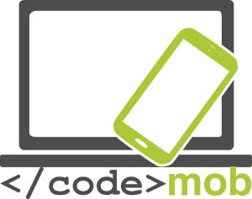

Effective use of mobile devices
for end users

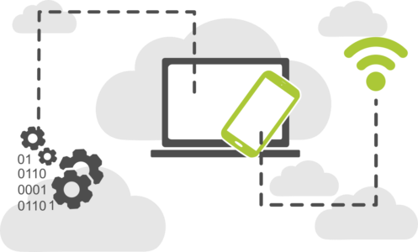

CodeMob: Effective use of mobile devices for end-users. Short version.
October 2017. http://codemob.eu/. Authors:

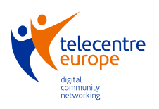

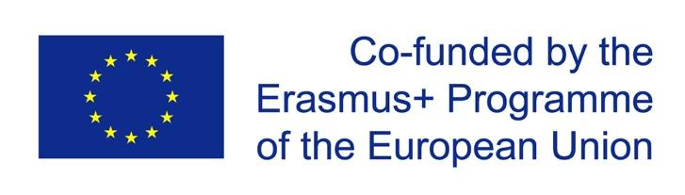
This publication has been co-funded by the European Commission’s Ersamus+ Programme.
The European Commission support for the production of this publication does not constitute an endorsement of the contents which reflects the views only of the authors, and the Commission cannot be held responsible for any use which may be made of the information contained therein.

Table of Contents
Operating systems of smartphones 5
Structure, features and choosing of smartphones 7
Physical protection of mobile phones (screen protector, cover/case…) 7
External features of smartphones 10
The sensors 10
Internal memory 13
Memory card 14
Capacity of mobile phones 16
Applications which measure the capacity of mobile phones 17
Charging the mobile phones, power bank 19
Settings 20
First usage 20
iOS 20
Android 20
Windows Phone 20
Managing contacts 21
Importing, exporting, editing, synchronizing contacts 21
Creating new contacts (private person, business, organisation, how to create and arrange the contacts of the possible workplaces) 25
Usage of the phone 26
Phone calls, etiquette of telephoning, etiquette of job seeking by phones 26
A little review of the Bluetooth communication standard 28
Application suitable for free calls 30
Conference call 32
Choosing keyboards 33
Making photos, settings (quality of photos, file formats), saving and sharing a screenshot (as a job seeker, what kind of pictures should be shared on social media platforms) 35
Settings of mobile internet, connection 39
Internet speed test 41
Settings of Wi-fi, connection 42
Settings of hot-spot, connection 44
Data transfer between phones, between a phone and a computer, between a phone and the internet (backups) 48
What is NFC? 50
Finances 56
Paying with Mobile phones 56
Managing bank transactions with mobile phones 57
Advantages and disadvantages 60
Online security 63
Smartphone’s security on the Internet and settings 63
Security applications, anti-theft tools 67
Setting of e-mail client 70
Sending and receiving e-mails 73
Applications 77
Google Play Store, App Store, Windows Phone Store 77
Security backups 80
Android 81
Installing, using, setting, enabling, disabling, uninstalling applications 83
Weather forecast applications 88
Browsers 90
Communicational applications (cheap communication) 93
Applications for sending instant messages 95
Social network applications 99
Searching on the internet (with key words; pictures) 101
How to search? Let’s see some tricks and some of the special tools. 104
Media applications (listening to radio, music, browsing photos, watching films, recording sounds, films) 106
Music , radio 106
Recordings 108
Photo viewers 110
Media players 112
Reading news, newsletters (scientific literature, SDI (selective dissemination of information)) 113
Browsing up-to-date news 115
E-book reader, reading books (searching for digital scientific literature) 118
"Applications connected to travelling: route planning, maps, navigational hardwares and softwares, applications for registering routes (travelling to the workplace)" 119
Apple Maps and Google Map 119
Navigation 122
Accelerometer 123
Clock and its functions 124
QR-code readers 125
Notes, notes protected by password, drawing 126
File managers, (systematic storage of CVs, covering letters, references in the mobile phone’s memory) 128
Office program packages 130
Applications for photo editing (but be honest during job seeking) 132
Calendars, schedule, time management 133
Storing and sharing files on the internet (systematic storage of CVs, covering letters, references in the mobile phone’s memory) 135
Storing photos on the internet (storing and sharing CV and reference photos) 139
Remote desktop connection with smartphones 140
Shopping list applications, receipt manager applications (healthy foods in order to preserve capacity for work) 143
Preserving health and capacity for work 144
Applications connected to Sport (compass, training programs, achievement tools, applications connected to hiking in order to preserve capacity for work for a long time) 144
Applications connected to preserving health (calorie counter, water drink reminder, sphygmograph) 144
Applications which provide unique appearance, customizing 145
Launchers 145
Task managers 146
"Employment, Job seeking" 148
Taking advantage of possibilities in social media during job seeking (Linkedin, Twitter, Facebook, etc.) 148
Job search on the internet and job advertisement 151
Job seeking applications (Infojobs, YouRock, EURES, etc.) 152
Making presentations 155
Coding 156
Tools suitable for developing mobile applications: MIT Appinventor or Mozilla AppMaker 156
Source 159

Operating systems of smartphones

What is an operating system (OS)? What is it responsible for?

„An operating system (OS) is a system of programs that, after being initially loaded into the computer, manages all the other programs (applications) in a computer, manages the hardware and software, as well as the computer’s memory and processes. It also allows you to communicate with the computer without knowing how to speak the computer's language.”

I’d like to demonstrate this definition with an example. It is widely known about iPhone that it’s a very smooth operating system, it stutters very rarely although for a long time there was only 1 GB RAM for its operation. One of the disadvantages of the Android systems, that they are prone to stutter and freeze even for minutes even if 2-3 GB RAM are available for them. The newer Android versions perform much better, but it is seen from this example, how the management and allocation of resources are important for the optimal performance of an operating system.

Examples of mobile device operating systems include Apple iPhone OS (iOS), Google Android, Research in Motion’s BlackBerry OS, Nokia’s Symbian, Hewlett-Packard’s webOS (formerly Palm OS), Microsoft’s Windows Phone OS, Firefox OS, Ubuntu Touch and the Xiaomi-developed MIUI. Android and WebOS systems are based on Linux kernels, while the iPhone system can be originated from the BSD, which is closely related to Unix, and the NeXTSTEP systems.

It is possible, that similar operating systems has quite different appearance owing to the fact, that the manufacturers adopt their own user interfaces to an existing operating system. Some of the examples are: the OnePlus manufacturer, which come up with its OxygenOS user interface and Samsung’s TouchWiz. These are not new operating systems, both have Android under the surface.

You can learn about the most popular operating systems later during this course. This course cannot deal with most of the above mentioned operating systems and it does not worth to deal with them in details. All the basic features, possibilities and functions are very similar in the different operating systems, maybe they can be found on different places with different names. If we don’t find a function, it is sure we can find an application for solving the problem.

Custom ROMs

Besides the original operating systems (in this particular case Android, preinstalled by the manufacturer), there is a possibility to use unique, aftermarket distributions, the so-called custom ROMs, which are modified Android operating systems. Manufacturers may not support one or another older devices but thanks to some determined programmers and freelancers, they write updates, custom configurations and program fixes to these older versions. With these ROMs new functions are available and many times they are faster than the original operating system. You can install them only at your own risk as the warranty ceases to be valid. The most widespread Custom ROM for Android systems is the CyanogenMod.

Structure, features and choosing of smartphones

Physical protection of mobile phones (screen protector, cover/case…)
Screen protection

We have examined displays in accordance with their operation, we concentrated on the inner parts, protective glass and parts under the plexi.
In the case of many displays, extra protection is not important because we don't bring them as we bring our mobile devices, it is a crucial point in producing displays. In order to make our mobile resistant against scratches and bumps, producers have to think of what they use as a protective layer for displays. I suppose many of you heard about Gorilla Glass, let's see where it is used and why it is better than a simple glass. Due to the technology, it is needed to be flexible in the case of resistant solutions, that's why they use plastic plexi. It the case of capacitive realisation, it is possible to use glass protection which is more advantageous from the perspective of light transmission. The most significant producer – who produces Gorilla Glass – is Corning Company. Their first developments can be dated to the sixtees, though according to the demands, those were not really resistant glasses. Steve Jobs visited the company to entrust them with mass production of the iPhone, it was a big risk at that time because there wasn't demand for these glasses and their production was expensive. Weeks miscredited the father of Iphone but they succeeded to produce the glasses for iPhone in half a year because they managed to convert the factory which produced LCDs before. They received recognition from Jobs at the introduction day of iPhone: „We couldn't have made it without you.”

The glass is subjected to ion exchange, thanks to this, a compression layer is formed on its surface and 1 mm thick layers are formed, too. Applying this technology, glass became more resistant but more fragile as well. The company announced a flexible glass in 2012 which is less likely to harm and break when it falls down. The new product is less thick, what is new is that glass tables are put into potassium salt solution bath of 400 degrees. During immersion sodium come out of glass and potassium ions subsitute them, this way the stiffness of glass decreases.

The development of Gorilla Glass is continuous, it is the 4th version on the market now. According to marketing, it is two times resistant than the competing producers' solutions. Glasses become harder and thinner year by year. There hasn't been severe problems with scratch resistance before, we often experienced that if our device had fallen down, the display broke into little pieces. The displays become more resistant by becoming thinner, from 0,7 mm to 0,4 mm. It is a curiosity that thanks to mobile developments, it even appeared in car industry, Ford GT's new model's windscreen is made of this. Naturally not every devices and producers get the latest 4th version. Unfortunately only a few device has Gorilla Glass, we can find it especially in the top categories, for example Apple, Samsung, Sony, HTC and OnePlus have it.

List of devices with Gorilla Glass

The protection of the display can not only be prepared by the producer, we can also take care of it. We can decide to buy a phone case or a film, a glass film developed especially for the protection of the display. People's taste differ, one can choose from a wide variety of phone cases. My advice is to choose a phone case which protects the device's edges and corners because the damage of the display often happens when we drop our mobile. Another advice is to avoid phone cases with magnet if we don't want our mobile work abnormally. We can even buy water resistant cases.
Almost everyone has used screen protector film before but we know that thanks to Gorilla Glass they will become unnecessary, it can be useful for simple glass srceen. According to my experiences, a glass film or a tempered glass can be very useful, we can put it on our mobile ourselves later or ask a shop assistant to put it on. Its price is starts from some hundreds and we can buy quite expensive ones, too. A better solution than glass film exists: tempered glass which protects the device in the case of much bigger physical impacts.

The essence of these two products is that they can sacrifice themselves instead of the device's glass surface. For those who needs a more simple protection, there is glass film but if we buy a more expensive device, it is better to invest in a tempered glass. It can be said that it is an obligatory accessory of the mobile if we don't want an expensive LCD exchange or if we don't have an assurance for break.

External features of smartphones

The sensors

With the help of the sensors, we get a sign which is made by the sensor about a measurable feature. The type of these can be physical, chemical, etc. There are different sensors in the smartphones, with the help of them, the screen turns, the games can be controlled more variously, the screen turns off automatically during calls, etc. In case of an ordinary device, there are not many sensors under the engine cover. There are only basic sensors, which are responsible generally for the orientation, proximity and light sensation. Certainly, there are phones in which there are much more sensors. Let’s see the most important ones.
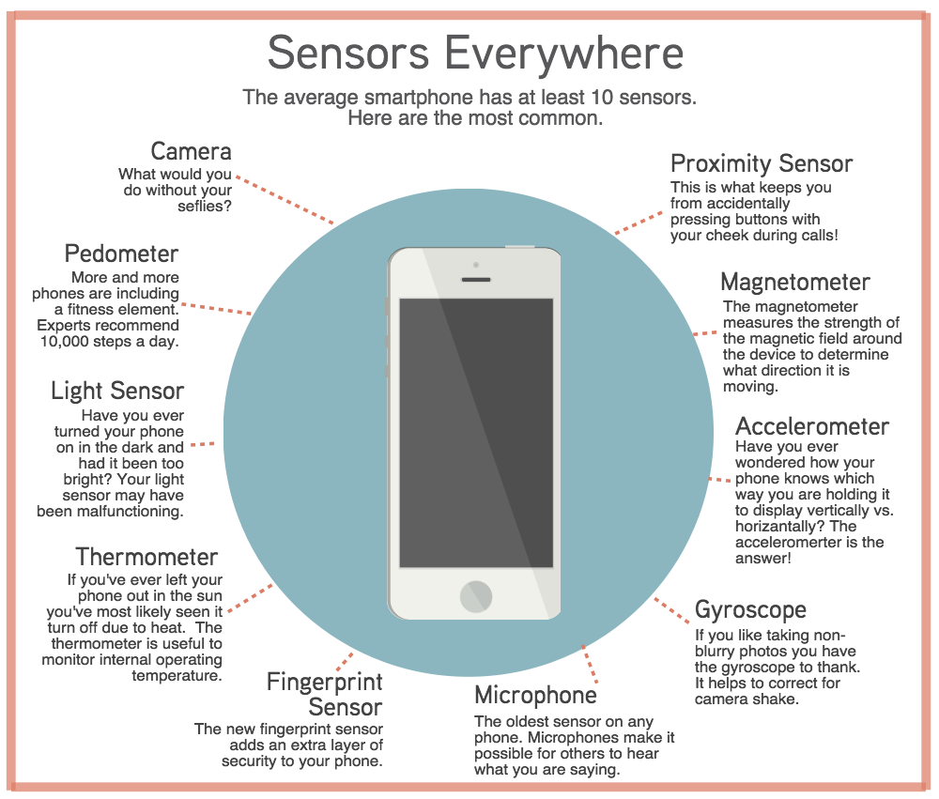

- The RGB sensor determines the measure of the red, blue, green and white components of the light, with this, even an adaptive screen, which adapts to our environment can be developed by the manufacturers.
- The motion sensor which senses the motion in front of the screen, with which, for example, the turning of the pages without touching can be realized.
- The proximity sensor is a basic sensor, which is usually used for turning the screen off during calling, thus preventing the accidental touching. In case of Galaxy devices, the Direct Call operates on this basis, with which the device starts calling a concrete contact when it is hold by the ear.
- The gyro sensor is not an innovation nowadays, it records the turning of the device along 3 axis. It can help in case of controlling games.
- The accelerometer observes the motion of the telephone on 3 axes. The Pedometer application records our daily activity with the help of it.
- The geomagnetic sensor measures the intensity of the magnetic field of the device’s environment. It helps to determine the direction of the motion, and also with the help of the digital compass, it can serve with data.
- There are also sensors which measure temperature and humidity, the values of them can be processed and visualized mainly by applications connected to health.
- The barometer measures the actual athmospheric pressure of the environment.
- There is also the Hall effect sensor which senses the magnetic field. It is used, for example, by Galaxy mobiles, where it senses the opening and closing of the magnetic cover. S View Cover case.
- In order to keep a pace with the improvement of health care, we can find pulse oximetry sensors, as well. Their function can be known from their name clearly. Moreover, as they are in the back, they can be used as secondary exposure buttons during taking a photo in many cases.
- In case of more and more telephones, there are also biometric sensors.

The data which were read and recorded by the biometric sensor can be used for identifying, paying, replacing, depending on the type of the software. Its punctuality and the speed of sensing have improved a lot in latest years, nowadays, the sensors in the newest, most modern devices always recognize their owners. The first of this kind of sensor emerged 8 years ago, in the HTC Sedna device, with less effectiveness if we consider the solutions of nowadays. Maybe, the first biometric sensor in smartphones which operates really effectively and well was introduced by the Apple, the 5S model got this innovation. There are gossips about that the new Android system will support natively the biometric sensors, thus not just the original individual applications could use it for identification but even the original application packages or the external applications, as well.

It can be interesting that sensing the fingerprints have disadvantages, when the hand is wet, the identification is not precise and this technology can be deceived easily. Samsung has a proprietary identification method which was used earlier only in hospitals and by police forces (FBI, CIA) for portable devices. The main point of it is that a sharp source of light would shine through the human vein and recognize its special structure. Its huge advantage against the fingerprint is not just that there would be more data and thus the identification would be more precise but it would also operate without actual touching. There is a conception picture which can help in understanding it.

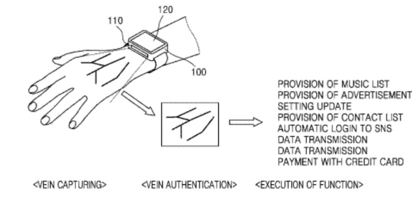

Internal memory

The memory of the telephone

In many cases the non-professional people mix up what memory and what storage is. The internal memory, the RAM stores the running programs and the temporary data which are needed by the running programs and services. Thus every opened application are stored in the RAM and they can be inactivate or closed later when they aren’t used. The RAM can’t be increased, so we should by an appropriate hardware according to our needs.
The other storage of the phone is the data storage device which can be integrated into the motherboard. It is also called internal storage in specifications, descriptions. Internal storage is also fix as RAM, data, files, programs, pictures and the operating system, e.g. are kept on it. This is why the real available space is smaller than the original storage. Increasing the storage is optional, it can be really different from manufacturers and models. Some manufacturers don’t support the increase of the storage with memory card (Apple) but some manufacturers support it in case of some models (Samsung).
If we know in advance that we store a lot of music, we watch films or take a lot of photo than we should pay attention to these possibilities. If the storage can be increased with a microSD than it won’t be a problem, otherwise we should choose a phone with an appropriate internal storage.

Memory card
Memory card

Memory card can increase the capacity of our mobile device, more precisely, increase the inner storage. If a lot of applications are installed or a lot of files (video, photo, sound) are on the device, cloud services will be used sooner or later or if we want to reach our data offline, we should increase the inner storage if it is possible. The place of the memory card can be found on the edge of the telephone or below the accumulator but nowadays it is more common that it is under the SIM card.
Memory card has 3 standards according to their capacity (in ascending order): SD (SDSC – Secure Digital Standard Capacity), SHDC (Secure Digital High Capacity) and SDXC (Secure Digital eXtended Capacity). There is also a difference between their size: traditional size: 32x21x2,1mm, miniSD (21,5x20x2,1mm) and microSD (11x15x2,1mm). The 3 standards are needed because bigger capacity was needed. The capacity of the biggest microSD card of Sandisk is 256 GB.
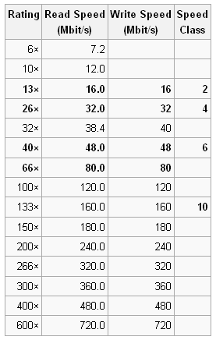
Memory card is a very important part of the mobile. It isn’t worth to buy a memory card under the capacity of 8 GB, if we have not so much data, 16-32 GB is usually enough for most of the people even if they watch films frequently. Bigger capacity is needed if we want to watch excellent quality films and photos or stream. For example, some films are projected on a TV during holidays or some good quality pictures are shown on a family event. Bigger capacity is also an advantage if the mobile is sometimes used as an USB flashdrive.
Speed is an essential factor. If the contacts or other data are stored on the SD card, it is important to run fast, because during daily usage, it could be disturbing if the SD card runs slowly. Slow running can be noticed mostly for example in case of running an application or using gallery.
The speed information is classified. Nowadays, minimum a class 10 SD card should be bought. In each class there are more ranks. Smartphones can record high quality videos in high aspect ratio and FPS (frame per second), thus quicker and quicker memory cards were launched into the market. UHS-I, UHS-II (Ultra High Speed Bus) can reach 100 MB/s in case of reading but it case of write speed, this value is lower. The UHS-II card could increase its speed with a help of 8 additional connectors.

Capacity of mobile phones
Capacity of mobiles

Today's smart phones' capacity is quite remarkable as devices of the top categories have as much capacity as a some year-old, average computer. It is not by accident that they discharge in a day, heat during playing games, it is because they have a powerful hardware. As we have seen earlier, they are built as a micro computer so their capabilities mostly depend on the same things as in the case of PCs. To compare the latest devices on the market, it is useful to consider their capacity but I do not recommend to make a decision based on it. We can assign capacity based on specifications such as SoC (CPU, VGA), RAM) but if we want to be farseeing, we need to consider other factors as well. A good software and manufacturer synchronizing means a lot, it is not by accident that many small Chinese manufacturers can sell the same hardware much cheaper than a big, well-known manufacturer. A lot of other factors determine price such as marketing, support, etc. So it is worth testing and measuring capacity with applications during operation. We have several facilities for this, it depends on what we want to measure. The question is that if we are interested only in computing, CPU speed or possibly in storage speed or we like playing and we are interested in 3D capacity.

In the case of a smartphone, computing capacity is much bigger than it was when people landed on moon in 1969. A super computer at that time was built of 75 big devices, they cost more million dollars and were able to carry out only some hundred thousands operations. Their storage capacity could be measured in MB. It is quite astonishing when we compare it with a some years old device. Let's have a look at on iPhone 5S' capacity, in my opninion, it is excellent, I, myself use it. In the case of floating-point operations, the computing capacity of its graphic unit is about one milliard operations per sec. Take into consideration that there are hardwares, for example the Galaxy S7's which can do even much more calculations, around four times more. It does not mean that we could repeat landing on the moon whenever we wanted but we can see how big powe is in our hands and pockets.

Applications which measure the capacity of mobile phones

Applications for measuring the capacity of our mobile

We use AnTuTu, Vellamo, Geekbench and GFXBench applications to compare the mobiles' hardware capacity. Do not buy devices based only on this as we are not going to play witha nd phone with benchmarks, we will also see that manufacturers are able to cheat on these synthetic tests, too. While the tests are running, programs fix the time needed for measuring, the appearing pics' refresh rate (FPS, frame per second), the operation performed, etc, based on these qualities, they will scores which reflect their performance. The comparison can be made in the following ways:

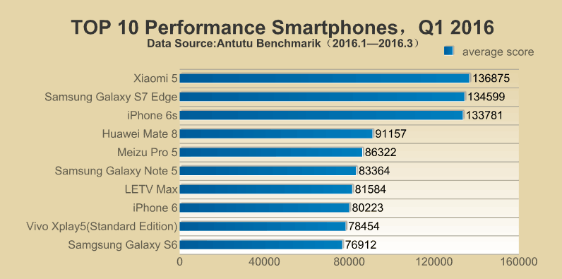
Choose the devices we want to compare and install the same version of programs. Run those hardware tests in which we are mostly interested. After this, scores can be compared. As for the speed, do not make far-reaching conclusions but we can get several useful information of the processor, graphic accelerator, memory, inner storage and wireless transfer rate. Synthetic tests are similar to whcich we are used to on personal computers, in the case of 3d mark, there is a seperate switch for test mode, guess why. :)

Antutu is perhaps the most widely known application of this type but we also included some more in order to get the most precise result as possible. Different tests value devices on different criteria and specify the final scores. We consider the switching off the screen as a criteria, with its modification, interesting result were born.

In the second half of 2013, there were news in connection with different Samsung devices, it was said that in case of running synthetic tests - when it is sensed by the device - it increases the clock of the processor and the graphic accelerator, and thus it increases the temporary capacity. Owing to the increased clock, the device will get higher points naturally.
The AnandTech website dealt with this topic more accurately than just discussing how and when the Samsung cheats, about this you can read hear -HIVATKOZÁS in more details. The further investigation dealt with which firms acts similarly to Samsung.
The Galaxy S4, Note 3, Tab3 10.1, Note 10.1 devices of the Korean manufacturer identify more benchmarks and “optimize” the capacity, with which even 20% capacity increase can be gained against the devices which do not trick. Moreover, the ASUS Padfone Infinity, the HTC One, the One mini and the LG G2 also optimize the settings, although in case of less programs than the Samsung does it.
From the checked devices, the Motorola, the Nexus devices and the NVIDIA Shield remained fair. That is why the Google Nexus devices get lower points constantly than the devices with similar hardware of other manufacturers.
The devices of Apple do not do optimization like this, although, the comparison is not punctual because of the measuring in other operational system.

Charging the mobile phones, power bank

What can we do if there is no charger hereabout and the phone battery is low?
First of all, if we have got a laptop, we can try to charge with it, although, many times a laptop is not available in this case. It depends on the mainboard, but usually many laptop can charge in a turned off state as well, because the USB port is remained under voltage. The changeable battery was a good solution earlier. To whom it was necessary to, even more days of operating time during a touring, that a phone cannot provide, principally in the case of navigation, then, more charged battery could help. It was a less good solution, because at the big percentage of the apparatuses the gatherable battery is not an option. There are repmanufactured endeavors to incrase the camacity of the battery, for example built in a backing.

In my opinion, this contruction is not the luckiest solution, because nowdayt the appearance of the phone is very determinative and this and the case make the phone ugly. Although, it is a fact, that it works, we use our phones longer with only one charge, but the graceful and convenient phone is groaned inwardly. Not to mention the price! What can be then a golden mean?

The powerbank or the portable chargers can be a very good alternative solution, anywhere, anytime. In spite of the good price, we can buy mobile batteries with a very good capacity, which can charge 1 or 2 apparatuses at the same time. The more qualitative chargers are provided with protective electronics, so the overcharge is prevented.

Settings

First usage
First turn on, putting into operation

iOS

https://www.youtube.com/watch?v=6WFLtIcqaoI

Android

https://www.youtube.com/watch?v=9wmIdmmIz8g

Windows Phone

https://www.youtube.com/watch?v=C4TeO3SW5LE

Managing contacts

Importing, exporting, editing, synchronizing contacts

The easiest solution is if we store and manage our contacts in the cloud-based register of Google. We have to allow only once the synchronization and than it save all of the elements and than it keep in syncron the modifications, deletings, new calling cards between the phone and the online version. If we save our data into the Google directory, they will be in safe there, whatever happens to our phone. For this we have to sign in to our gmail account; in case we have missed this step at the first turn on of Android system, then we might experience problems with some Google services. If we experience stoppages after singing in to our account, set the device to the original factory status and singn in with our account right that time. Compared to the conventional calling cards the manufacturers build many extras and comfort functions into the software, thus the register of Android and iOS are smarter. We can import our contacts from the SIM card, where limited (a few hundred) amount of information can be saved, or we can also import them from our previous device (for example with Bluetooth connection). Personally, I would prefer to save in the Google account. If your contacts are not in the same place, you should expert them into one file first. Set the device to show all of the contacts, so those that are on the SIM and those that are on the mamory card as well, then save as a CSV (comma-separated values) or as a vCard (mainly Nokia uses) file. We can import this file into the Google contacts. Let us see, how can we do this? Open the contacts: https://contacts.google.com, where search for the Import menupoint from the menu on the left side, under the Furthers menupoint. We can see, that we have several possibilities to import, starting with different mail and outlook accounts, through the icloud email of Apple, to the CSv and vCard farmat. After selecting the correct source and after uploading the file or the correct authentication (identification) the importation starts. After importation a routine runs immediately, that checks the repetition of the contacts. If it finds repetitions, it indicates us and if that is really one person’s data, fuses the data with a single touch. So, we can make tidy easily with it. If we are ready with it, we only have to select the editing mode of the Google contacts and delet these data from the other places. A very big adventage of cloud-based saving is that we can modify, edit our contacts online, anywhere, anytime, and the phone will update them during the synchronization when we connect the phone to the internet. The same will happen, if we ad new contacts on the phone, those will get into the cloud.

The online page can be available here: https://contacts.google.com
The previous online page here: https://www.google.com/contacts/u/0/?cplus=0
It is interesting, that saving out and exporting the old contacts is only possible on the previous page. Let’s see, how can we export contacts from the Google register. Open the page; select the wanted contacts, then under the Furthers menupoint we can find an Export menu, and by selecting that the following page will appear.

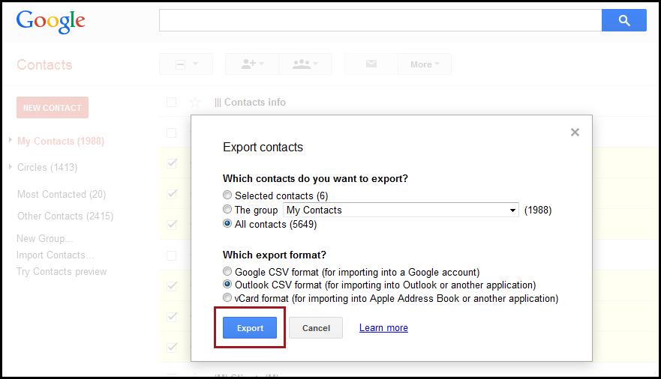

We can set if we want to save out only the selected contacts or we want to save only the informations of the members of a selected group or all of the data of everybody. Before saving we have to select the format, I suggest CSV to Google importing, that is the proportioned by commas version. If we want to save into an Outlook account, CSV save is possible, or the vCard, which is accepted by many programs and that is used among others by the Apple. Thus, if some years later we do not want to use the Google services anymore, we can export our data and we only have to import into a new buffer. The editing of contacts is very easy. Select the contact, start to edit with the lillte pencil icon (or edit menupoint), and do not forget to save after the modification.

Android
The sign into the Google account is needed because of synchronization of the contacts, emails, calendars, if we want that. Hence, do the followings:
- Push the MENU bottom on the HOME screen (applications icon), then find the Settings menupoint and select from them the Accounts and synchronization element.
- Push Add account > Google elements
- Follow the instructions!

In the case of Gmail we can choose from IMAP or POP3 mode. In the case of POP3 protocol, masseges will be downloaded to the phone and at the same time it will be deleted (not every time, but usually) from the server. In the case of IMAP the mails are in syncron on the phone and on the server, so if I delet a mail locally, it will be deleted from the server and from those places, where we are still signed in through IMAP protocol. In fact, in the case of IMAP the execution of the taks happens on the server and the mobil sees only a copy in this case.
If we have more gmail or email addresses, do not despair, because we can give, use and keep in syncron more accounts at the same time.

iOS
I bravely suggest also to iPhones using Gmail account to keep syncron, although, it can work from several other sources, as we can see on the picture below.

Those who work with mac, there is the Contacts (Adress Book) program as one more positive thing, with which the calling cards can be managed. Here we can export data as vCard as well. All in all, every export and import processes converge and we can say that in the case of every apparatuses it is solvable to copy and keep the contacts in syncron. However, the Google account gives the most comfortable and everywhere usable solution.

Windows Phone
In my opinion, the easiest is to import the calling cards from the SIM card to the device. Put the network identification card into the device, then pushing on the People button the possibility of import appears. The syncronised data get into the Microsoft Live.com cloud, inside that, connected with the Hotmail account. This is a positive thing, because this mail-system can import data from several services. It can work from Facebook, Outlook, and Gmail that is WinPhone Gmail as well.

Task:
- Add a new contact to our contacts which are possibly kept in synchron.
- Add a new contact with the same name, but with other informations.
- Merge this two repetiting elements on the online page.
- Delete the contact from the device, once it is successfully merged.

It can also happen, that somebody does not want to synchronize the data into any kind of cloud; and in this case we should save the whole register out and store in vCard format from time to time. A save like this gets into the internal memory or into the microSD, copy this with the file manager to an independent device, where tha data will be in safe. In my opinion, you do not need to be afraid of the safety of the data stored in the cloud, If anybody gets through the protection of Google and wants to get even our data, there is a big problem for a long time. ☺

Creating new contacts (private person, business, organisation, how to create and arrange the contacts of the possible workplaces)

We can add contacts manually, but if we buy a new phone and we want to use the previous contacts, we have to review the part of import written above. In the case of adding a new contact we can also add several other informations, besides the phone number, name, email address, nick name, birthday.

Adding a new contact on an Android and iOS device is very similar.
One possibility is to enter the register and seek for a plus icon or a plus icon with a human contour. Here we can give the data, make photo or assign a photo, or we scan from the calling card using our phone. (The factory support can be very different in the case of the certain apparatuses, but there are 3rd party applications for it.) After saving, during the next automatic syncron this data can get into the cloud too. When we add a new contact, the Samsung device asks weather we want to save into the device or into the cloud.
In the everyday life, adding after typing occurs more often. Type the phone number, and if the apparatus finds a connecting calling card, that appears, otherwise we get a similar “+” icon like above, whith which we can give the data and create the contact.

Usage of the phone

Phone calls, etiquette of telephoning, etiquette of job seeking by phones

One of the most important functions of mobile phones is making a call, the role and use of it decreased receantly because of the fascionable quick messages, chatprogrammes, and free message senders.
However, we need a dialer to make a call. Those, who are ready for more, want to know in the case of an incoming call, what are the relevant call antecendents, or want to dial on the base of a smartlist, instead of a traditional call list. For those who think that the integration of the free message senders, like WhatsApp, Viber, Hangouts is useful, I suggest the dial applications that can be downloaded from Play Store. The dial applications usually show the antecendents, our favourits, our calling cards and the dialer itself, of course, showing us the listed on different pages. Among the call antecendents, we can also get to know the details of that, thus, we can always follow the exact date and term of the call. The antecendents will be deleted automatically after some time, so pay attention for that these informations will not be available for months.

Telephony etiquette
The spread of mobile phones has brought many changes in our daily lives. A lot has changed by the fixed access, anytime, anywhere can make the phone calls. Sometimes in the most extreme places and situations. It provides a lot of help that the device displays the caller's number, in many cases the caller's image, photo, associated photos, their anime used on social networking sites. We can decide if we want to pick up or reject the call. The communication has transformed. The traditional telephony is increasingly pushed into the background and instead of the sound the text and the pictures will take over the role of the mediator. This can be partly explained by nominal reasons, because some connections are free on smartphones, and partly this is a general trend that the image and the moving pictures have taken the place of the text. We share pictures, videos with our friends, you write short text messages and vigorously spread the video chat, where we not only hear the sound, but we see the live image of the partner who we are talking to.
These new forms bring new decorum.
Unconventionally, the traditional roles can survive in the same way. When we are making calls we still need to introduce ourselves and to say hello. Strive to talk concisely and clearly. Have always regard to the contract, do not hold him/her up unnecessarily.
The text messages slightly altered the traditional labels. It was an elementary rule not to call too early or too late (except in emergency case). Earlier we could send a text message at any time if we did not expect an immediate response. It is good to pay attention and not to waste unnecessarily the partner's patience, do not write too long, and pay attention to the lucidity! The existing devices and programs are now generally supporting accented letters and special characters. To avoid confusion rewarding you should use them.
If a live video conversation with (such as Skype), it is important to pay attention to the background. Again, this says a lot about us, it is important that appropriate conditions are visible all around us. (Numerous photos can be found on the Internet, on which various housing advertisements can see inappropriate objects)
Of course, the general toilets would telephony also applies to the use of mobile phones. And here is the general rule, the partner determines the method. In other words, we are talking about friends, family, colleagues, work with taxes, with any prospective employer.

A little review of the Bluetooth communication standard

Nowadays the most popular and latest smart phones standards are the 4.0 LE and 4.2 LE (Low Energy) versions. With these modern energy-saving opportunities we can run the tool from key pile for years. Two types can be distinguished, the single-mode and dual-mode. To simplify, they use Bluetooth Smart for the one-way communication supported, low powered and limited functionality devises, while the only energy-efficient, but high speed two ways transfer connection type devices are called Bluetooth Smart Ready. It can be found in the latest generation devices such as in pedometers, in smart home modules and in different medical devices The standard's benefits is that they can be found in older Bluetooth compatible systems and accessories.
The standard was a surprise to resolve a problem, as I mentioned earlier, that is consistently used by all producers. Nor it has helped its spread that it had a slow data transfer rate, it was difficult to connect (pairing) and the consumption was high. Now it is one of the most important communication platform, considering that over a million user purchase accessories connecting through the standard every day. A few years ago, nearly 2.5 billion Bluetooth enabled devices have been sold in a year.
The Android systems were installed in very late the above mentioned Bluetooth 4.0 Low Energy Profiles, almost lost in the market. Previously it did not support natively the operating system, so for Android it was very difficult to develop an application and it may be unprofitable. In the recent years, thanks to native support, developers can easily and quickly develop applications that use Bluetooth devices via the API. Installation and support of the standards is essential in case of smartphones so they can connect to smart watches, to activity measuring devices, to scales and other sensors.

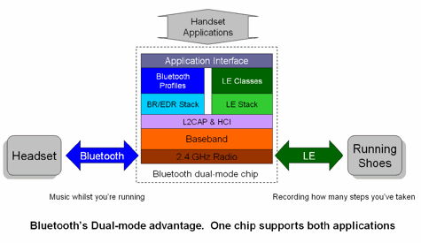

The iOS platform users have long enjoyed the benefits of the standard and the developed application too. It has appeared first on this platform the Blue Bulb lighting controller, the FitBit pedometer or the Garmin solutions that directly transfer data from sport watches.
Current efforts aim to increase the stability striking-distance of the standard, which would help to ensure that a building could be controlled from one location, from lighting, heating and cooling perspective. For this, however, it would be required a few ten-meter range.

Application suitable for free calls

One of the great pioneers was Skype, which offered free telephony and offers today, between two devices or smart device, which is connected to the Internet, if the Skype client program is installed and the device owns a speakers and a microphone. Previously, the Internet or mobile Internet fees had a considerable cost, now it is almost negligible, so we can really enforce the advantage in nowadays. Earlier, 1-1 mobile internet subscription price was so high that domestic phone calls were not necessarily worth it because of the data transfer. The services freenes is and were compensated by the revenue from the voice based (rather before) or from the client integrated advertisements.

This number of VOIP service users and the amount of calls that they have made is continuously growing, although it is not that spectacular like in the last 10 years, even so the monthly data transfer is rising with a censorious monotony.

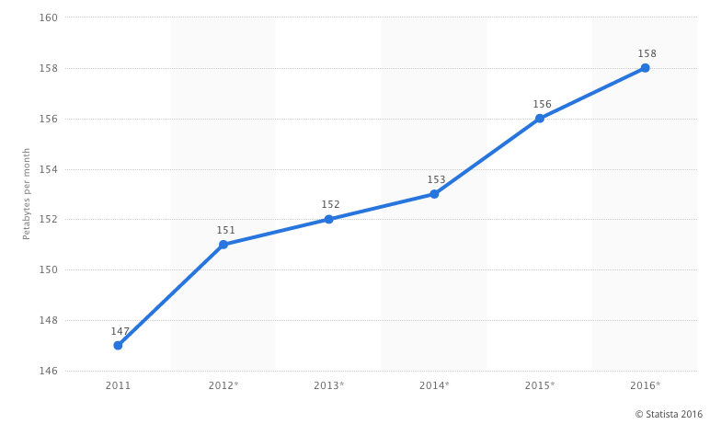
Its bandwidth demand is not very high, 0.5 / 1 MB per minute, of course, it depends on the set quality, from the used codec from, is it a video call or a phone call, that is measured. So you do not have to have a great internet package to make a call through the internet, which can provide a real (cheap) alternative compared to the normal cells.
Anyone who goes a bit more into the optimization, soon realizes that there must be a testing facility in order to test the codecs.

Plenty of similar services exist in addition to the above-mentioned Skype, which can be installed free of charge to communicate between clients via the Internet. There are applications that allow only to transmit text messages, others only audio or video chat sending and receiving. We are interested primarily in the voice based communication in the case of mobile phones. Let's look at some of these applications.

The most popular applications that provide free calls, video calls are the following: Skype, Viber, Fring, WhatsApp, Facebook Messenger, Hangouts. The applications will be explained in more detail. See them below.

Conference call

If we are using a GSM-based device we can initiate multiple phone conversation and talk to people at the same time, such as Call Conference call. Parties participating in the call may have different service provider.
To make a conference call, choose option ’Add call’ during the telephone call or dialing then choose ’Merge calls’. In order to add more calls repeat these steps as many times as it is needed.
The conference call can be ended only with one person. For this, push the icon next to him/her name and choose End function.
Conference Call cannot be the only GSM based, but can be IP-based Skype calls as well. More than two years ago, the company required subscription fee for this extra service which is now free on multiple platforms, but only 10 persons or computer can connect at the same time to connect.
If we want to make a conference call via our smart phone for as cheap as possible, we can use the Facebook Messenger latest innovations where a family conversation or call of a full group is not a problem, it is free of charge. A call of the entire Android group is not a problem, it is free of charge, if we have Android or iOS operational systeme on our cell.

Within Messenger, after selecting the group we want to call, when we press the little phone icon, you can select which group members are notified of the call and participate in it. The maximum number of participants in a conversation can be 50 people. If We missed a call, but it is still going, it is also possible to subsequently joined the call by tapping the phone icon.

Choosing keyboards

Why are we buying for our desktop PC or for our laptop a keyboard which cost a small fortune when we can also purchase for a couple of hundred?
The comfort, design, customization and extras, so for the same reason, to replace your usual product solution for maybe a better app, or it just gives us that feeling. I think the speed meant problem mostly for the first few editions of Android, when in my opinion the pop up keyboard was very slow. But we can still have a better accomplishment (memory usage), and other extras in some virtual keyboards.

Let's check how we can replace any default Android keyboard.
Download a keyboard app, SwiftKey in the present case will be the test subject. Once installed, navigate to Settings> Language & input, then push the default keyboard, change the input mode, first with the SwiftKey authorization, and then with selecting it. Thus, the default keyboard changes.

In the case of iOS, we have the possibility to replace the keyboard, only from the 8. IOS version. It might not need it because it is fast and simple, it figures out what you want to write, really it has everything that you can have in a third-party application.
How can we replace it after all? Download our new virtual keyboard, and then navigate to Settings> General> Keyboard menu. Enter the list by tapping Add New Keyboard. Type in an arbitrary field, and on the left side, we find a globe on the keyboard, by pressing on it we can replace our active keyboard.

Let’s review some popular keyboard.

Swiftkey Keyboard

We can replace our Android keyboard with an alternative. A hugely popular and very useful program an application called SwiftKey Keyboard, that not only helps to describe the words, but it offers the potential words. It allows a faster typing option than the default one. When correcting the text, it does not only correct the words, but it helps to add space and appropriate point and stops to the sentence. Indeed, it is able to learn from us, it tries to imitate the writing style to offer the words on the basis of it, speeding up writing by this function. Its look and color scheme is customizable, so you don't need necessarily to stare at an unanimously colored keyboard while you type-in. Not only the look, but the character layout is also customizable.
Over the years the its efficacy has improved a lot, so it is a really quick popping-up, disappearing and very fast keyboard.

It can be effectively used with the "Type with a swipe" mode, that means we can type the letters without lifting up our finger, but we keep pulling them letter by letter. Letters of the break points gives the formation of the word.

Its dictionary supports many languages. The SwiftKey has several unique image icons that we can send or insert arbitrary when we are typing.

Task:

- Install the app from the Play Store, and then replace the default keyboard to SwiftKey keyboard.
- Type any text in the traditional way.
- Type with Swype technology, so without releasing your finger
- Customize your keyboard look
- Let's look how we can switch to a keyboard hands, where the numbers appear behind the letters on the top row. Assuring faster access to the numbers.
- Send an instant message to the person sitting next to us, which contains emoji icon.
- Restore the default keyboard

Making photos, settings (quality of photos, file formats), saving and sharing a screenshot (as a job seeker, what kind of pictures should be shared on social media platforms)

Producers will attempt to increase the quality of the camera, on the one hand, this can be achieved by hardware (see above), and by software, such as the continuous expansion and ever greater freedom for the user to do manual settings.

The preparation of a photo can be initiated by launching a camera application.
It may be convenient if the manufacturer provides a quick photo session as well, such as we can take pictures without unlocking the phone. Naturally with much tightening that foreign hands could not be allowed to reach the images, the current photographed images can only be accessed from the application. Upon the completion of the photography we will see the lock screen.

Our photographer application can vary considerably depending on case of Android phones from the producer. There is a basic API, which is used, but the image processing, the utilization of facilities largely depends on the producer's own software development level. That is why there is a big price difference between smart phones even they have similar hardware.

Keep the device on what you want to photograph wait until its edge with the help of the focus and press the shutter icon on the camera. Before the shooting we have many opportunities to make more lifelike the subject in the photo, or if we want we can be creative by using effects and filters.

Setting options in S6.

There are icons for quick setup, such as image size, which can be 16 megapixels, that is 5312 x 2988 pixels and 16: 9 aspect ratio of the prepared image, this is the maximum resolution that is available on the device.

The picture is made up of pixels, that means a picture made of rows and columns, each pixel contains a valuable colour information, which is 15,872,256 pixels seen on the former resolution if the number of rows and columns are multiplied. That is how we obtain the value of the megapixels. We can choose to use a lower resolution, for example, we only want to use our pictures in small size, and thus we can save considerable storage space. The lower resolution does not mean that the image quality will be worse until a certain level, just do not try to make a large print of it. About the aspect ratio, I just what to say that the number of rows and columns are in a 16: 9 proportion compared to each other, which will result a widescreen picture. Today's devices, monitors, laptops, TVs, almost use 16: 9 or 16:10 aspect ratio, so you should also stay with it.
It depends on application, because there may be that someone has a 4: 3 points, which means the person would need the older format and he or she do not want to crop his or her images so it worth to choose an appropriate resolution to this.
The following quick setup applies to the LED flash or "flash". It has 3 status, AUTO mode: when the device's software decides whether there is enough light without a flash, that the picture would be free of failures. It has "off" and continuously "on" mode version as well.
You can use a timer shooting, which is useful if you have no other selfie or group picture helping tool at hand.
These settings can be found in each device, but at the upcoming HDR (high dynamic range), it is far from certain. What it is responsible for what can we achieve with it, when to use it? Accessing the higher dynamic range can be spectacular when shooting, which means that the lighter and darker areas simultaneously appear in vivid detail. Imagine that you want to take a picture of the shepherd sitting under the tree, however in the background, the sun is shining so brightly. It is impossible to prepare from one exposure, shoot an image where the background is also relatively good and the shepherd can be seen on it, because of the bright background, the phone takes the exposure value down, which resulted that the shepherd sitting in the shade will be darker, perhaps even barely visible. Thanks to the HDR function the camera will take one picture with many different exposure values, all completely automatically, without even realizing it.

The last icon in the row of a magic wand, which can take photos with various effects. Here it is possible to expand the default filters by downloading even more.

Although it does not display an icon, it's worth knowing that it is possible to influence the autofocus, because we can choose a focus area by poking the screen. If we press anywhere on the screen we can change the exposure by moving our finger up and down (or from left to right), which result that his picture will be even darker or lighter.

To activate the front camera we must press on a small camera icon where the icon contains the arrows, which symbolizes the change.
We can find a MODE and a bolt symbol, which contains the extra settings and the MODE menu offers many new opportunities.
Selective focus, professional, panorama, deceleration, acceleration, etc .. If we want to create not only a classic picture we must navigate here so we can select the desired mode and make a smooth picture or video media.

Video recording can be initiated by using the red circle in the middle. If we select a special mode, such as slow motion, which only makes sense for video, you can already get the button just when we start making the video.

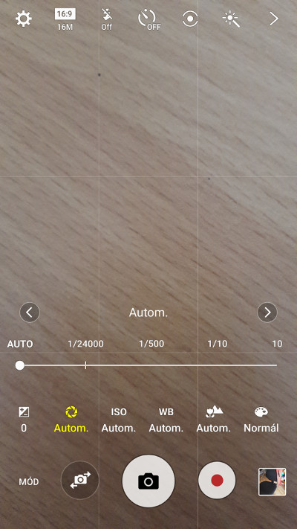
When we activate professional photography mode, we will have the opportunity for several professional photo settings, so we can set it up manually and not by the machine's sensors and software. In this way we will have more creative opportunity. You can set the aperture, the shutter speed, the ISO light sensitivity, the white balance, any extra filters, color settings. It is possible to set a different light value (the image luminance indicator) and not the sensor determined one. It depends on the shutter speed and aperture. These properties inherited from the wonderful and complex world of photography, so we will not review it because it is part of a different course.

Settings of mobile internet, connection
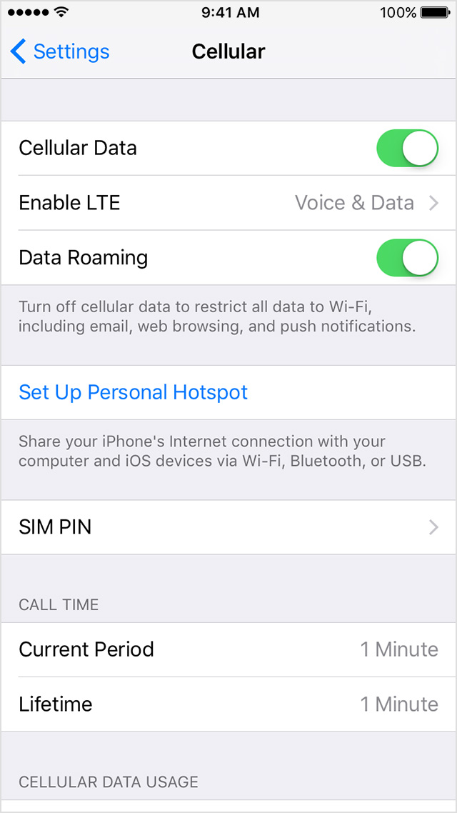
For mobile Internet reachability, we will definitely need a subscription, which can be monthly, or packet-based. If we have a subscription, we will usually only need to turn on the mobile web, and we can use it. Pay attention to the foreign use because roaming fees are similar, it can easily produce a sky, flapping bill we can by using other mobile service towers is to send and to receive data.

For Android device, depending on the version of the notification bar on the top we find the quick help button on and off. Thus, a button to activate or deactivate the wireless internet was our relationship with the world. In fact widget that is independent gadget can also be done on the screen, which are accelerating the on and off so you do not have to look for this icon in the notification bar or arrange special place.

For iOS device, you should switch on the button by side of Settings > Mobile > Mobile Data Traffic. You can see on this side more settings, which is generated, if we consider the data traffic.

You can see our call duration and the amount of data used in the current period. You can also see that is generated after reset.

Depending on the device also allows an LTE mode, although this depends on the service provider, but basically it allows faster Internet access if the conditions are available.

When you are abroad, turning off data roaming, you can avoid roaming charges.
By scrolling you can see below the applications and their generated data traffic, if you do not want to in the future, that the application goes on mobile iternet, update, upload or download data, then you can set in to avoid for decreasing our data.
iOS 9 innovations, that the active Wi-Fi phone will automatically switch to the mobile Internet, if wi-fi connection is weak.

Internet speed test
The measurement of the speed of internet connection

We can measure the speed of the Internet through the applications. However, there are some websites, which use Flash, but without installing them, we can measure via our connection speed.
Let's look at some of the speedometer application. In the case of applications where it is possible to choose measurement points, try to assess to multiple servers because one measurement is not measured.
The Internet speed is determined by the speed of upload and download. Its distance from the server and speed of communication is characterised by Ping ("Packet InterNet Grouper"). Ping is a test packet (packet), which we send out on the network to the server and when it arrives to the server, it immediately reflected / returned to the sending party. so the server act like a wall. So the Ping shows the elapsed time between the sending and the return. We can find out what the speed is between us and the host server. It is measured in milliseconds. Up to 20-30 ms count very well, there may be disruptions over this rate.
The upload and download speed definition does not need to be explained in detail, when we visualise the data, demand download, then we are downloading. Once, while somewhere we enter data or share a picture, we are uploading data. In general, the amount of data downloaded is more than we have uploaded.

Speedtest.net

The site enables us to measure our speed through our current accession in the direction of the world. Meanwhile, they developed for major platforms the measuring applications so that can measure our mobile Internet or WiFi's speed.
When we start the application, it will ask us to allow access to any of our positions, because it will measure the server which is the closest to us. The application is free because of the advertisements contained in it. This is one of the business model, in order to not necessarily pay for an app.
The application saves the previous measurements, so they become easily to compare. It will indicate separately our measurements, we used WiFi or mobile internet to record the measurement. Note that our devices have a maximum data transfer speed, our devices can not use high-speed Internet 100 percent. I measured the Apple iPhone 5S device, it was able for 50 Mbit / s speed in both directions, but the internet and the router would have allowed far greater.

Task:
- Insert a gadget, widget on the screen
- Set up a notification for roaming
- Set your monthly data transfer limit
- Use cellular network and WiFi for data transfer

Settings of Wi-fi, connection
Wi-Fi settings, connectivity

Normally, when we are connecting a new way-if it should be the simplest task. Settings> WI-Fi select the SSID of the network, its name (Service Set Identifier), which we want to connect to. Enter the corresponding password and, if we are not mistaken then we will be able to connect successfully. If the wrong password has been given upon accession and then again it do not ask you the password again, or the password has changed, then press and hold on the name of the network and make it forget with the device.

If the network's SSID, the name the network is not detected, you can manually add to the network. In iOS device, it can be found under another item menu within the WI-Fi menu. We must enter the network not published name, the password for encryption and like the method before the password. If we press the other menu button or the settings menu button on the Android device, a submenu brings up, where we will find the Add Network function which is working similarly.

For Android, there are many varieties of settings, in the previously mentioned latest systems the buildings, in the intelligent network selection included. If the WI-Fi becomes unstable, it will automatically switch to mobile data transfer, providing smooth use of the Internet.
There is one other important setup options, how should behave the WI-Fi in standby mode. It is possible to be always on in the background, always turned on when charging or never, so like, in standby status, when the screen is inactive the WI-Fi is switched off, saving battery life with this.

Set the Wi-Fi network using our QR code.

QR code WiFi setting http://www.qrstuff.com/
- On the left side, at the bottom of the list, select "WI-Fi Login (Android Only)" 2 Up at the center enter the WiFi data
- Upper right download the QR code: "Download QR Code"
- Print.
- Put away in an easily accessible place so you can give it to the guests can.
- Prerequisite: Download on your phone an app to be able to interpret the QR code.

Task:
- Generate a QR code corresponding to your network
- Test how easy the connection is on your old or your new device, where you have removed the known networks
- Create one for your workplace (if it proved free connection) that guests will be able to connect easily and quickly then.

Settings of hot-spot, connection
Hot-spot settings, connectivity

If while traveling with no internet places and you want to read web pages, answer to your e-mails or simply to work and you would do it not from your phone, but from your computer or portable, that this will be possible by sharing your smartphone's mobile Internet. Let's see with different operating systems how can we set up in advance and then activate and connect to our device via WI-Fi connection.
Our mobile phone connected to the WiFi is not able to share the internet access as WiFi's network, just as mobile Internet connection. The reason is that at the same time it cannot operate the WI-Fi hotspot and the traditional one as a receiver. When we turn on the hotspot feature, it will be automatically switched off the WI-Fi.
Let's see how it is look line in the practice.

Android

Settings > More > Wireless and Networks> Internet sharing and Portable hotspot or in the latest systems > Mobil hotspot and internet sharing.
On the Samsung Galaxy S6 latest operation system, you can see here:
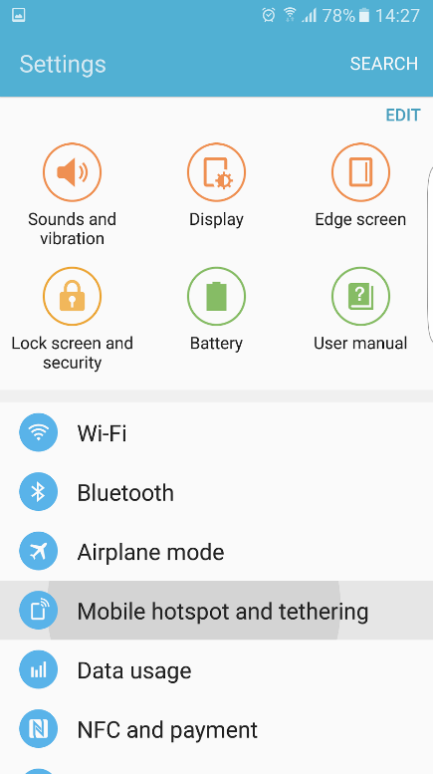
On this telephone we have as more option the possibility to share the internet access via Bluetooth, which is very useful for older PNAs, where there is not WiFi compatible GPS-s, but the software would be able to recommend an alternative route based on data transfer information if it gets this required information.
Is it possible to share internet via USB cable. To do this connect the device (USB cable) and then use the Internet.

Before we enable the mobile hotspot function, we must give some network settings. The default network name is AndroidAP, we can edit the name. Enter any other than "no" option, preferably WPA2 PSK encryption type and password, which we will connect our tools to our device.
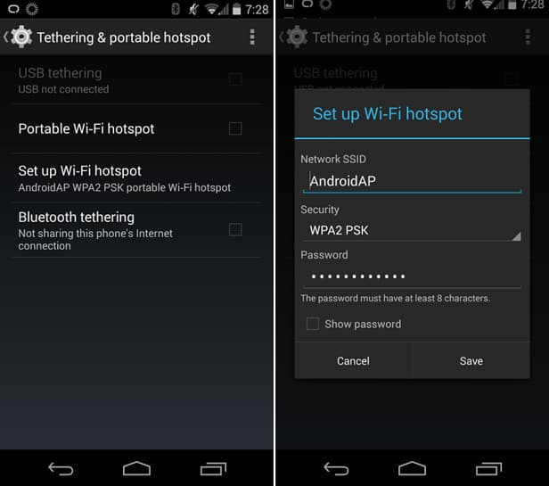

We only have to activate the configured hotspot by dragging a button, and then we can already search the first set network in the air.
Thanks to the Samsung and to the more recent operating system more extras have been added. We will review some of them.
Set a time limit, which predetermine the active time of the hotspot feature, then automatically switches off, thus avoiding rapid phone dive. Because the phone consumes many batteries during active use.
For the SSID we can hide our network name, but be aware that by adding it manually, we will be able to use it in the same way but no one else will be able to see our network.
You can enable and disable specific devices. The network devices can be clearly distinguished because it is a unique identifier based on MAC addresses. All elements involved in the network have such a unique address. Such a MAC ID can be applied and allow to connect to the phone.

iPhone - iOS hotspot

Look for the Personal Hotspot option in Settings> Mobile phone menu. A small switch activates it, and if any devices are not connected to it, iPhone automatically turn it down. If you later need to be on it again, you can easily activate it at the same place again.
We will not find here the myriad of hotspot settings, but "just" the well operating function. The network name displays in the explanation of the device, read it. If you plan to make it more options, then certainly we would need a jailbreak (not recommended at all!), Because to this part of the iPhone 3rd party applications do not have access (in this case it would be useful).
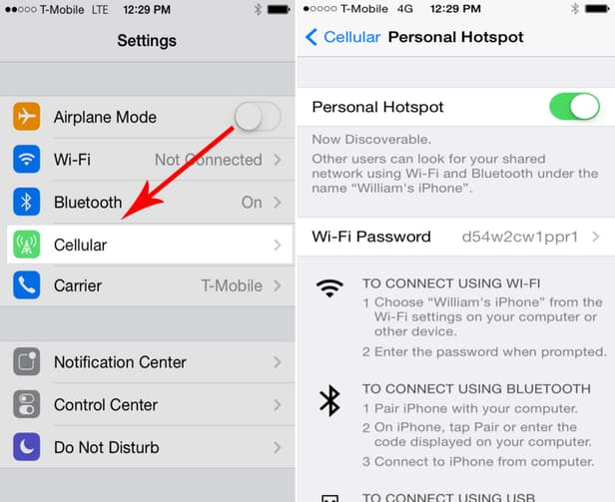

Windows Phone
The following pictures were taken of Windows Phone 8.1 system, which visually look similar to its predecessor systems, except that less connected device were supported. WP 8 editions allow the connection of 8 devices to the phone.
Settings> Internet Sharing and then next to Sharing we should pull away or turn on the switch. Click on the edit so we have the possibility to change the connection identification information, such as network name and password.
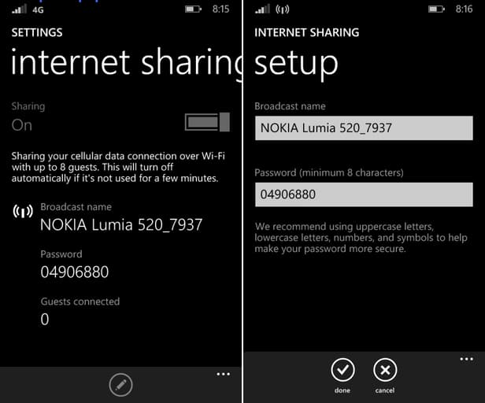

How to join hotspot, provided by our mobile?

It's easy to answer this, just as we connect to the WiFi. Search between the reachable network the name and password provided by us or by the phone. Look up the available network provided by us or phone then press on connecting button. After this our computer will use the mobile's internet.

Data transfer between phones, between a phone and a computer, between a phone and the internet (backups)

There are more opportunities to send photos and data to the phone of our friend next to us or a relative`s laptop living on the other side of the world, or if we want to keep in safe our photos and want to save data from the phone to the computer. All in all, there are more opportunity, depends on what our goal is and which devices between we want to build communication.

Need to pay attention how big is the amount of data that we want tosave or send. Firstly, I think about not sure we want to share an oversized photo through mobile intrnet. Before, we do it, save (security), then easier through unlimited and faster network at home.

Maybe, many of us experienced that many years ago, data should be devided, shared, if we want to copyon floppy or want to write tracks, photos on cd/dvd in order to save space on computer.

Let`s see a solution for transfering file between devices without causing problem. Many options and variety of program support transmission.

Communication between phones
(Bluetooth, NFC - Android Beam, AirDrop, Wi-Fi Direct)

Small distance between a few meter and not too much data suggested to use Bluetooth, with which we have opportunity to send anything that is sharable between two devices. Today, experience that 1-1 device does not compatible with an other, so it can cause problem. For connecting them, need to switch on Bluetooth function on both devices and should authoriz the visibility until the other device start to the connection.
A code and a simple agreement and the connection is done between the devices. Enough to do this once, then the connection is live.

The NFC transfer is more simple, but works only in small distance and able to slower transfer. The Android Beam function will help us for content sharing. Easier, because there is no need for pairing , simply touch, which immediately builds up relationship, then you only receive the desired material is saved and you have to accept the sending between devices.

To activate, navigate to Settings > More (under wireless and networks) or NFC and under the payment option, NFC must be switched on. Android Beam option should be switched on. Function remains active until switching off, although consume a little, but it worths to switch off, if you do not use often.

Numerous information, data can be sent using NFC:
- To do this, open the image, map, contact, website you want to send.
- Back of the devices should Getting closer.
- The interconnection beeps, vibrates and screen image compression will let know the device about the operation.
- Press the Radiation button or a similar message, and then wait for the end of sharing transfer complete message.

Video: Android Beam

Task:
- Switch on the fuction NFC and Beam
- Send a map to the person who is sitting next to you
- Send a contact
- Send a photo

What is NFC?

NFC is the abbreviation of the Near Field Communication, its functionality can be determined from its name. Let's take a look at how it has been developed an what is its functionality today beside the above mentioned ones.

Till its technology base, the RFID (radio frequency-based identification) technology, we must hump back in the time in the 1980s. The technology ensures that in communication, by an active and a passive (not consuming Energy) person, a "tag" or identification code can be read without direct contact between the two people. The NFC has come off very late, only in 2004, thanks to Nokia, Philips, Sony giant firms. Then the tempo became faster and already in 2006 the NFC tag has been specified, then in the same year the first mobile phone with NFC reader has been released. The Nokia 6131 NFC Edition was this model. Now days, in the most high-end device the chip is added, but it is not uncommon in the middle category. The success was almost guaranteed, then at that time prevalent BlackBerry also stood by the initiative and has equipped with almost all their devices, and then in 2012, RIM (BlackBerry former name) became the first company recommended in the PayPass service. Google also recognized the opportunity and created Wallet (electronic wallet) service.

NFC technology has been discussed above, the name does not even require too much explanation. It is operating on the devices near to each other. As seen on a previous figure, on the Data transfer speed, the NFC's range is not more size, only a few centimeters. NFC is a very versatile usable, the simplest everyday to deploy the chip contained in the smart phones. To do so, we will need a so called NFC tag beside the reader, which the reader which contains identifying information, or possibly more. Touch your phone to the tag, the phone will operate pre-defined instructions automatically, with re-touch other operations.

I will show you through an example the automatism, which I use / have used on a daily basis.
I have in my car an NFC chip, when I touch it with my phone the wifi change to mobile internet, turns on the music, the Bluetooth turned on because of the speaker and start speed camera warning app in the background. When getting out of the car in case of re-contact the previously opened, applications turn off the activated features.
All this would need 1-1 minutes when I take my seat and when I debus from my car, but with this movement only 1-1 second is enough. I think there is no need to explain the advantage of this, how much you can make your daily routine more comfortable and effective. But imagine that you arrive home with a tag waiting for us at the door, where we switch to WiFi, turn off the GPS and so on. We may also mute our device, and then again when leaving the apartment different steps can be effected by means of a touch.
These NFC tags can be purchased for a small amount. An application will be needed, so after scanning tasks, it can be executed with the phone. The program is determined by what happens, when and in what order.
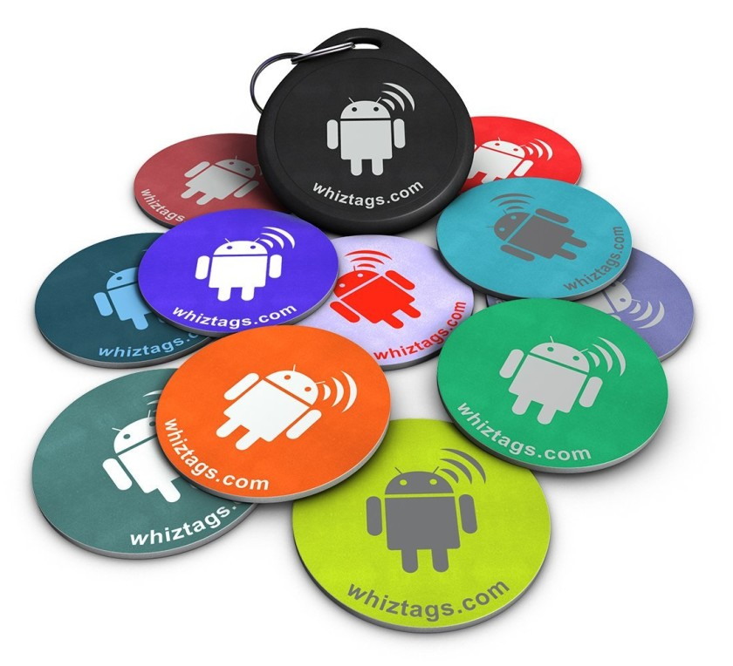
Another example is that the NFC sticker, placed on the conference table, can help our customers get our contact card by tapping on it, or to open our website. Use an unlimited possibilities of combination that is offered by the NFC!

There are also a number of other possibilities in the NFC, for example, several years ago there were "tab to open" hotel doors. Convenient, since there is no need for pairing, code specifying, the connection is established quickly.
The operating conditions depend on two key participants. There must be an active initiator and a passive party, which breathes life. The passive party is also called as target (target, tag). The storage capacity of the tags depends largely on the size, the smallest are 64 bytes, while the larger one is able to store data in kilobytes. We distinguish different transmission speeds 106, 212, 424, 848 KB / s, these shows that the transfer of information in text will not cause any problem, do not try to share a video with it.
The active party uses power (battery), in order to create a magnetic field around it, so when the passive NFC tag roll into this field, it will be able to communicate with the active party by adding energy through the antenna. One device is only able to communicate in one direction for the time being. The passive half consists of two parts, the chip and its associated antenna.

Three fundamentally different ways can be distinguished in terms of their operations. Reading and writing, it is activated during normal pairing, it reads out the information stored in the tags and the connection will be established. The card in emulation mode acts as a teachable card, which panoply buy a single ticket treats or we can use it as a writing course.
A third one is the P2P networks, IE peer-to-peer mode, which process and send back and forth the information. For example, sharing the business card data through Android Beam.

As for the remaining issue is about NFC, the security issue. Without proper software would not bring such good results, although communication works in a few centimeter distance, it`s possible to steal data with an appropriate antenna from a distance of several meter. Developers use encoding against data theft. They use TSL or SSl encryption, even if bank information is leaking , they can do almost nothing with the encoded data. Only a specific key is used to decrypt this information. Another safety factor is that, NFC devices can be distinguished each other, but the interstitial computer intending to steal data, does not know, so it gets confusing encoded data. (binary codes do not row, get back in a confusing way) Besides data theft, the other form of attack could be the disturbation of communication, it is rather annoying , it does not mean to intend to abuse or use data.

List of NFC mobiles

Task:
- Brainstorming: what kind of task can be used NFC?
- Download an NFC reader program, with which we can do tasks after scanning

Connection between mobile and internet (Dropbox)

Maybe the title isn't the most accurate, because the phone and the Internet isn't a special connection. Although we'd like to generalize and give fulll access from any system to any system.
This is when all different kind of cross-platform transfer solution comes into the picture. More precisely some kind of Cloud based storage can be for our benefit, for which -with the client downloaded to the specific phone or computer - we get full access. This way from anywhere, from any kind of even from another device our datas will remain available. This kind of service is for example the Dropbox, a bunch of alternative, Cloud based solution (Google Drive, Bitcasa, OneDrive) is available on the Internet, let's pick up the service that offers the most advantegous package.
The cloud based service sharing a distant server resources, provides the download and upload, and the browser of our data via our devices. The Drobox is available on the Apple devices, on Windows Phone and on tablet, on BlackBerry,Android,Windows,Kindle etc devices.

As a downside we can only mention the security and the lack of private usage. The security can only be mentioned in an aspect that the user are mistrustful about these services, so their confidential data would get into the wrong person's hand. No stress, because we don't have to be afraid about that, because these data got stored by codes and without the accurate encryption desolving key there's a really low chance that our datas would be available.

Eventual and fast resolving option can be if we send the files via e-mail, even to ourselves, or to our friends. So our mail-box wouldn't get filled before time and the evasion of the sending restictions, let's use e-mail sending services. The uploaded attachment can be downloaded by the user in a package from the server. The entire size of the sent files can be even more than one GB. We get a notifications about it's download, however there are some program where we don't get to know if they open our attachment. It can provide a lot of other comfortable funtions- for example password access, the storage of the files, if we don't choose the free package. The Wtransfer and the FileMail both provide this service. If these argument weren't persuasive enough, let's see a video.
Advantages of FileMail

Finances

Paying with Mobile phones

However the elecronical payment and the mobile payment are both absolutely safe, most of the users think the reverse. Most people find electronical payment methods more risky than the paper based, palpable money. The opinions about the transaction's charges and speed are similarly contradictory, comparing it to the cash based and card based paying.
In the case of cash there's no transaction fee, in many countries the mobile based payment has a fee, here in Hungary the banks are forced to deal with it. However, where there's a fee they try to keep it very low, so this payment method will become popular and will be able to spread, because it absolutly worths for banks as well for a long term. Furthermore, every money transfer can be registered, and by the way the paying is much safer and there's no unreasonable cash flow either.

Under mobile payment we mean when we pay with our phone at a terminal instead of our bankcard.

In the last few years a lot of mammoth company and startup promised that they will completely cut out the traditional wallet solution to a virtual alternative, unsuccessfully to this day. The attempts are very forward but we can not talk about any ground-breaking success.

The mobile payment isn't waiting for a new, non-existing technological achievement, because these are already available for us for a few years now. However it's a fact that there's no agreement for the most effective payment method. Why isn't the mobile payment spreads? Maybe exactly because of the industrial participants. The mobile payment and in general the not cash based payments arepretty comlicated. This what all the participants justify, because let's just think about it for a second, the payment goes through sarting from the banks, card issuers or smart phone manufacturers, through the service provider, the traders, and it is all initiated by the user. The non agreeing (the differences of solutions) is might be understandable, taking in consideration in the field of credit cards that until the Visa and the MasterCard are absoluute monarches the mobile payment is a new opportunity and the participants are trying to cut as big of a slice of that imaginary cake as they can. The constant batttles and advocacy make the process slower and who's interests and perspectives are gonna worth the least? Of course the users'. The banks are trying to break into the most places, the traders and lobbying next to gratuity, the transaction goes through the mobile providers and we'd like to have a safer, faster and more comfortable payment method.

Managing bank transactions with mobile phones
Mobile wallet
A shared enemy equals unity. An American example: "the Isis made by the Verizon,AT&T and the T-mobile ,and after the rise if the terror organization the Softcard named mobile paying system,which went to the war against the wings spreading Google Wallet. The Verizon took the battle so seriously that on all his android devices it disabled the download of the Google mobile wallets. The Softcard however didn't accomplished it's hopes,a year ago it stopped an it has been replaced by ironically the Google Wallet,as a mobile wallet that has been downloaded in advance to all the providers' devices."-HWSW

The mobile providers are in a position of strength and there's a possibility that they can even transfer the spread of the SIM based NFC, with which they can make thr system closed and more expensive. This isn't serve the dinamical spread and development, however it provides a steady payment for the operators of the system. The idea is similar by the way as in the case of Apple Pay or Android Pay,so the users can pay with their NFC based phones at the shops,however joining the service isn't that simple. Next to the download of the applications there's a need for a special NFC supporting SIM card. After that we can register our credit card that will be the base of the payments to the phone application.
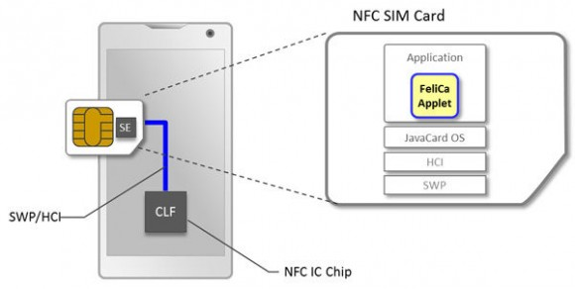

The slow spread of the mobile wallet is contributed by the commercial banks that are as usual lagging behind. Unfortunately this attitude is visible in whole Europe and in the whole world, that most of the people are only willing to settle next to a full-blown technology and will line up behind the market leader,one by one.

It seems like that the winner technology will be the touch negleckting NFC based payment (proximity payment). Now it's only the security field where there's no agreement, a great example is the solution of the Apple and Google.Hwile the Apple Pay stores the sensitive informations needed for the payment on the Secure Element (SE) on the phone, the Adroid PAy - that has been debutated last year replacing the Google Wallet's solution- is based on thhe cloud formed Host Card Emulation (HCE). And the third option is the earlier mentioned SIM card based storage. The big platforms still have a common spot because the use the tokenization to get the card datas from the trader to the banks, with this they are securing these senstive datas. There's some lightat the end of the tunnel.

Using the NFC technology next to reaching it over the operaion system running on the mobile phone the other option is the SIM Toolkit, which deals with the transactions with specially enginnered SIM cards.

The advantage of the users is touchable, if the system works, because they don't have to carry around x+1 plastic cards with them (credit card, bank card,pointgaining cards,supershop,company bank cards),and it can be cheaper and faster than other payment methods. For now the biggest revulsion is trigerred by the fact that the request of a new PAYPASS based card is needed.

It is worth mentioning that the Apple PAy was introduced in 2014 and becase of the popularity of the company a lot of its' announcements were revolutionary, this way they accomplished to convince a lot of the market's partiipants that there's potential in mobile payment. The newly introduced Android PAy can strengthen this spreading process.

Advantages and disadvantages

Risks of smartphone usage:
https://www.youtube.com/watch?v=hLDYUcDQa9g&feature=youtu.be

The disadvantages of using only one device

Work e-mails, phone calls, parking, a bank, shopping, we have slowly started the heating via our phone, you can, but this may have dangers downsides.
This is a thought-provoking chapter, obviously everyone decides for himself how deeply to engaged or not to engaged in this issue. Many people only face with a temporary loss of phone if it happens to theme and they do not learn from the other's fault. It worth, therefore, to be a little more careful, to make backups, synchronization and should not be lazy when changing our passwords. Today our phone turns to our personal assistant, and we can also make photos with it, we navigate, play, listening to music with it, and it is also an important connection to the World trough the internet.
It is a bald fact, when our device goes wrong after weeks or months of using it, and we should live temporarily without it. In this case, we find that measures how many thing we manage with it. If you have been accustomed to mobile payment, it is can uncomfortable if the device is not working or it is not with us, perhaps we are out of habit to wear the card and cash. So we suffer from a serious addiction, even if we succeed in a few days to buy a phone with similar hardware. I mean under hardware especially the NFC capability and perhaps even primarily I mean the biometrical identification, which is closely linked to payment.

The worse case is when unauthorized persons gets the device. If we lose our device or it has been stolen, details, passwords are in a serious danger. Securing device containing payment information is causing serious headaches for manufacturers and developers. Use all kinds of strong password? Then usability and comfort as an advantage point will be lost. Although the opportunity is given, many people do not deal with the protection of their phone and do not think about it, or how much property damage can cause the loss of phones.

The most obvious solution (Android also warns us), is the use of an unlock code. We can choose from a variety of convenient solution, we can draw an unlock pattern, we can enter a PIN code, we can, in case of LG, even knocking the screen. As biometric sensors are getting better and increasingly spread it will be the primary safety barrier (first defense). The fingerprint reader's or mainly the users foult is that after reading incorrectly the fingerprint three times, we must enter a security code and many people enter the "1234" combination which is not a very safe act.
Use strong passwords, which contains large and small letters, numbers, with at least 8 characters long.
Do not use a birth date and a series of consecutive numbers.

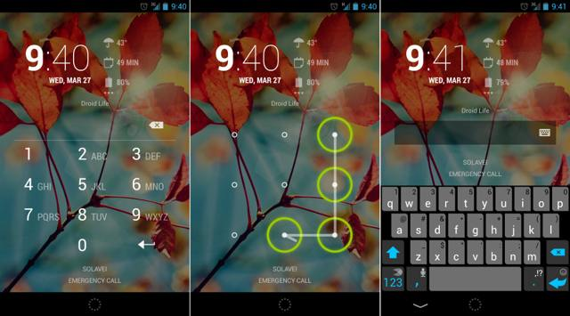
The biometric sensor offers comfortable and effective solution even if you do shop with your mobile over a certain limit. Although, this sensor for the identification can not be found in many devices.

It is interesting that, bank transactions from mobile is also popular and bank interfaces are increasingly available for mobile. With this the former 2 steps authentication by 2 independent devices is transformed. The extra entrance code was sended by SMS. Many bank provide own application for accessing the bank interfaces, which start to operate by getting the user`s password. The application recquires a limited time code for entering the system.

It makes our daily routine more simple, fast and more convenient. If we follow a few security suggestion, we won`t have any problem. Innovations designed to make users everyday life more convenient while tending to increase security level.

Online security

Smartphone’s security on the Internet and settings
Among the smartphone systems, Android has the worst reputation regarding cyber security. How come that so many malwares can get through the Google’s numerous security checks?
Malware can be any software capable to hurt a computer or operating system: such as viruses, worms, spywares, adwares and the so called rootkit tools which enable administrator-level access to your device.
According to a survey of the Department of Homeland Security (DHS) 79% of all mobile threats targeted Android mobiles in 2012. Investigation of Kasperky Lab shows that 94% of malwares are made for the Google’s system.
It is important to mention that mobile threats and PC viruses are different. In the case of mobiles you don’t get malwares from E-mails or they don’t download and install themselves from fake websites and they don’t forward themselves to your friends’ mobiles which may even erase your personal data. In the case of mobiles you have to install these kinds of programs deliberately, although without being aware of the danger. In most cases the user itself is the greatest security risk.

The basis of Android’s security is the multi-layered permission system, which is well-known from the UNIX systems. Android protects the system against malwares with the help of this permissions-model. Therefore, each application has a permission level which does not allow them to collect unnecessary data or does not exhaust the resources of the system, unless the user (YOU) gives permission to do that. Thus, it is essential to be careful what kind of permissions an app asks for at installation. Be careful and cautious to give permissions for the apps. It requires your specific permission to do almost anything that could lead to your system processes. These limitations are required by the security mechanism of the runtime environment of the operating system.

The first obstacle a malicious application has to go through is Google Play Store, from where applications are generally installed. On the Google’s servers the uploaded applications are checked in a virtual environment and the malicious ones are removed.

One of these security frameworks is the Bouncer, which sorts out most of the malicious applications. So, when you download an application from an external source (not from Google Play Store) and install this file of APK extension on your mobile, you are not protected from malwares. That’s why these kinds of installations from external sources are not allowed in Android systems by default settings, not without reason. If you want to permit them, you can do it in the „Settings” menu item. The system warns you for the potential risks, although many users do not pay much attention to this.

But even in this case Google tries to protect you (the user) from yourself and provide a solution with Google Verify Apps. Verify Apps intervenes when an app is downloaded, compares it to a large database of malware information curated by Google and warns the user if the app is potentially harmful. After installation the app runs in a secure environment called „sandbox”, where each program runs separately in accordance with its permission. Moreover, a quick runtime security check is performed before executing a program.
As a result of above mentioned security instructions, less than an estimated 0.001% of app installations on Android are able to evade the system, although they can cause just enough harm and anger.

Google collects information on its’ servers every time you download and install an app, thus the spread of a malware can be traced easily. With the help of a development in 2008, users are able to erase applications from all their Google devices at the same time, provided „Remote access” is set on. This function’s name is „killswitch” and is used only in the final security case but there have been several examples of its usage in the last few years.
The above mentioned security measures has been introduced in the recent years. Android systems are supported 2-3 years dating back which means that about 98% of all the present devices are supported. As a result, Android Security chief stated that less than an estimated 0.001% of app installations on Android are able to evade the system’s multi-layered defenses and cause harm to users. But according to the survey of DHS there is an increasing number of malwares. It’s very difficult to say the truth as on one hand, it’s only the Google which has access to the platform to measure how many times a malware app has been installed. And this information is not public. On the other hand, independent security researchers and companies may exaggerate the threat level in their own interest. To emphasize this point Google revealed in his analysis that some of the most publicized recent malware discoveries are installed in less than one per million installations. Otherwise, credibility of Google statistics is reduced by the fact that it is based on app installs and detected malwares that Google gets through "Verify Apps”. The malwares not detected by the Google’s system are not involved in the statistics.

There is more reason to fear from those apps which have access and want to gain our personal data. We can easily download an alternative SMS app and we have to give permission to this app to access our SMS, accounts and even the Internet. Let’s think. What prevents this app not to forward our bank account and security code to another server in the form of a text message? And we don’t even know about it! Needless to describe the damage it can cause and it could happen bypassing the two-step verification.

The protection cannot be extended to the behavior of the user. If you allow sideloading you must be aware of the fact that your data are vulnerable.

So, as I mentioned at the beginning of this chapter, the users are the weakest link in the security. We have multiple layers of protection, which we can switch off although it is not recommended as we do not suffer any disadvantages to have them on.

The mobile informatics has 3 major sources of problems: the digital body, the wireless communication and the data loss. Let’s see these on by one. Digital body is a range of information we collect about ourselves consciously or unconsciously. We can find lots of information about ourselves on the web, most of them we don’t even know. Similarly for example, there are pictures, shared information, news about babies before they are born. These sources of information existed in the past as well, but these information was exchanged on a family dinner and not digitally on Facebook or by e-mail. Now the information reaches more people and the most important is that it can be accessed anywhere, anytime.

The popularity of wireless communication is understandable as with Wi-Fi technology cables are not needed all around the house and Internet is still available everywhere. We have got used to the comfort and many people don’t even think about the fact that we manage our important official businesses, bank accounts and payments through this network. Many people do not care about encryption, thus enabling access to their data with the help of a simple directional antenna from a few hundred metres distance. Hacking techniques are developing all the time and security techniques are developing as well but many people and even companies do not take use of them.

Security applications, anti-theft tools
Securing your phone, anti theft facilities

When we buy a new phone we do not think about being stolen or lost. Anyway, it would be recommended to think in advance about its protection, besides the regular backups of course.

How to find a lost mobile

In the case of Android and iOS systems it is highly worth to use the built in options of the manufacturers. At Android systems the Device Manager, at Apple systems the iPhone Search performs the function. With the help of these functions you can search your phone and what’s more, you can lock the phone or generate ringing from the remote.

With the help of the following webpage you can detect your phone on its map in case your phone was connected to the Internet:
For Android: – https://www.google.com/android/devicemanager

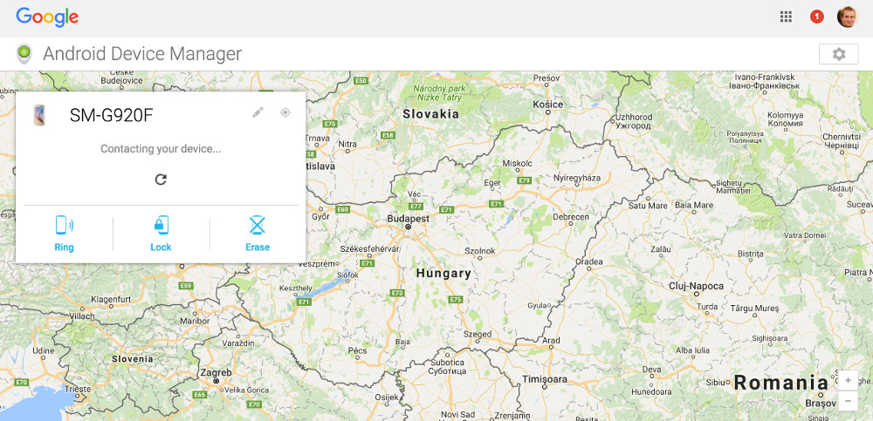

For iOS and OS X systems: – https://www.icloud.com/#find
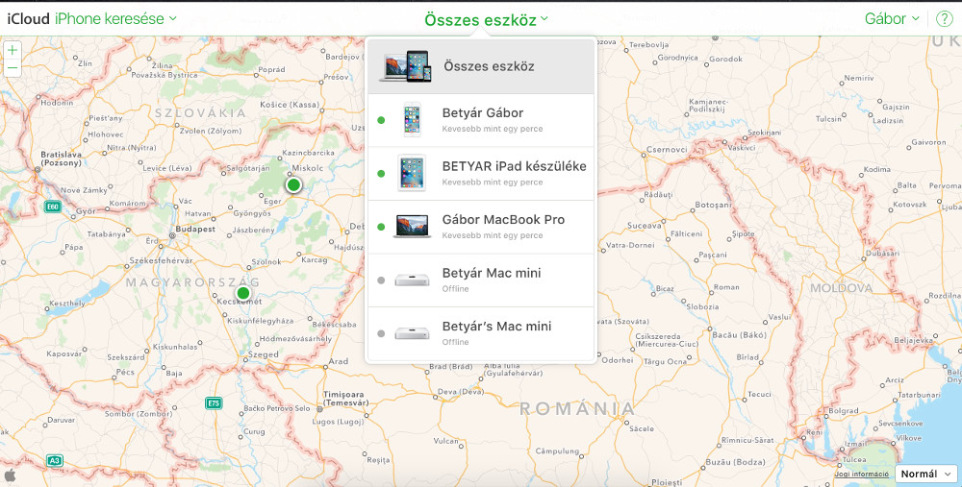

You can see that with the help of this website you can find all of your devices which entered iCloud, so it is useful not only for finding the location of a lost phone.
You can check your locking status at the following website:
https://www.icloud.com/activationlock/

Windows Phone
Similarly to the two other widespread operating systems, the manufacturer provides a built-in app here, too. After activation of this app and entering the following site you can generate ringing, lock the access to your data, you can fully erase your data from your phone or you can choose displaying the location of your phone on a map:
http://account.microsoft.com/devices

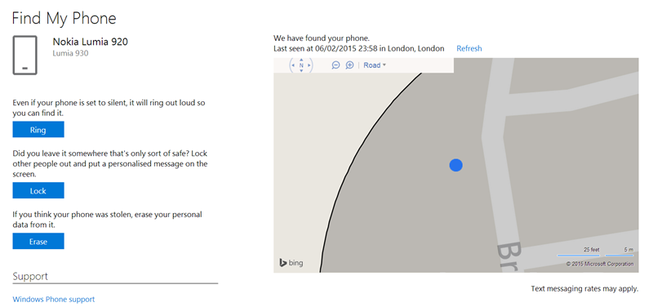

Setting of e-mail client

Before sending E-mails you need to set up your mail client. The functions of sending, receiving, storing, forwarding and archiving E-mails take place on the mail server. We, users can reach our E-mails through the Internet and a client program, which resides on our computer or phone. Thus, the client is connected to the mail server and we either make operations directly on the server or the client downloads our letters and after finishing the works on them synchronizes the alterations to the server.

So, it is necessary to set up our E-mail account and upload it to the mail client. At Android systems an in the case you have already have a gmail account – which is recommended – you don’t have to do more than typing your password and the gmail application is ready to use. If the application is not installed on your phone, you can find it in Apple Store and install it.
Another option is to use the manufacturer’s application which is in most cases also a good choice.
Although there are numerous mail clients on the market capable to manage even several E-mail accounts in one app, I prefer gmail or the manufacturers’ option. Besides, Gmail application supports IMAP, POP and Exchange protocols as well. It is recommended for not Google-type E-mail accounts and many other systems. It has a lot of functions which fulfill most of the requirements. Let’s see some of them.
- Automatic vacation reply
- Download of attachments solely through Wi-Fi
- Dumping E-mail threads
- Archiving
- Marking E-mails with stars and labels
- Prioritizing our E-mails
- And one more: easily handles Outlook and Yahoo E-mails, too
Disadvantages: Cannot integrate other applications. E.g. we cannot place items directly to the Calendar or „to do” list from our E-mails.

If you want to look for another alternative application for some reason - e.g. because of dissatisfaction with Gmail or just simply searching for something new – you surely bump into Boomerang (Email App for Gmail & Exchange), assuming the mail capacity of Gmail and Exchange is enough for you, which - by the way - will be expanded in the near future. With this app we can set the time of sending our E-mails, we can request a reply and we can send our E-mails „to sleep” which is a unique feature of this app - neither Gmail nor the manufacturers’ (stock) service can do this.

The next application is the Boxer which is very close to be the number one app but still it is about the third. Let’s see why. It has a built-in „to-do” list, knows all the most important E-mail features and its message options are wider than that of the Google’s program, but at present it does not support the Exchange function free of charge and some other important functions like quick response and signature. All of the applications mentioned earlier provide these services free.

Microsoft cannot be missed from this range. It has sent into the battle its well-known Outlook application which supports Outlook, Exchange, Yahoo, iCloud and IMAP and integrates the OneDrive, Dropbox and Box storage spaces. This latter is a unique virtue of the program. We can set the time of sending and integrate our E-mails into the Calendar. If we take into account the wide range of possibilities, the conclusion is that this free program can be a good alternative choice.

Task:
- Install the mentioned apps
- Set up the E-mail account
- Compare the functions

In most of the cases the client programs can handle the mail service of any service provider although in some difficult cases we have to set some of the parameters manually. But if we choose a popular, well-known service provider we do not have to do that.

Let’s see the protocols in a nutshell, just to understand the expressions, which occur during setting up the client

POP3 (Post Office Protocol): At POP3 protocol our mails are downloaded to our computer or phone, so we can reach them on our devices. You can set the period of time your E-mails remain on the mail-server. By default they are deleted at download. Outlook Express and Thunderbird operates like this. You can reach your E-mails without to be connected to the Internet.

IMAP (Internet Message Access Protocol): E-mail clients using IMAP generally leave messages on the server so the user can reach them from anywhere any time. The E-mail messages are „cashed” by the client program, the tasks are made directly on the mail server. Continuous maintenance of the account is very important as if the storage space for the account is full we can’t receive more E-mails. Any change of your mobile’s settings will automatically affect the server’s settings.

IMAP protocol is more advisable as it provides a two-way connection - besides its other advantages. The only disadvantage is the maintenance of account and the need of deleting the unnecessary E-mails.

SSL/TSL: This combination of letters means encryption of passwords and your E-mails as well. It means that your E-mails are transferred through the network encrypted, so it is recommended to set up this function if there is a possibility to do that.

Sending and receiving e-mails
Steps of adding a new account

iOS
At the manufacturer’s application navigate to “Settings > Mail > Adding new account” menu item. Here you can choose from the most popular mail clients as iCloud, Exchange, Google, Aol, Outlook or others.
First let’s see the simplest case, when we have an E-mail address from one of the dedicated service providers. We have to type in the name, description, E-mail address and password. If it was correct the next step is setting the items to be synced: E-mails, contacts, calendar, notes etc. At the end of the setting process, after clicking the “Save” button the synchronization begins immediately.
Going back to the screen of Mail application we could see the new account. In the case of deleting the account we have to go back and choose the “Delete account” option. This will erase the data from the phone but they will remain on the server.

When we have an account from a third party service provider then after typing our personal data (name, E-mail address, password) we need to provide parameters to connect to the mail server. We can choose either POP or IMAP protocol and we have to know both the incoming and outcoming server information for the proper configuration.

Adding a new account in Gmail application: After clicking on “Settings” a new panel will occur on the side of the screen. Next to your current account info, tap the arrow to collapse back to the main menu. Now tap on the plus sign in order to add a new account.

Android
At Android systems the default mail application is the Gmail from obvious reasons. :) But there is not only this one E-mail client to be supported. We can choose Google, Outlook, Hotmail, Yahoo, Exchange and other (IMAP, POP) accounts, too. After typing E-mail address and the correct password we have to click “OK” to accept the conditions and after tapping the “Save” button the synchronization begins.

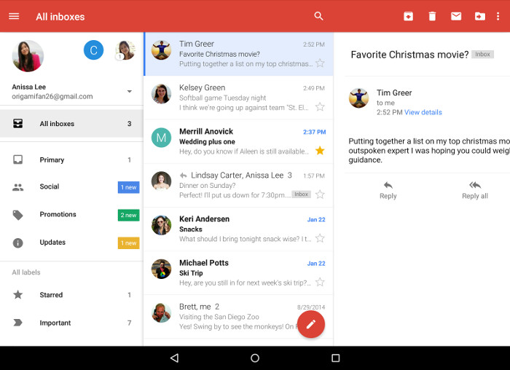

For the configuration of a third party account the same data are needed. After entering the E-mail address the system will ask if we want to use POP3, IMAP or Exchange protocol. If it is possible then IMAP is recommended or the Exchange for office work. The next step is entering the password. Here we can see the settings of incoming server, which was generated by our data. We can see a similar screen to that of iOS systems but this is more detailed and contains:
- Name of the incoming server (IP address or DNS - Domain Name System, which provides translation services between domain names and the IP addresses)
- Port of the communication
- Type of encryption – this is an alterable parameter

If you do not know these parameters ask your service provider.

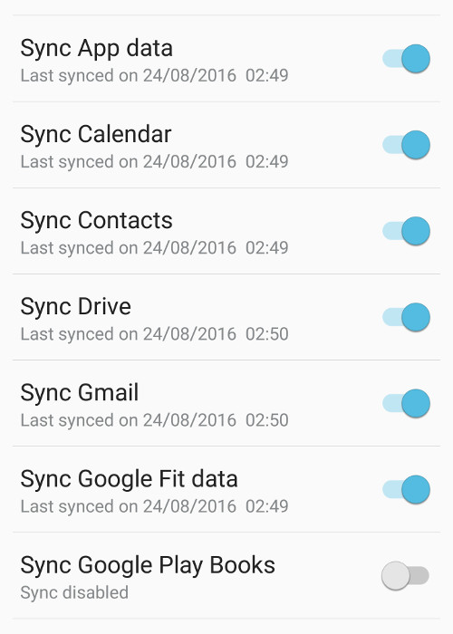
We can manage more than one E-mail accounts at the same time. Tapping the menu button we can choose from the accounts. This way we have the convenience of working with several accounts at the same time: our personal account, office account, civil organization account etc. We can fine-tune our data with selecting particularly the ones we want to be synchronized.

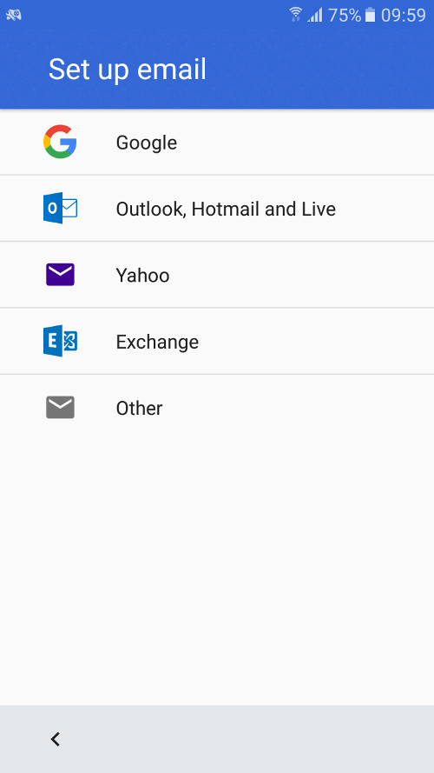
Another option is the Push notifications. Push notifications let the application notify a user of new messages or events even when the user is not actively using the application.
The incoming E-mails are categorized automatically so the newsletters, advertisements are separated from our important E-mails. A latest improvement increases the productivity of the program as it „channels” the users. In the earlier versions the user had to step between the accounts but now we can handle our E-mails together. At the „Search” function autocomplete helps to find the information more easily.

Now our adjusted and synchronized accounts are ready to use. How to send E-mails? I guess all of us are over writing and sending hundreds of E-mails by now. If somebody isn’t he/she should look for a pen icon on the screen (sometimes on red background). An E-mail has to have a mail address. The subject and message content fields are optional, although in the absence of neither of them there is no point to send an E-mail. Addresses can be chosen from our contact list but if we begin to type them the autocomplete attribute helps us. We can send our E-mails as copies and secret copies. At iOS systems these are in the cc and bcc fields, at Android systems you can reach them in drop down fields from the address field. You can attach different kinds of attachments to your E-mail by clicking on the little “Clip” icon. You can choose a file from your device or from Google drive or you can send your photos in attachments.

The program has a very useful convenience function. If you see a little microphone icon when you type the text, clicking on it you can even dictate the text for the program. Testing this function on an iPhone we got an almost 100% perfect text at a very good speed (it means it was faster than a good typist). Before starting the dictation we have to set the language to be recognized of course.

Receiving letters is very easy, we do not have to do anything extra. This is an automatic process in the background. But in connection to our incoming E-mails we can set up notification options. In this case we are noticed about a new E-mail and we can see them even a on locked screen.

Applications

Google Play Store, App Store, Windows Phone Store
Google Play Store, App Store, Windows Store

In this chapter I try to give a brief outline about the app stores of the greatest platforms based on data of 2015.

Google Play Store
- It is Google's official pre-installed app on Android-trademarked devices which provides access to content on the Google Play Store.
- With the introduction of Google Play on March 6, 2012, the Android Market app on old devices was upgraded to the Play Store app. It allows users to browse and download music, books, magazines, movies, television programs, and applications.
- It is a distribution service operated by Goggle
- It serves as the official app store for the Android operating system, allowing users to browse and download applications developed with the Android SDK and published through Google.
- The application can be used from Android Froyo (Android 2.2 – discontinued operating system)
- Applications can be downloaded directly to an Android or Google TV device through the Play Store mobile app, or by deploying the application to a device from the Google Play website.
- As of November 2014, developers in 61 countries were able to distribute paid applications on Google Play. To distribute apps, developers have to pay $25 as registration fee for a Google Play Developer Console account.
- The Google Play store has reached over 1.4 million apps published and the number is increasing steadily.

App Store

The App Store is a digital distribution platform, developed and maintained by Apple Inc., for mobile apps on iOS.

- All the iOS systems support App Store by default.
- The iPhone App Store opened on July 10, 2008
- A digital distribution platform, developed and maintained by Apple Inc.
- The store allows users to browse and download applications that are developed with Apple's iOS SDK.
- From the iPhone 3G the platforms are pre-installed with App Store
- The apps can be downloaded to iOS devices directly, to our PC-s with the help of iTunes.
- Developers should pay an annual fee to use the iPhone SDK (Software Development Kit) and upload applications to the store. The developers receive 70% of money after purchases of their applications.
- App Store has 1.2 million apps available

Microsoft Windows Store
- Windows Store is an app store for Microsoft Windows, starting with Windows 8 and Windows Server 2012 (if it is not preloaded).
- It was introduced on 29th February 2012 at a presentation of Windows 8.
- Windows Store is the primary means of distributing Windows Store apps to users.
- The store would be able to hold listings for both certified traditional Windows apps as well as what was called "Metro-style apps" (tightly-sandboxed software based on Microsoft design guidelines that are constantly monitored for quality and compliance)
- Windows Store and its predecessor the Windows Marketplace are pre-installed from Windows 8
- Both Windows Store and Windows Marketplace allow customers to purchase software online and download it to their computer or phone
- Individual developers are able to register for $19 USD and companies for $99 USD. Microsoft takes a 30% cut of app sales.
- As of the beginning of 2015, there were 193.728 apps available on the Windows Store,

Security backups

iOS
In the case of iPhone we have less but easier to use options, which operates more simply and automatically and they do not need installing or regular configuration.

There are two methods of data backup if we buy a new mobile or in case of a system error – well, in order not to lose our hair. You can set the automatic backup feature in the „Settings > iCloud > Store and Security backup” menu item. You do not need your mobile to be connected to the computer as the whole backup process takes place through Wi-Fi connection. At a new mobile or after recovering the factory settings the backup assistant offers several restore points from the iCloud (restore from iCloud backup), so you do not have to choose the latest restore point if you want to go back to a previous state.
The cloud-based iCloud storage is free until 5 GB storage space for pictures, security backups. If you have more data than 5 GB you have to sort out the less important ones by setting the types of data to restore. Or you can buy more storage space.

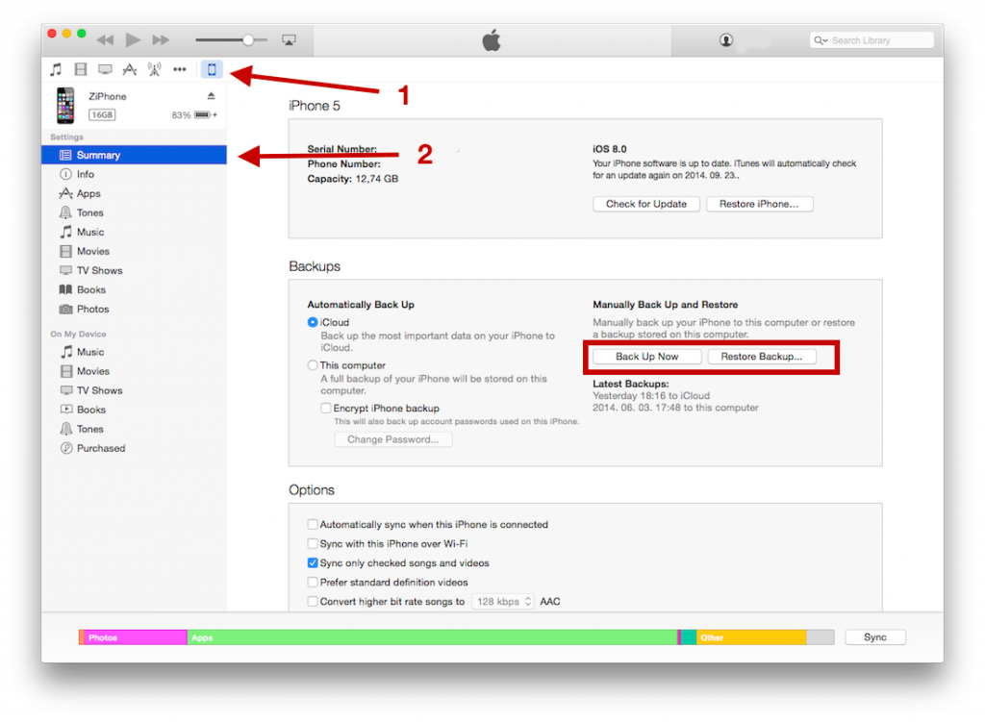

If you want to backup your data to the computer, you have to install iTunes, which starts automatically just after connecting your device to the computer, unless you decided not to install it. The function can be activated by choosing „File > Tools> Security backup” item. Restoring is similar to that of iCloud: it can be managed with the help of the assistant or by choosing “Restore from security backup” function through „File > Tools” menu items. This security backup can run in the background when you connect the mobile to the PC, so you do not have to worry about losing data.

During the backup it is the notes, contacts, Touch ID, photos, music, App Store content etc. which are saved.

Android

In Android mobiles with 4.0 version or above the security backup can be generated directly in the menu system of the mobile, so the background images, google calendar, the language, datum and time settings, data of applications, Wi-Fi settings etc. are saved into the relevant Google account’s storage space. But our telephone numbers, SMS messages and the incoming and outgoing calls list are not saved, these can be saved by downloading an external application from Google Play.

Helium

Despite the fact that it can save data both to the telephone and into the cloud, it is capable of synchronizing data between the two devices. In basic settings it saves merely the data of the apps because of the less data usage, but it can save messages, Wi-Fi settings and others, too.

Titanium Backup
It can be used only on rooted (Linux administrator right) device and it’s user interface is a little bit outdated. In exchange the users get a variety of functions and features although this app may be too complicated for a common user, who for example have such options as scheduling regular backup processes.

Other applications:
- My Backup
- Ultimate Backup
- App Backup & Restore
- EaseBackup

Windows Phone
At Windows systems you can choose to make backups into your cloud storage space allocated to your account. You can activate and set the scope of data be synced in the „Settings > Security backup” menu item. You can save your telephone numbers, contacts and messages and the list of applications, the call log and bookmarks, too. Restoring your data is as simple as saving, you just have to enter into your account and choose the appropriate restore function to see your personal settings on your mobile.

Task:
- Make a backup of your mobile’s data

If you make your backup to an SD card or inner storage space, do not forget to make backup to an external media tool.

Installing, using, setting, enabling, disabling, uninstalling applications

As it was mentioned earlier, there are two ways of installations: from Stores and by sideloading (from external sources). We discussed the fact in details that sideloading makes your phone vulnerable because they can contain malwares. If sideloading is still necessary, in Android systems you can allow it in Android Settings. After downloading or copying the APK file into your phone you can open it with a file manager. If the phone puts a question, choose the Android package manager or installer and the installation begins.
Let’s see the traditional and security installations.

This function works on the big platforms in a similar way. Let’s open the Store application, search for the required application and if we found it click the Install button. In case of a paid application you have to pay it before. The installation service will check the free space on your phone and if there is not enough space, it will warn you.

Usage of applications is the simplest of all processes. We choose them from App Drawer, from the application list, from menu or we can launch them with an icon. This latter is the most frequently used solution. Some programs may run background services, for example may send a notification about getting a new E-mail.
At Android systems we can use the programs in so-called widget mode, too.

Settings, permissions, deleting
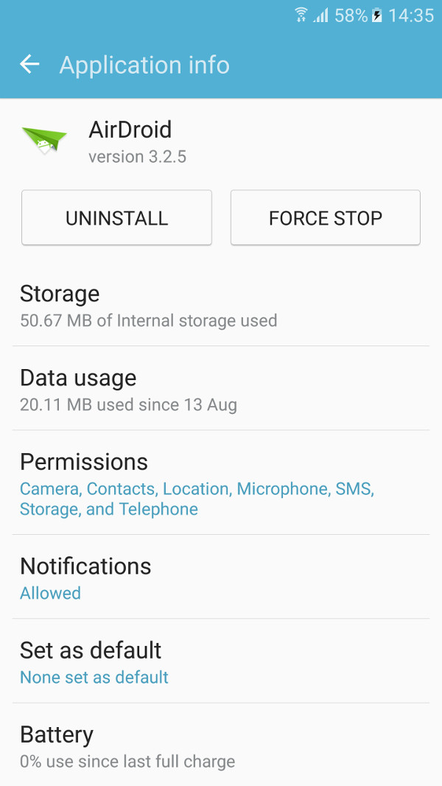
Several applications have the opportunity to make extra settings within the app. In most cases this is signed by an icon. Clicking on the icon the settings menu shows up. In some devices and at earlier versions of Android this function can be available from a menu item.

The applications ask for permissions during their installation. We have to answer these requests otherwise the applications would not be installed. We discussed earlier the importance of permissions and that depending on what kind of permissions we give an application, “viruses” can infect our phones during this process. If a note app wants access to your SMS messages, be suspicious. Unfortunately, most of the people don’t even see these quests and click the Accept button. In this case we have the possibility to change these permissions and alter that what kind of services the apps can access.

At iPhone systems navigate to “Settings>Security” menu item, choose what you want to disable for certain applications, for example detecting your position, access to your photos, access to the microphone or calendar etc. Let’s choose for example the photos. We can see that the list contains only those applications, which deal with our photos. If we want to disable the access of our photos for some applications, we can do it with clicking the button.
At Android system the logic of permissions is reverse. Choose the “Settings > Applications” menu items. You have to find there an Application manager where all your applications are listed. Choose the program from which you want to revoke permission. Let’s choose for example the AirDroid application. There are the following possibilities on the page: deleting, forced termination and several information (size of the application, data usage, notifications) and permissions. All these are referred with the term Application information. Choosing the permission part we can see that which applications have access to the SMS messages, Location, Camera, Telephone etc. We can revoke the permission by clicking the switch off button.

In case of revoking permissions from applications we have to count on the fact that the application may not work properly or it would not work at all. But the system will display a warning about it.

Notifications do not belong to this topic but their settings can be found here, so let’s take a few words here about the importance of notifications.

Application updates sometimes may be exasperating as there are so many of them. But they are useful because of their information or because they can provide competitive advantage for us. Let’s take the discount newsletters or notifications of birthdays, anniversaries in order not to forget them. Weather applications can send us valuable warnings before storms and hails protecting us against damages.

At Android systems on the Applications page we can turn on and off the notification function and what’s more, we can turn on this function even when the system is set into „Do not disturb” mode. We can set the function to show a small preview on the top of the screen.

The same fine-tuning can be set at iOS devices at „Settings > Notifications” menu items. In the list we can see those applications which have notification function. Let’s choose any of the applications and we can see the diversity of settings: setting of sounds, notification on locked screen, notification during operation etc. In the latter case there are three options: we can switch it off or the notification can appear at the top of the screen as banner-line or in the middle of the screen.
Deleting applications

If we are not satisfied with an application or just simply there are not enough space for our photos we have to delete applications. How to do that?

Apple
The most attractive, comfortable and fastest solution is if we hold pressing the icon until the phone perceives it and the icon begins to vibrate. At the same time an „X” sign is put onto the left corner of the deletable applications panel. Pressing this sign the deletion will be completed. Even before the deleting process we have to confirm the deletion. In this mode we have the opportunity to rearrange the icons or to create libraries if we pull the icons.
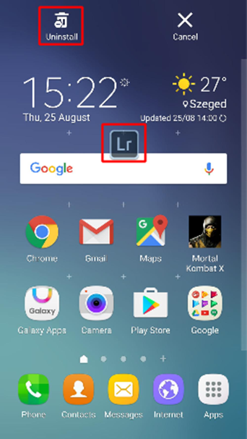
The other possibility for deletion occurs when there is not enough storage space and our phone warns us to delete applications. This function can be reached by choosing “Settings > General > Usage > Storage space” menu items. Here we can delete the application. At each application there is the allocated storage space, so we can choose the appropriate applications in order to free some space.

Android
We can delete applications on the above shown screen under the Application management. The method which was mentioned at iOS - holding and pressing on the icon - does not work here because it does not effect the application, only the icon will be replaced into the trash. If our Android system has an Application menu, there is a possibility of uninstalling but it is not the same in the different versions. As this figure shows, the Lightroom’s icon floats waiting for our decision if we want to place it as an icon or uninstall the application.

Weather forecast applications

Accuweather

For Android systems there are a lot of weather applications. One of the best ones is Accuweather. After installation the app asks for entering with your Google account so it knows everything about your position at once. It always sends the current weather information about the place where you resides well in time. Here you can find all the information: temperature, Real Feel (this is a complex characteristics which takes into account the wind, humidity and other factors), level of UV radiation, windspeed and the current state of the sky (cloudy or sunny etc.). Besides, we can get a weather forecast every hour or day, if we want several weeks in advance. The application contains several maps with radars of the given regions. Clicking on a tab we can watch interesting videos from all around the world. Weather states are indicated by little figures and diagrams. There are two visualization themes: dark and white. The weather position appears in the notification bar and on the lock screen, too. The update intervals can be modified easily. We can set if the weather attributes should be about our current position searching for our position by GPS or it should be about a fixed place. This latter one spares our battery life. The application warns us in a pop-up window if a dangerous event (hail, thunderstorm) is coming. 7

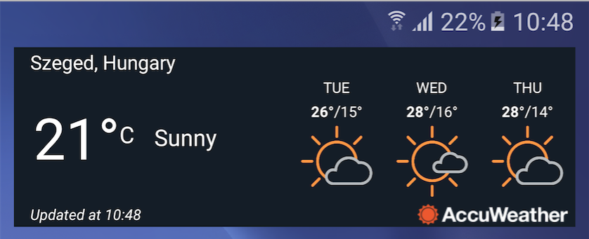
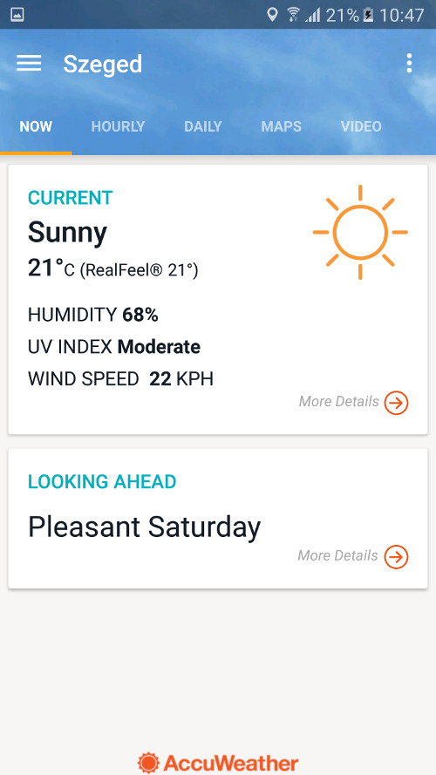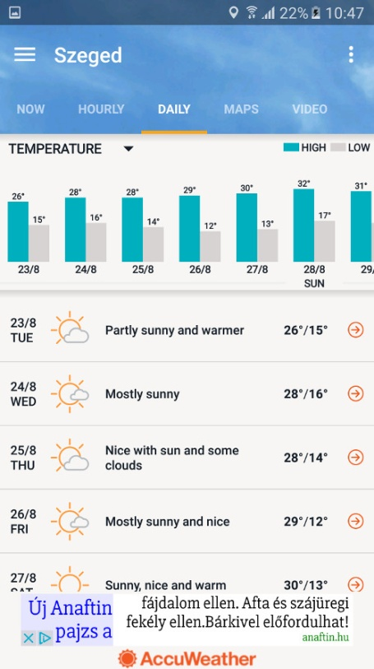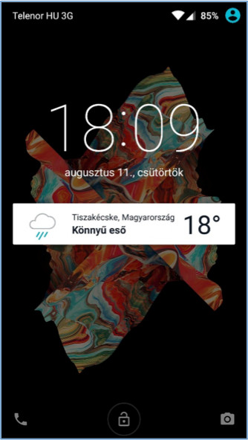
Task:
- Install the application from App Store
- Set a fix place to watch and see the weather forecast for a few days later time
- Change the theme of visualization for dark and set that the Reel Feel should appear in the notification bar
- Look for other weather apps and compare them

Browsers

There are several browser apps for Android systems now. The three major ones are: Chrome, Firefox and Opera. At iPhones the Safari is important and on Android systems there is the Internet as basic app. Many people use the pre-installed applications, let’s see now some of the browser apps.

Chrome

This application enjoys a definite advantage against its competitors as it is synchronized with most of our accounts like Gmail, Youtube etc. Launching the app it asks us to enter with our account so we are connected to our PC’s Chrome immediately and our passwords, bookmarks etc. are passed through. The browser is very simple to use. Just type the URL in the address bar and the website will appear. If you type any other text the Google will search the Internet. The websites are saved automatically so we can find them later by clicking on the square in the top-right corner. Here you can see that how many websites are open at the same time. We can step among the websites by pulling the cursor left or right in the upper bar or pulling down the upper bar we get a stage layout. There is a possibility to change the font size. We can set a certain Reduced Data Transfer mode which compresses the downloaded data. We can trace back our search history on the phone and on the PC as well (provided we entered with the same account). There is an incognito mode, too, which does not save the websites, passwords or history.

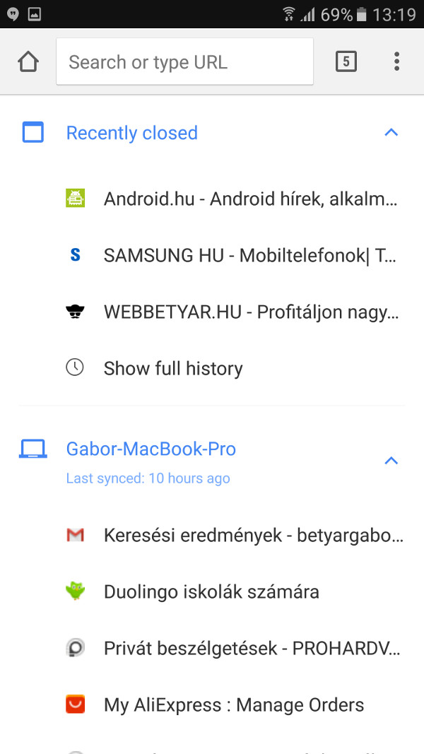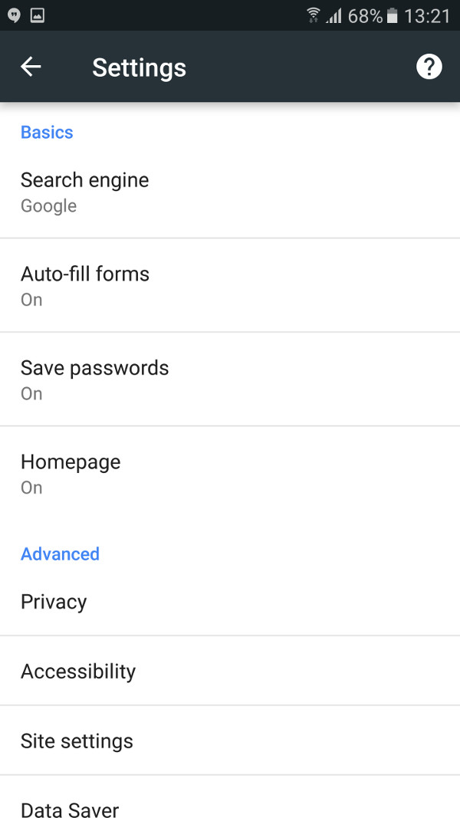

Firefox

Firefox has a great disadvantage: cannot be synchronized with our Google account, difficult to reach our Gmail and Youtube accounts and our passwords cannot be saved . It can cause problems if we use Google services on our devices. Firefox has most of the functions the Chrome has. The history and the frequent websites are more emphasized on Firefox’ home screen. We can place bookmarks, which can be synced with our PC’s Firefox’ data. Similarly to the Chrome’s incognito mode, Firefox provides the possibility of private browsing – the two are practically equivalent.

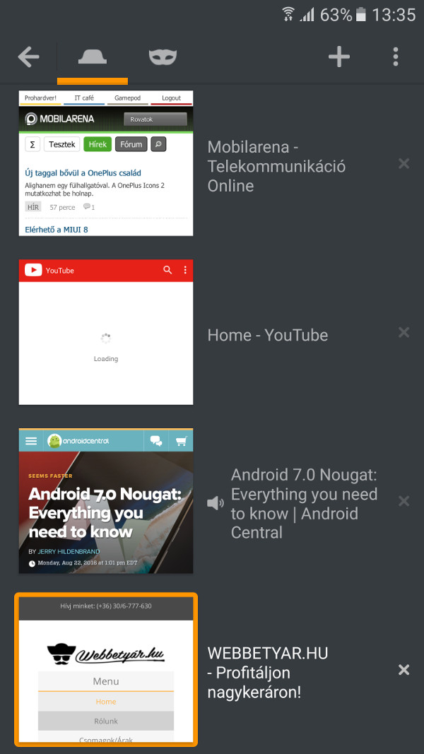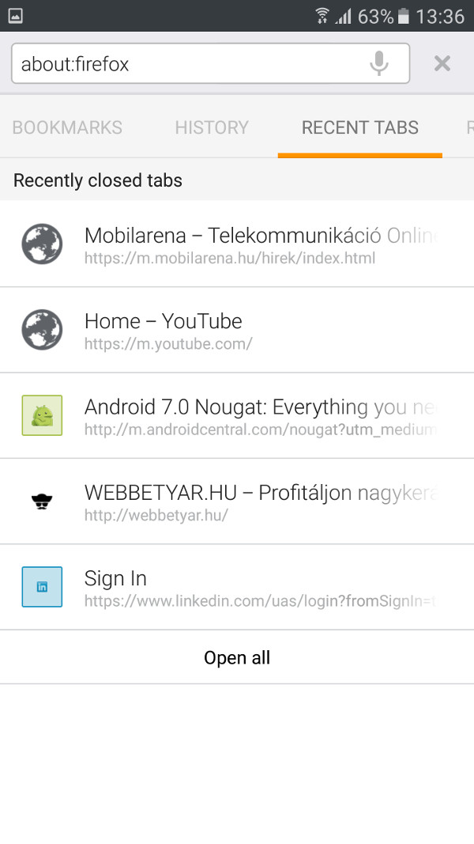

Opera
Opera is the least used browser from the three ones but it has several useful functions. It can be synced with our PC’s Opera browser, so our passwords, saved pages can be recalled. On the home screen we can see the collection of previously browsed pages, the history and a latest news function. This latter offers a collection of interesting news, articles about previously chosen themes and countries. So we have the convenience of being up to date without browsing news pages. Opera also has a traffic reducing service, which seems to be very effective. In the bottom bar of the browser there is a button to step forward and backwards to help us to navigate between the pages. It also has a private browsing opportunity.
It is possible to download 1-2 websites in order to browse them offline. Opera can be used simply and quickly.

Task:
- Install these browsers
- Try out the mentioned functions, compare the advantages, disadvantages

Communicational applications (cheap communication)

Instant messaging, VOIP and video call programs have become popular and widespread because most of them provide free (or very cheap) service. All we need is a smartphone and a home or office or mobile internet network. Smartphones has become everyday household objects, services connecting to them has become much less expensive, and there is a choice on the market. Thanks to all of these developments, nowadays it is not a problem to be online most of the day, which is essential for the operation of the earlier mentioned programs. Needless to say that if we communicate through the Internet and not through the mobile service provider we spare a lot of money either on voice calls or on the SMS messages. It is especially important if our business partners or relatives are abroad. In this case on one hand there is a free service, on the other hand there are the roaming fees.

Skype

Probably the most popular free phone application. It is available for iOS, Android, Windows Phone 7 and Symbian systems. Originally it was written for PCs as chat program.
Parallel with the spreading of smartphones it was adapted to the different platforms. With this app we can call or even video-call our business partners, friends any time if they are entered into the service. It is possible to have a chat or make a voice call as well.
If the partner is not entered into the service we can not call him/her but we can leave a message what he/she could see at the next entering. Nowadays this drawback has been disappearing continuously as we tend to be online more and more in the everyday life. The service provides an excellent sound quality and delay, so we can talk a lot without using much our data traffic quota. If we have subscription for a package or have credits, we can bother those partners, too, who have no Skype or are not entered at the moment. Unfortunately in the past there were several service providers who disabled the traffic of Skype via their mobile network. So, if you can make Skype calls only through Wi-Fi networks, the cause of the failure is probably the service provider.

Viber
Viber is a free chat application. Originally it was written for Android and iOS platforms but now available for Windows and Mac systems, too. It can be used on Android tablets and smartphones at the same time. It is very popular among young people as it needs only Internet and a telephone number. This latter is necessary only for the registration. After activation it can be used for voice calls, sending SMS and voice messages. It is free but only if our partner also has the app. It lets you text, call, and make video calls with anyone on the service from anywhere in the world. We can share photos in a group telephone conversation. The service supports emojis, but it places more emphasis on stickers. You can use a colored background as well.
You could send standard SMS messages from Viber to offline Viber users. They will read the message at the next entering Viber and the app shows when a message has been read but not when other parties are typing. Tap on the entry of someone who doesn't use Viber and you have the opportunity to invite them or make a Viber Out call - which basically means a normal phone call. But it costs money. The center tab, Contacts, mirrors your phone's contact list. Viber users are marked with a purple icon, and tapping one gives you the options for free calls, free messages and video calls. Tap on the entry of someone who doesn't use Viber and you have the opportunity to invite them or make a Viber Out call. Your complete call information, including whether the call was incoming or outgoing, is in the far right Calls tab. Viber can sync our data in all devices with the app. The great advantage of the app compared to the Skype is that it is incorporated into the system, runs in the background, thus we are always online and available for our friends. It’s sound quality is excellent, 3G recommended but it does not require a broad bandwidth in case of voice calls.
Other application: Fring

Applications for sending instant messages

WhatsApp
WhatsApp Messenger is a super light and easy to use popular cross-platform text messaging alternative. It has an enormous global user base, according to the statistics of this year, February 1 billion people used it day by day. WhatsApp lets you send person-to-person messages, but you can also send a group message which is a payable service at the service providers. In addition to text messages, you can send images, audio clips, video clips and (finally) emojis. You can also attach files, locations, and contact cards. There is a communication tool, which is really unique to WhatsApp: it is the „broadcast message”. This function is a little like a blind carbon-copy. If you send a broadcast message to Alice, Bob, and Condolezza, it will appear as if you sent the message directly to them. Broadcast messages appear threaded in recipients' existing conversations with you, not in a separate thread as group messages do. This is a bit confusing, but it's clearly a powerful communication tool,
WhatsApp is available on all the big platforms: Android, iOS, Windows Phone and Blackberry, what’s more we can install it on our notebook or desktop computers provided they run Windows or Mac operating systems.

Facebook Messenger

Nowadays everybody knows already the Facebook as it is the world’s most widespread application. Facebook is useful for voice calls – among other services – and Facebook Messenger was developed from Facebook. Facebook Messenger is a free app definitely developed for the purpose of voice calls and chating. It does not need deep knowledge of computers when loading and installing it onto the phone. All you need is a Facebook account (and who doesn't have?), simply log in and you're finished. The application runs on iOS, Windows Phone and Android platforms. If you’re already logged in you can reach everybody who are signed up. Immediately, for free. Sending SMS through the Messenger is stunningly simple, all you need is an Internet connection (Wi-Fi or mobile).

As we open the Messenger we can see that it is divided into five parts. In the first part we can manage our SMS messages. The second part serves for our personal calls, the third part contains our group calls. In the fourth part you can search for your partners who are using the app and the fifth part is for maintaining your personal account.

Let’s see first the SMS sending function. What possibilities are available? Choose from the list the name of the person you want to send a message to and type in the content. Then press the „Send” button. And here begins the exiting part of SMS sending. You can choose an emoji or sticker depending on your mood or the content of the message. The variety is fantastic. If we are finished with this step, in the bottom-right corner we can fix our favorite or most frequently used emoji. This step helps us to respond more quickly.

There is a Messenger Sticker store with continuously freshening supply. Search a sticker for your present mood and send an adorable, stupid, charming or any other sticker to your friends or just discover and browse thousands of cute, high-quality images. Facebook Messenger also supports a variety of third-party apps that add functionality to Messenger. Most of these let you search various databases for reaction GIFs, which can be sent through the chat box. The unique characteristics of these GIF files, that they are “moving pictures” in fact. If you still find your conversation with your partner boring, you have the chance to change the color of call for pink or green or yellow or any other color. Your partner will see you in this color, either.
After sending a message in the Messenger we can see the punctual time of sending by clicking on the message. And then we can see immediately if the partner received the message and if he/she read it. Thus we can be sure the message reached our correspondent. All kinds of special tools are available in group chats and group messaging. The app provides all the tools you'd expect for a modern group-messaging platform, such as the ability to add members to the conversation, to give a name for the conversation or for the group, attaching photos. You can remove yourself from a group if you don’t want to be online, you can mute notifications from a particular group etc.

But let’s not stop here. Facebook Messenger goes further by supporting voice and video calls. Clicking on the microphone icon we can dictate our message. It’s a very practical function if we do not have time or we have to send a message during traveling.

Let’s talk about calls. It’s free. You can call everybody you know and signed up everywhere in the world. There are two ways of voice calls. One is the HD voice call and the other is the face-to-face video call. It’s well worth to use especially if you are abroad. Beyond the messages we can share our photos, videos with our family members and friends. With the built-in camera you can make selfies, which can be stirred up by drawings, texts etc.

If these functions are not enough for you, you can send your position (the telephone recognizes it by itself), you can send maps to each other just to make easy to find a suitable place to meet. An extra tip: If you put the command icons on the home panel you could directly start a call without searching for partners in the Messenger.
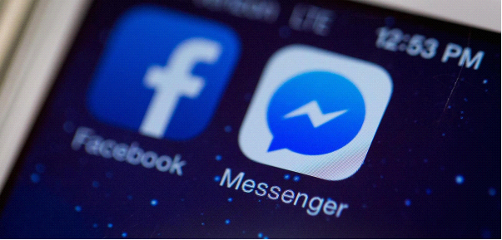

Hangouts

This is another application with which we can call our friends free. All what the app needs is a Google account and signing up with it. We can make phonecalls, have a videochat or send messages with it. Originally it was written for desktop computers under the name Google Talk, maybe it is familiar for some of us. Nowadays it can run on every platform, on Android and on iOS as well. People with this app can be called free of charge, be they anywhere in the world, provided they have an Internet connection and they are online. Voice calls can be initiated either from computers or from mobiles. In order to make it possible to call landline or mobile phones, it was extended by a freely available Hangouts Dialer program. While voice calls to other Hangouts users are still free, you have to pay a fee if you call a landline or mobile telephone number. Video calls are a little bit different. The matter is that it is not available everywhere in the world and some service providers may charge a fee for it. Users can perform a group video chat with up to 10 users at a time. In the desktop version there are drawings, pictures, runtime effects available during videochats.

The situation at voice calls is similar to that of other applications’ voice calls: it is free until you call a partner with the same application. A message can be sent even if the partner is not online as he/she will receive the message when signs up. Group phone calls can be initiated up until 150 users. Calls can be stirred up by emojis, gif-s, photos and we can send even maps.
Synchronization can be a very useful feature of the app: should we use any of our devices, in case of interruption we can follow the call or the chat on an other device. My experience: when I used other similar apps and problems occurred with sound quality, Hangouts still amazed me with a good quality sound.

Social network applications

Twitter is an online social networking service that enables users to share short messages, thoughts, small pictures with friends and followers. That’s the difference between facebook and twitter: at twitter you are allowed to send only short posts and not full stories. You can be a follower of some interesting, famous people or news portal or the place where you live and in this way, you can get a brief information about the important news and happenings. These “tweets” (short posts, links, photos) appear in account-customized timeline view which shows tweets in reverse chronological order and which makes it easy to close up to the events. For registered users the application sends notifications about the new tweets, which the user considered to be important formerly. We can send messages to others as well. Users can group posts together by topic. Users can share a post by use of hashtag (#). These hashtags connect together the same topics. E.g. #olympics show that these tweets are all about the Olympics. Similarly, users should choose a username at registration in the format of the "@" sign followed by a username.
Registered users can perform several operations on the tweets. They can reply to tweets – in this case the @username of the account you are replying to is added automatically to the beginning of the tweet. Users can retweet a post, which means they share another tweet on their own site. Users can also "like" individual tweets and send a message to the tweeter.

Twitter is a good social media application with the sympathetic feature of not showing all of the posts, the user can sort out the interesting ones. It’s very useful for sending and reading short, up to 140-character messages called "tweets". It’s easy to inform our friends about what have happened to us recently and similarly easy to follow users who we are interested in. It’s fast to review, brief, easy to use.

Task:
- Install the application from the Play Store
- Make an account, the name is up to you
- Post a tweet with a matching picture and using a # (topic)
- Look for some interesting users
- Retweet a popular photo or news
- Set up the Messages settings of a news portal in order to get the messages even if you are signed out

Searching on the internet (with key words; pictures)

There are several search engines available on the net, all have their own different algorithms. We can surely say that the search engines are very clever. They not just simply compare texts, their operation is much more complicated. We can search solely the picture title of a particular website, we can reduce the range for the articles published in a certain period of time or we can choose our mother tongue to search. The most popular search engine is Google. 90 % of all of world’s searches are performed by Google.

After this giant we can meet Yahoo and Bing search engines, too. If we type a text into the address bar of Chrome and of many other browsers, the default search engine (most of the cases the Google) begins to search immediately.
So, normally the only thing you have to do launching a keyword search is to type the keyword. If there are too many search results or on the first few pages there are irrelevant results then either you should repeat the search with a similar keyword or you can reduce the scope of the search with built-in functions.
If we mistype a word, the Google helps to find the correct word by offering an option closest to the typed word.

Image search

If we have a picture and we would like to know the source of it or want to know more about it or want to download it in a higher resolution or just simply we want some similar ones, then the Google has a function to do that. On the simple Google platform click on the „images” link in the top-right corner. This will navigate you to the Google’s image search.

Let’s open this page: https://www.google.com/imghp

We can see that a little camera icon is added to the little toolkit at the end of the input field.

Click on the camera icon and give the URL of the picture or upload the image from your device. After these steps Google will find the picture for us or a similar one.

Both at the desktop computers and at mobiles we have the option to dictate instead of typing. It can be very useful if we are doing something else or just simply don’t like typing. In my experience the voice-based search gives a very good result but you have to speak more articulately than general.
If the little microphone icon does not appear you have to click in the input field and look for the icon on the keyboard.

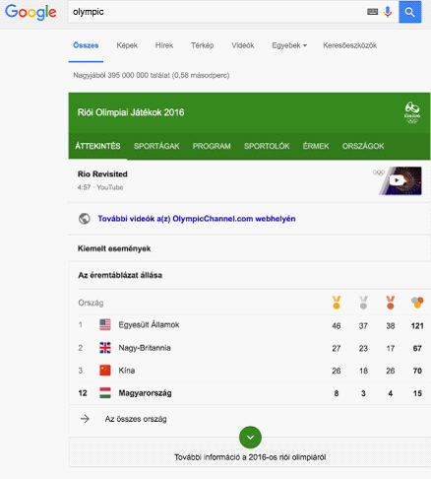
While Google is known as a good tool for finding your illness after searching for symptoms and thus curing yourself or watching movie trailers it's also provides lots of useful information even before the first results. Let’s see an example. We are searching for the word “Olympics” and before the search results we get an up to date result list and medal table of the Olympic Games.

Task:
- Search for your favorite singer or song. E.g. “steve jablonsky”
- Search for the books of your favorite writer
- If you are a gamer search for the word „zerg rush”

How to search? Let’s see some tricks and some of the special tools.

Searching from the entry field is fast. In Chrome just press the „CTRL+L” key combination and you can use the search function.

If there are a lot of not relevant results containing the same word we can exclude it with the ’-’ (minus) sign. Let’s try for example the next: „apple –iphone”. It will give interesting results. If we search for the „apple” word we could get the Apple Co. among the first results. But excluding „iphone” the company itself probably wouldn’t be on the first page.

If we have already thoroughly watched a website and want to watch more websites on the topic we can do it with the „related” function. E.g. „alternative shopping -> related: ebay.com”

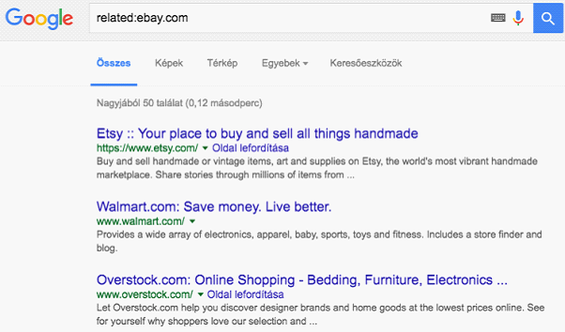

We can search for files. By default, Google searches in all of the file contents. But if we want to search exclusively in .pdf or .ppt file contents we have to do this: „keyword” filetype: ppt. Naturally we can search in other filetypes, too.

If we want to search for precisely a letter-by-letter equivalent, we have to put the word or the expression in quotation marks. E.g. „smartphone antivirus”

The search engine is capable to interpret the „or” and „and” operators.
If we want to covert measures or exchange currencies we can use „in” and „to” operators like this: 1 USD to HUF.
Searching for something in the neighborhood. For example it’s lunchtime and you want something to eat. Probably in the neighborhood. Type the word „restaurant” in the entry field and on the first place in the result list you can see a map with some restaurants in the neighborhood. This function works on mobiles as well, in the Google Maps application.

Media applications (listening to radio, music, browsing photos, watching films, recording sounds, films)
Media applications (radio, music, movies, photo viewers, sound recorders)

Music , radio
Spotify Music

On Android systems there are a lot of ways of listening to music. One of them is Spotify. Installing it you can listen to nearly whatever you want, wherever you want. With a subscription you can listen to the songs without Internet connection. Even downloading whole albums doesn’t cause much difficulties. If you’re going to pay 5 Euros a month you can download playlists and tracks to your phone to make sure the music keeps playing during your subway ride. The whole application can be synced with our PC and later controlled by our mobile. It has a so called „Discover Weekly” function which generates a playlist with new tracks carefully chosen according to your unique taste profile. Needless to say how timesaving it is. Although the Discover section is filled with custom recommendations based on your music history, if you are stuck picking out something new to listen to, you can get lost scrolling down the page. Spotify Radio functions like a typical Internet radio streaming service. You can create stations by artist, song, album and genre. Playback can be controlled on the lock screen of the mobile but the navigation panel can also be reached in the notification bar.

Playlists are Spotify's main draw. You can create your own by clicking the New Playlist button, or following and subscribing to other users' playlists. You can highlight your favorite music in Spotify's social feed by sharing it. There is also a Send tab, which allows you to send music to individual users in a private message.
The great advantage of Spotify is that you can listen to nearly whatever you want, wherever you want if you are connected. But this is also a disadvantage as you should be connected and if there is no Wi-Fi near you , it consumes your mobile traffic limit. The downloaded tracks can quickly fulfill your mobile’s memory so it is advisable to copy them to an SD card if it is possible.
If we get familiar with these features we get an excellent listener. It has a vast music selection and while music remains Spotify’s focus, the service is expanding to add podcasts, radio shows and others in the future.

Recordings

You can use the record facility on lectures or discussions provided you asked the permission of the participants

On Apple devices the recording function is built in (it’s not the recording of phone calls). You can find it in the „Extras” with the name „Voice Notes”. It can make three basic things: record, edit and play. At recording the app shows a volume figure. We can cut the unneeded pieces from the recorded material and overwrite the original one. The recordings can be sent by E-mail or in a message or through the AirDrop app.

Recording telephone calls is evoking debates in a lot of countries. That’s why we can’t find such applications for iPhones (perhaps after jailbreak - it means removing of software restrictions imposed by Apple). At Android systems the question is more interesting. Pre-installed recording facilities generally are not available only in some geographical locations like China. Earlier I had a Xiaomi Mi3 device, which was equipped with phonecall recording function by the manufacturer.

Some of the most popular apps: Smart Voice Recorder, Hi-Q MP3 Voice Recorder, Easy Voice Recorder, Voice PRO, Tape-a-Talk Voice Recorder

Smart Voice Recorder
This is a simple and well-structured application. It has an editing and sharing function, too. The sound quality can be set, the place of storage can be changed. There is an option, which automatically removes the silent parts from the recording. It’s disadvantage is that the recording can be saved only in WAV format.

Photo viewers

Manufacturer’s gallery applications on Android devices may be different at each manufacturer. We can say that these galleries perform well but without extras. At iOS systems there is the Photos application which is - in my opinion – a state-of-the-art and practical app especially if we want to search our photos by the place they were taken. When we shoot a photo the app records the place of shooting as well.

Let’s see the alternative gallery solutions. There are a lot on the market. Let’s take first the Google Photos app, which saves the photos to the Google storage space. The unlimited storage supports images up to 16 megapixels and videos up to 1080p. Google Photos is the standalone successor to the photo features in Google+, the company's social network. At its launch, reviewers wrote that the service was among the best of its kind.

One of the best – if not the best - alternative app is QuickPic. We can choose from several color scheme. It contains an automatic save option to receive more than 1000 gigabytes of cloud storage for your images for free. The application allows you to surf all your photos at the fastest possible speed, showing you miniature displays in the resolution that you select. It means that loading the miniatures of several thousand photos takes only a second. It has a mosaic system for viewing folders and we can even set the folders in order of their size. You can easily hide your privacy photos and videos from all gallery apps and protect them with a password. Supports the Amazon S3 Cloud upload which is a marketleader solution nowadays. Supports several online album services like Picasa, Google Drive, Dropbox, Flickr, OneDrive, Box, Yandex, 500px, Amazon, OwnCloud, Samba etc.
It is capable to deal with most of the image and video formats. We can view our photos as slideshow. Automatically rotates the photos. Contains an Internal picture editor, which allows you to rotate, shrink, crop pictures, set wallpaper with best quality freely. If you install you will feel: There is NO other app out there like Quick Pics Photo Manager!
Here is an alternative for iPhone owners:
MyPics
A powerful photo viewer, editor and manager. You can customize the design of the app and create folders. Albums can be edited, customized, and deleted any time you want. To ensure your files are kept safe you can back them up through Dropbox and iTunes file sharing. Speaking of sharing you can share your files by email, Flickr, Twitter, and Facebook and the app supports AirPlay, too. You can protect your private photos by a passcode.
Your videos and photos are imported from your Camera Roll leaving the original one where it was and unchanged. Location and time stamps are also imported which then allows you to view things in calendar view.

Media players

Nowadays external application is not needed for watching videos because our mobiles support a lot of formats. But if you like watching TV shows or want to watch movies with subtitles, you will need a smarter application. Let’s see now some apps, which enhance the experience.

VLC media player
The deservedly popular VLC media player is an open source program. OS X users are probably familiar with it but many people use it on Windows platform. In my experience, VLC player knows most of the movie formats and can handle the HD movies, too. Thanks to an update you can now stream your media files without having to download them to your phone or tablet and you can access your files from your Dropbox account and play them directly. It has no problem with subtitles. It’s a good free application but let’s see what can we get for a few Euros? We get a density modulator, some filters that can distort, rotate, split, deinterlace, and mirror videos as well as create display walls or add a logo overlay. There is a gestures control plugin and you can control VLC with moving your hands before an 3D camera. It can handle multitrack audios as well. There are widget options to control the audio player.

Reading news, newsletters (scientific literature, SDI (selective dissemination of information))

In the genre of news portals basically two trends seems to have been forming.
If you have already have any favorite News source or TV channel or News magazine, you can install them directly from the Stores. E.g. USA Today, MSN News, BBC News, CNN, Fox etc.

I’m writing about these channels in general as they perform similar functions although their operations are slightly different. Everybody has the possibility to choose from the treasury of news portals. On a “general” news portal we can select from a lot of tabs, each providing different topics and sorting possibilities. These can be live channels, top stories, my news, most popular news, latest news etc. At the “my news” option we can select the parameters: from which countries, regions and what kind of topics we are interested in. The applications are capable to send notifications, too. Great emphasis is given to the sharing options. We can share the news items by SMS, WathsApp and Hangouts quick message services and by Dropbox, OneDrive etc.

Task:
- Search for some news channels of your country
- Select the news, topics and parameters which reflect your interests

News channels of the other trend function as news aggregators. Both the news sources and the topics vary on a wide scale. Such applications for example Google News and Weather, Briefing for Samsung, Flipboard: Your News Magazin. Downloading and reading these magazines is similar to that of ebook applications or some of the newsreaders. Magazines generally can be read after subscription (Google Play Magazin). The magazines – either free or purchased – are placed onto a virtual shelf where they are refreshed regularly as a new issue is published.

Browsing up-to-date news

Flipboard
First let’s see Flipboard application, which is available both on iOS and on the little green robot. I advise to try with this app firstly if you don’t know where to start. Its topics and selected news items are interesting, its user interface is pleasant-looking and easy to use. There are several other well-known portals, but if you want something new and interesting, that’s it. This app is more like a personal magazine. First we are asked about our range of interest and the app selects the news items for us on this basis. The reading experience is similar to that of reading a published-on-paper magazine. Just try it. Read some news then take a break, relax and then go on with reading at the point where you stopped. Just as you did before Internet. Flipboard is a pre-installed app on several Android devices. As it can be seen from the above mentioned examples, Samsung has its own version of Flipboard. This was one of the first app, which applied the present trend: less text with smaller fonts and big photos accompany the news items – which is the general appearance of published magazines. If the pre-offered topics don’t meet our interest, there is a possibility to add an own „FEED” to the range.

Newsify
Newsify provides a similar experience that of Flipboard. It is somewhere between the traditional RSS readers and the Flipboard. It shows the news items with plain text elements. If somebody likes the “articles cut off from newspaper” appearance then he/she would be satisfied with this app. If you have the time to read randomly chosen articles then this is for you. If you use RSS, the Newsify imports your categories and folders. Thus we will have the structured layout of RSS but with a more interesting, magazine-like appearance.

Other applications:
Reeder 3
NetNewsWire
Google News & Weather
MSN News

What’s the essence of RSS and how does it work?
“RSS (Rich Site Summary; often called Really Simple Syndication) uses a family of standard web feed formats to publish frequently updated information: blog entries, news headlines, audio, video. An RSS document (called "feed", "web feed", or "channel") includes full or summarized text, and metadata, like publishing date and author's name.
RSS feeds enable publishers to syndicate data automatically. A standard XML file format ensures compatibility with many different machines/programs. RSS feeds also benefit users who want to receive timely updates from favorite websites or to aggregate data from many sites.
Subscribing to a website RSS removes the need for the user to manually check the website for new content. Instead, their browser constantly monitors the site and informs the user of any updates. The browser can also be commanded to automatically download the new data for the user.” (Wikipedia)

Let’s see two of the RSS readers. These perform a more simplified reading capacity and experience than that of news readers as the material is a „mere text” without pictures and graphical elements.

Feedly
One of the most popular RSS reader is Feedly, especially because Google supported the transfer from it’s own RSS reader, the Google Talk after shutting it down in 2013. It integrates the most popular social media and note-taking applications like Facebook, Twitter, Evernote, OneNote, Pinterest and LinkedIn. Feedly is nice-looking , the layout is attractive (contains pictures as well), and it offers a lot of views of your news. It updates itself quickly and provides a lovely, easy-to-use service.

Pocket
The Pocket application is not a “classic” RSS reader. Why is this here, anyway? Because if we use it wisely, it is like the above mentioned apps. The Pocket, as its name indicates, is a virtual “pocket”. The application allows the user to save an article or web page to remote servers for later reading. The article is then sent to the user's Pocket list (synced to all of their devices) for offline reading. The service lets you bookmark anything on the Web; articles are stored in your personal library, where they can be easily located and read when it’s most convenient. With this app we get not only an offline reader, but unlimited server space and a cross-platform support. We can discover new articles as well, because the app offers new articles for us according to our personal reading history. Pocket has developed a number of tools for „pocketing” the news pieces or sites. Almost all devices, platforms and browsers are supported with plugins: Chrome, Firefox and Safari.

E-book reader, reading books (searching for digital scientific literature)

As a result of continuously increasing screen sizes, more and more people have been reading on mobiles and tablets. The pace is not mitigated by printed book prices not to mention the cheapness of e-books. I know that the reading experiences are not the same, but let’s see what apps help to make e-book reading more pleasant. We can expect from an e-reader to have the capability of adding notes to the bookmarks, making categories, making highlights, notes, supporting a wide range of file extensions (e.g. epub, txt, doc, pdf,fb2) etc.
Kindle
Amazon as the greatest e-Book publisher issued it’s own e-reader for iOS and Android systems. Kindle provides three functions: online shopping, reading and library functions. In the webshop one can find several millions of titles from the bestsellers to the free public domain books. Fonts have been hand-tuned at the pixel level for maximum readability. Choose from eight text sizes to prevent tired eyes and keep you reading longer. With Kindle, the page is the same brightness as everything else in the room, so there’s no adjustment needed. Whispersync technology synchronizes your last page read, bookmarks, and annotations across all your devices so you can pick up exactly where you left off reading. Kindle has recently expanded it’s supply with thousands of audiobooks as well.

Applications:
Apple iBooks
Google Play Books
Marvin iOS
Moon + Reader
Scribd

"Applications connected to travelling: route planning, maps, navigational hardwares and softwares, applications for registering routes (travelling to the workplace)"

Apple Maps and Google Map

Goggle Map is definitely the marketleader with its twice as many users as the apple competitor has.
The search giant’s map is updated regularly. It’s a very precise, reliable application. Special thanks that they pay attention to users with cheaper mobiles and subscription packages with small transfer quota. So this year they introduced the option of offline navigation and downloading mapping data for a given area to an SD-card.
Google has provided a downloading feature long before but it required lots of mobile storage space. E.g. downloading the map of Budapest decreased the storage space by 100 MB, which was a great luxury in the case of a 4-8 GB mobile

At the downloading and updating functions you can set an option to allow exclusively only Wi-Fi operations, sparing the precious transfer quota. But if we are not connected to Wi-Fi for a month, our maps will be erased automatically avoiding the inconveniences an outdated map may cause. Voice navigation is also possible e.g. during driving a car. You can search for places like restaurants, companies, businesses and you can get important information like opening hours, website URLs, contacts and Internet ratings. For downloading Google Maps for offline usage first search for a town, a country. Then click on the name. Among the emerging information there will be a downloading opportunity: The other way is for downloading: from Google Maps menu choose “Offline regions -> Add new region”. After downloading a map you will not be lost in case of lack of cellular connection e.g. in a tunnel or an underground garage. Your mobile phone will sense the returning signals and returns to the online mode. When we are online we can get real-time traffic data and alternate directions if there’s unusual congestion ahead. Google Maps app is not only a navigation software but capable of perceiving the driving speed of the user and calculate the travel time, possible traffic jams, accidents etc.

It’s counterpart, the Apple Maps also capable of watching the traffic, although it uses different sources regions by regions. In America and Great Britain it uses the data of the large navigation company TomTom, while in China and South-East Asia it uses data from mobile phones.
An Internet magazine tested the reliability of the GPS navigation softwares. Apple Maps was tested on an iPhone 6S while Google Maps on a Galaxy S5 and iPhone. When these two competitors were run on the same device, there was not much difference. But there was a significant difference when running the software on the Galaxy (with the same network service provider). With this test it became clear that hardware is more important than software at these applications.

Task:
Make some comparisons if it is possible. Walk or drive a car with your friends and compare the two apps. Find a place for a weekend program and compete: who can plan a more precise, more optimal, faster rout with these apps. The weekend program itself should be found on Maps, of course.

Google Maps is stronger in real-time mass transport, walking or biking, which can be very important to commuters and travel to office, places of work. Not to mention those tourists who like to discover foreign places walking or by the local mass transport. Google Maps now cover several cities, so we don’t have to keep in mind the mass transport timetable if we can find it on Google Maps.
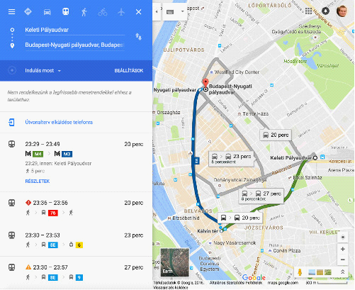

Today more than half of the world’s population does not have continuous Internet access. Sometimes it can be difficult to find a place somewhere in the world with Internet access but it is always advantages to think in advance.

Street view is a very useful invention of the Maps. If we search for a town or a tourist attraction and click the result, the application will show a lot of information and photos about it. Let’s see for example Eiffel tower. The first photo is a view. Clicking on the arrow on the bottom-right corner of the panel we are in the tower, where we can walk in every direction with the help of arrows – virtually, of course. There is a compass icon. Clicking on this icon, with the help of our phone’s built-in gyroscope, the actual looking-around feeling can be imitated.

Task:
- Download some regional maps
- Search for Rovinj, look around with the help of your mobile’s gyroscope

Navigation
- IGo
- Waze

Some useful extra applications when on the road:
- Traffipax notifications
- Drivers’ mode
- Traffic jam watch (online Waze, Maps)
- Where did I leave my car? (locator)
- Route planner (https://www.viamichelin.com/)
- First aid applications
- Paid parking places
- Gas manager
- „Black box” (instead of on-board camera)
- Message reader
- GasBuddy (list of gas stations)
- Forsquare (It’s a very good application during vacation, holidays. One of the best in it’s category. With this help we can get a picture of the locals favorite restaurants, coffees, pubs. And the program navigates us to these places. Its data are always up to date. It has a clear rating system and we can rely on the feedbacks.)
- Torque Lite and Pro (car information and diagnostics obtained through a device with ODB2 plug)

Accelerometer

Accelerometer Analyzer
This program measures the acceleration of the device on the basis of its spatial location. The positions of the device are described in a 3D coordinate system with the help of x, y, z co-ordinate axes. Position changes (acceleration) can be downloaded. The view can be rotated in order to operate in a landscape mode and can be set to warn if the acceleration reaches a predefined value. We can change between units of measurement and set if the Analyzer should take into account the gravitation acceleration.

Accelerometer Meter

This application has more functions: it can show the position and the acceleration both in a table and in a bar chart and in a coordinate system. Moving our device we can generate a light show or a voice show with the app. We can change the measurement units and can change the speed of the sensor.

Clock and its functions

Applications:
- Alarm Clock Xtreme
- Alarmy
- Timely

QR-code readers
QR Code Readers

What is a QR code? What is it good for?
QR code was developed by Denso-Wave Co., an affiliate of the Japanese Toyota, for the quick and reliable identification of car parts in car manufacturing. QR code is an abbreviation from Quick Response Code. This two-dimensional barcode became popular all over the world due to its fast readability and greater storage capacity. Applications include item identification, time tracking, document management, and general marketing. QR codes can be shot or scanned from any direction. Explanation for this is that there are three little squares in the corners of a QR code. On this basis decoders know the correct orientation of a QR code.
We can hide and share links, name-cards, telephone numbers, texts etc. using QR codes. Just let’s visit a website which generates QR codes. There are a lot of such sites on the net. Let’s take this one: http://www.qrhacker.com/ , http://goqr.me/.

Application:
QR code reader

Task:
- Install a QR code reader program
- Read a QR code

Notes, notes protected by password, drawing
Making notes, password protected notes, drawing

ColorNote
This is an Android application with which we can make notes and to-do lists. After launching the program we get an „add” screen. We can select from the note and to-do function. We can search the list by clicking a magnifying lens at the top. The program lets you connect the list items with dates. The fulfilled to-do items, notes can be archived or discarded. There is a possibility to sync them with our Google or Facebook accounts. Appearance of the app could be altered by different schemes: fonts, appearance of the list, type of the list order and if the app should sort the list-items by colors. Lets you place a widget on the home screen for saving the notes and entering the password. We can make memos and share them.

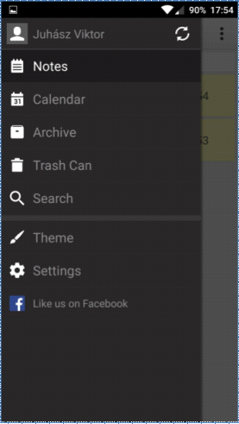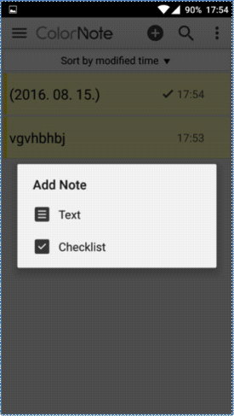

Evernote
This app has similar functions but this saves the places where the notes were taken as well. The app lets you add pictures, attachments and handwritten notes to the notes. Within the program it is possible to make office talks by E-mail. You can set passwords, messages and the app can be synced with the Google account. Notes can be shared, placed to the home screen if we want. Sequential organization of notes is also possible. At the drawing function we can set the color of the pen, erase or draw different shapes with a special tool. There is a forward and backward button. Evernote has desktop clients as well. The Evernote is integrated into several task manager apps or other apps, which improve the productivity. It is easy to make a task or a ticket from a note.

Task:
- Install one of the apps from the Store
- Make a note with a message to phone a later time
- Save it into the memory of the phone then send it to a friend

File managers, (systematic storage of CVs, covering letters, references in the mobile phone’s memory)

The appropriate storage of our files can be very important. If we cannot find one of your files, we will be at a disadvantage or we will waste valuable time. In fact, in most cases, if we cannot find anything, but we know that it can be downloaded from the Internet, then we download it again which thereby increase the redundancy of the data stored on the device. Use folders and drag and drop files into these. Thanks to the folders you can create a folder hierarchy that are demolished to several parts, tree structures, making easier the separation of personal and professional documents.

ES File Explorer File Manager
ES File Explorer is a file-management program and it can be found on the Play Store. You will receive the home page by starting the app where you can see how much free space you have on each storage space, plus the latest files and the data on your storage locations organized into categories. By using the magnifying glass in the upper right corner you can search through your files, by pulling the screen to the right, you will be able to select between the files stored whether on the phone or on the SD card. Clicking on the upper left you'll see the settings
where elements within the applications display can be set, additionally it is possible for cleaning, configuration of the library and the notifications or password-protect the program. There are more options to save the settings, trash and download manager.

Press on those files which are in the folders so you can select, copy, delete and rename one or more items. In addition, it is possible to hide, share, compress or move it up. The cleaning function helps us to liberate files from the storage locations, that gives you more space for more important things. We created a new startup tab so you can reach folders quickly by pulling to the right the main page. To exit you must press the back button twice. In the side toolbar there are still favourites, local settings, folders, settings, network settings and you can also set up different gestures. The application has been downloaded more than 100 million times, it is constantly updated and it gets good reviews from the Play Store.

Other applications:
- File Manager
- File Commander

Task:
- Install the sympathetic application from store.
- Look for a picture in the phone's memory, rename, compress, and send it to a friend through e-mail.
- If you do not like any application return back to the default file manager.

Office program packages

We cannot only modify tables, CV or our presentation on the computer, but it can be done also on your smartphone or tablet as well.
The applications of iWork package have a really stylish look, we can say that they are design-oriented. Partly it triggers off the office’s capabilities. The applications can be used seamlessly for both iPhone and iPad devices. Thanks to cloud integration the application is more efficient. The application took over the maximum number of the desktop version functions. Apple devices over the last few years became even more intertwined, so that the work started by the desktop platform can be very easily finished on our mobile phone, thanks to the Handoff service. The good news is that the iWork package will support this option.
Office provides good performance and optimize the workflow. It provides more opportunities than in the corresponding part of the iWork. Mobile version amazingly inherited many parts of the functionality of the desktop which means there are many possibilities of editing.
Google's solution is a bit more minimalist, it possess less functionality. Which is not wrong if you think that on the around 4 " display size, too many devices is not necessarily an advantage. Here prevails in the " sometimes less is more." principle.
Let’s compare them under sharp deployment. If you just wish to organize an event and you would like to make a flyer or just want to finish your homework (school, work) on the bus then you will need a good editor toolbar. The Pages and Word supports the use of templates, while unfortunately the Docs does not provide such comfort for us. So if you like to work from templates, you then have to look for extensions or select one of the first two programs for your documents. While editing the Pages uses an interactive format interface, so depending on the item, on the content you want to from appears 1-1 editorial and formatting menu, formatting toolbar. As you type, the keyboard above the text formatting options (letters, paragraphs, etc.) are being produced. It supports connection to Bluetooth keyboard, which make the work comfortable and fast.
The Word has been made for absolutely touchscreen devices, but many items will be familiar from the desktop version of Office Word. This is true for most Microsoft applications as well. You can reach the creation, editing and formatting elements with the help of different tabs. It is possible to insert and format almost any object with about two-touch. Perhaps it is a bit sore point that with track changes, section fractures and a few other functions, the Premium package is required, which can be activated in the Office 365 by subscribing to it. But with the free version, most users will probably find their calculations. The formatting toolbar is very similar to those seen in the Pages.
The Docs, which is a Google product offer a simpler solution to us than the two production option above. The editing toolbar is even simpler, poorer. The moulding tool does not appear above the keyboard, but in the upper area of the screen. Some features are missing from the surfaces, which can be found in the web version. Excellent extras is that changes are automatically saved, even when you do not have Internet, you can continue to use offline.

Synchronization, sharing, teamwork
The iWork package is iCloud, so it can work with Apple's own cloud-based storage options. This also means that no matter what device we are working with because any device synchronized to iCloud (Mac or iPhone) will be able to access and edit it. Use the advantage of Continuity which is provided by the Handoff , start the editing on your phone and finish the formatting on a larger screen of the computer. The most popular formats are supported and recognized, so it should not cause no problems of sharing documents with others, either by email or through iCloud share (link).
The Office is synchronized with the Office 365, so you can access anywhere sensitive data and your work over the Internet. Dropbox connectivity is available as well.
It stores Google documents on a hub (a collection site) called Google Drive. Here you can see all of your documents, your spreadsheets and your performances in one surface. Here happens the synchronization so they become easily accessible from Chrome or from any other browser. It is easy to share, the export supports a variety of extensions. In case of the collaborative editing work Google is unbeatable. Together with around 20 people can simultaneously edit the content without conflict or without disabling temporarily someone from editing. Most programs cannot be able to allow do more than one person to edit a spreadsheet. The changes are immediately updated, so that is why it is useful to automatically make a backup.

Other applications:
- WPS office+PDF
- Office suite + PDF editor

Applications for photo editing (but be honest during job seeking)

Airbrush
As starting the application, it immediately requires us a photo, the front camera will be opened, but the already edited image will be displayed, before you prepare the picture. You can also edit pictures stored on your cell phone. Filters can be set, but you set the strength of the elements (smooth, brightness, error correction). You can choose between the front and the backside camera, and you can choose flash mode in the case of need. There are two kinds of the aspect ratio, the 3: 4 and 1: 1. Additional effects and timer can be added to the image. If you have taken the picture, the program will immediately show the edited image, if you press the B | A blue button you can see the original picture. You will find on the bottom right corner the toolbar, there a lot of editing options will open up for you. It is possible to smoothen the image, defects can be improved, tooth can be bleached, color tone can be changed. If the image is fine, you can share, or you can save the image by pressing the complete button.
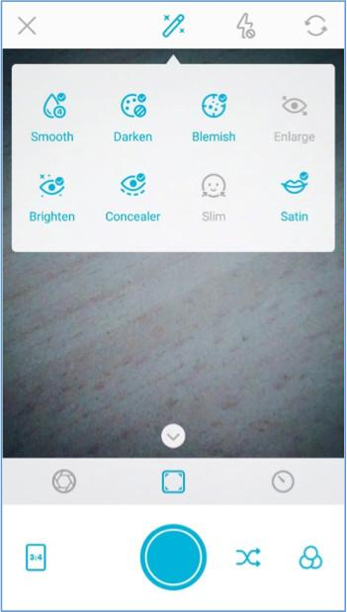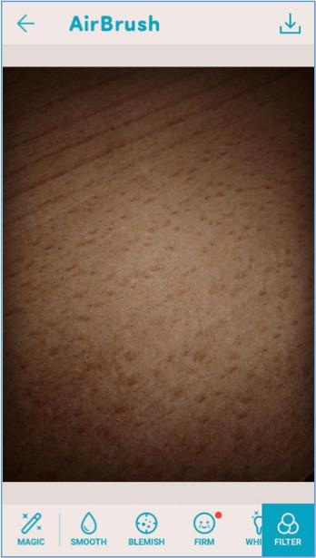
Other applications:
- Cymera
- PhotoDirector

Calendars, schedule, time management

The appropriate time management, the increase and maintenance of the efficiency can not only be useful for the workers, but for the people staying at home as well. It can happen to anybody, that thinking back of our day at the evening, many missed things come to our mind. Use a calendar, and pay attention to when, where, with whom and what do we have to do, or how much time do we spend on specific activities, how much time a specific task requires, even the daily routine.
Most of the mobile platforms provide their own calendar application. Let’s take a look at which are the most popular ones, or are outstanding due to a specific attribution they have.

Applications:
- The Google Calendar
- Sol Calendar
- Fantastical 2
- Sunrise
- Cal
- Digical
- Calendars 5
- Wave
- Today
- UpTo

Task:
- Try to install some of the apps mentioned above
- Compare it with the built-in app
- Add some events and require notification before the event’s beginning
- Place a widget on the screen

Besides using calendars, task and project managers can be used for our schedule and time management. Altough many calendars can handle our notes, tasks and thins to do, you should take a look at an app, that is specifically designed for this purpose.

Applaciations:
- Google Keep
- Any.do
- Wunderlist
- Todoist
- Toggl
- Rescue Time
- Moment
- Asana
  - http://www.creativebloq.com/software/best-project-management-71515632

Storing and sharing files on the internet (systematic storage of CVs, covering letters, references in the mobile phone’s memory)

Altough we are able to send pictures, videos, information to the other edge of the world, sometimes we are facing troubles by sending the required informaton to the person sitting next to us. The cloud-based storages can be used to eliminate this problem as well. The service accomplishes the load distribution in a transparent way through the cooperation of multiple servers, and this makes it possible to reach big size of data without any special deceleration. Such a service, that is not running on our own desktop computer or mobile is Google Drive, contact synchronization, Dropbox file opening. The users will be glad, since the competition for them is huge, and due to that more and more services will have great offers from year to year, like to get bigger and bigger storage for more and more cheaper. Partly due to this is that we can get unlimited storage for 60 USD per year. Those, who are storing many data at many different plaes can ask the question, that is it really necessary to deal with USB-cables, external hard drives, pendrives, sector errors and backup saving?! The answer is NO!
In the past few years the SSD (Solid State Driver) began to spread rapidly, which is intended to replace the hard drive, since it is able to produce multiple speed and doesn’t even contain a moving part, and its lower consumption is especially important in the case of laptops. However, the relatively small capacity is a disadvantage. Of course they exist in the size of hunderds of GB, but their price is increasing exponentially, which means SSD is not recommended to store data, but mainly to run the operation system. At this point the need for the online data storage has become even more important eventually. This need was not only formed because of the small storage space, but because the cloud-based storages have many other advantages as well.
- It’s a safer technology, than the home storage of the data.
- Professional engineers, experts are managing the hardwares and softwares.
- Our data can be reached and edited from many different platforms and devices.
- It can be expanded flexibly, since we can decide about which package to choose from the provider’s offers.
- Reasonable price/value rate.

Nearly the entire population of smartphone users is using cloud-based services on a daily basis. Some people are synchronizing their pictures with the cloud, to have them even if a harware error accurs or in can the phone is lost. Some others are actively uploading and downloading files, sharing them with their friends, but some others only manage their contacts and calendar events, which are automatically uploaded to the cloud by Google and iPhone in order to keep our devices synchronized.
Why not to make backup save of our data stored on our computer?

The bigger storage packages are pretty useful in this case, when we would like to store a significant amount of data in the cloud (on a server in a serverpark). This way a possible dataloss caused by a hardware error can be avoided. Many others rather use these services for file sharing, since the file transfer is much more simple, and if we want to share it with multiple users, we can save bandwidth, time and money at the same time, because we have to upload the files just once. We should distinguish the services, and not only along the price and opinions. Specialized services are existing which can be used especially for managing pictures and photos, so do not choose those for general file management. Such a service is for example the Flickr, Creative Cloud, Canon Irista, etc..

According to the services, we can distinguish three types of clouds and an „other” cathegory:

- Software service (SaaS): the software is the service itself (Google Sheets)
- Platform service (PaaS): it secures the environment that is required for the application, along with load distribution and software updates (OpenShift (RedHat), Google App Engine)
- Infrastructure service (IaaS): is assures a virtual computer, a client (web storage, server). (Google Compute Engine, Amazon EC2)
- Storage service (SaaS): this is the „other” cathegory. Those services can be listed here, which are used by the most of us, and we make the bacup saving and synhronizing of our data with their help. (Google Drive, Dropbox, Amazon Drive)

A comparison talbe of the cloud-based services
 | OneDrive | Dropbox | Google Drive | Box | Amazon Cloud Drive
File size limit | 10GB | 10GB | 5TB | 250MB/5GB | 2GB/ unlimited
Free storage | 5GB | 2GB | 15GB | 10GB | none*
Paid options (per month) | 50GB / 2$ | 1TB / $10 | 100GB / $2  1TB / 10$ | 100GB / 10$ | 12$/year unlimited picture  60$/year full unlimited
Platforms | Win, Mac, Android, iOS, WP | Win, Mac, Android, iOS, WP, Linux, Kindle, BB | Win, Mac, Android, iOS | Win, Mac, Android, iOS, WP, BB | Win, Mac, Android, iOS, Kindle

Applications:
- Onedrive
- Google Drive
- Dropbox
- Amazon
- iCloud
- Box

Storing photos on the internet (storing and sharing CV and reference photos)

Like we could see in the case of cloud-based services, there’s a chance to store, manage and organize photos at each service. The options listed below were made especially for photos, so during the upload the photos gone through a compression and analysis, and thanks to that the services provide many convenience feature and browsing option.

Google Photos

Google Photos is the new default photo manager app for Android. Basically we can choose from two different storage types: we can choose from full size (original size) or good quality. The latter is worth to mention, since it doesn’t compress util 16 Megapixels, only the photos will be compressed that have more pixels. We can set up the option if we want to make the uploading solely with WiFi connection or with mobile internet as well, which is proceeding in the background anyway. The saving of videos is not a problem either for the application that is specialized for photos.

The mobile application has received a great function, that is responsible for deleting the uploaded files from our mobile with a single click, making more free space on our phone. During the synchronization not only the photos, but the date and location of the capture will be stored as well. An intelligent assistance comes along with the application, which makes a collage or a video of our uploaded pictures from time to time. One of the most ueful function is the visual browser, namely we can make a search according to the information found on the photos, e.g. flowers, baby carriage, sea, etc. We can create albums, that we can share optionally.

Other application:
Flickr

Remote desktop connection with smartphones

It’s Friday afternoon and we are working on a project with upcoming deadline. Our child gets sick (or we have something else to do), and we have to go home. I’m sure that it has already happened to everyone else, too. What can we do? Controll our PC remotely from our mobile device! So we can controll our desktop computer or laptop with the help of our phone when the computer is turned on and is connected to the internet. The mobile phone will become the monitor and the peripheral input at the same time. Considering that the screen of the phone is much smaller, and is lacking the right mouse click and other keyboard shortcuts, this is the task of the spcific RDP clients. RDP is the remote desktop protocol, through which we can reach and controll our computer running with Windows.
Considerint the applications, it has two main groups. One of them is the cross-platformed 3rd party application, which was made to be able to be installed on any system, and to make it possible to control our computer with any device.
Also there are solutions from the manufactures, which is assured by the Windows in the form of RDP, or as Apple Remote Desktop and VNC produced by iOS X. According to my experience, to install a remote assistant for an average user, the Logmein, TeamViewer or Chrome Remote Desktop (service) can be set up easily.
In order to connect to RDP, the service has to be authorized on the PC that we are willing to connect to. We have to know it’s internet adress (IP), and leave a port open on the firewall, where the app can communicate. After all, we only have to sign in to the Windows with the username, and we can start the work or give a remote assitance from home. Such a program is like Xtralogic Remote Desktop Client for Android or the factory developed Microsoft Remote Desktop, which can be reached from many mobile platforms. After giving the correct IP address and username with password, we can view the resized copy of our computer’s desktop on our smartphone’s screen. The information is forwarded via an encrypted channel. We can even play a music or video from the remote host, thanks to the effective compressing methods.

Applications:
TeamViewer
Google Chrome Remote Desktop service
LogMeIn
QuickSupport

For our desktop computer’s Chrome browser, the installation of a plug-in module is necessary, which can be found in the web store, and which is connecting our desktop computer with our mobile phone through a PIN code, and we can start to control the computer through our mobile. But for those, who has got an ad hoc problem and needs an instant help from someone, can use the application named QuickSupport. This doesn’t have to be installed, only run and the program generates an access, which is usually a sequence and a password, and we can connect to the computer through this. It’s safe, since it allows a single connection, and if we don’t run the program, the computer won’t be available.

Shopping list applications, receipt manager applications (healthy foods in order to preserve capacity for work)

There are two things one should follow before going shopping: don’t go with empty stomach and make a list about what to buy. The latter can be fulfilled with the earlier mentioned ToDo list apps. In many cases these ToDo list apps are demonstrated with a shopping list as en example. If we have already bought an item, it disappears or is cancelled from the list, highlighting the remaining items. If we are not alone on our shopping spree or we can get a remote help, let’s share the task of handling the list.

We can find several shopping-list apps. They possess similar functions but their user interface show a fairly various picture.

Task:

Install one of the apps from the following list and compare them with the ToDo apps and their functions:

Apps:
- Shopping List
- SmartBevásárló lista
- Shopping List - Listonic
- Bring! Shopping List
- Cookbook – recipe apps

Preserving health and capacity for work

Applications connected to Sport (compass, training programs, achievement tools, applications connected to hiking in order to preserve capacity for work for a long time)

Applications:
- Smart compass
- StrongLifts 5x5
- PocketGuide
- TourPal
- TripAdvisor
- Forsquare
- Layar
- Wikitude

Applications connected to preserving health (calorie counter, water drink reminder, sphygmograph)
Health apps (calorie counting, water consumption, heart rate monitor apps)

- S Health
- Drinkwater
- My Daily Bits
- Body mass index – losing weight - BM
- Yazio – calorie counter

Applications which provide unique appearance, customizing

Launchers
On Android devices we have the possibility to personalize our phone. The so-called Launchers can help us with it. The appearance of devices is different but they use the same software. These apps let you change the lock screen, icons, animations, notification bars. The simpler apps cause only slight changes but the more serious ones may give the appearance of another operating system. Don’t change your launcher without reason, always save a proved one. If you erase all the applications, which handle the user interface, it will cause that your phone may not operate for a short time (until recover).

Arrow Launcher
One Launcher
ZenUI launcher

Task managers

The Task Manager contains the current running programs, namely those apps, which use and allocate a certain part of our phone’s memory. We can monitor the memory allocation of apps and in certain cases we can stop them.
Task killers perform the following functions: at starting, the program looks at the applications in the memory. Then after a manual instruction or pushing a button it tries to force their closing. As a result of these processes memory space will be deallocated and some accumulator life will be expended - in theory.
Android is a multitasking operating system, it means that it was designed for being able to manage programs that run parallel. This is an essential requirement from the system as we do a lot of things with our phones parallel: during making a phone call we receive an E-mail, take a photo and top of these a synchronization can be in progress.
An installed program can be in 3 states: Run (active), Doesn’t run (stopped), Passive. Passive means, that it is still in the memory, but it isn’t active, doesn’t do anything. It doesn’t mean any disadvantage, doesn’t exhaust the device.
When we use Task Killer, the program kills everything in the memory. Thus, without knowing it, the program stops important system-programs, which are necessary for the normal use of the device. Because of this, the operating system will restart. And ‘shut down’ and ‘restart’ do cause unnecessary processor and memory use, slowing and exhausting the resources of our phone.
Task killer causes a similar problem when we have already opened an app earlier and want to open it again.
Free memory can be taken as a waste of the system’s resources, as the optimal operation of the system may consume even 70-80% of the memory space. Owing to this, all the important data remain in the memory, but there is enough space for the applications, too. We don’t have to worry about memory space, there is a RAM and let the Android system manage the work.

Applications:
- Watchdog Task Manager.
- Others

"Employment, Job seeking"

Taking advantage of possibilities in social media during job seeking (Linkedin, Twitter, Facebook, etc.)

The social media
By the permeation of the web2 technologies certain applications used by millions have become dominant. It is almost impossible to list them. Some are known by almost everyone, at least the logo and the inscription. However, those who know it do not make it sure that they know well and they are able to use them.

The power of social media lies in the community. And this power is what we are trying to take advantage of in all fronts of the life. Therefore, we feel free to use Wikipedia the different wikis, we search for pictures on the Pinterest or searching other users Flickr account.

The power of community

The web2 tools, and the spread of cheaper and cheaper devices who in parallel followed and survived the web2 devices made possible the usage for more members of the different population strata. This is facilitated by the translation in the national language as well. The more people can be reached, the more people can help or pass on his knowledge. It is needless to explain. Most Facebook users have already experienced that it is much easier to find the answer for an interesting question like as before, or how quickly you can give up on a redundant stuff. The most society based software tries to exploit this.

How to manage our pictures on the social media?

I mentioned earlier that our social media appearance says very lot about us even we post at the real or the false picture of ourselves. It is always important to pay attention how much information and what we share of ourselves. The excessive, anonymous status can be just as negative as the excessive exhibitionism is. Do not forget that "the Internet" does never forget. The images, texts we share will be retained and retrieved at any time.

The uploaded images can show our political commitment, our relationship with our religion, our interests, our knowledge, our relationship to work. The completed data sheets show our education and qualification. With a little research our contact system can quickly be checked, which also can be negative or positive in future our employer's eyes.
Of course, this does not mean that we do not share our interest, or any important photo for us. But do not forget that they characterize us. If you want to work as a civil engineer specialized of high building, pay attention on your Facebook profile, make sure it does not show that you are afraid of heights. If this can be seen everywhere, do not sign up for this kind of job.
For many employer our family status can also be important. Therefore, it should not show a different picture of ourselves than the reality. We cannot say about our resume that we are childless if the social media is full with the pictures of our children.
Not only is the content of the images betray of us additional information. Our presence in the community itself carries a lot of information. In some extreme cases, it can be very useful if the potential employer sees that we are very active in several forums. The same, however, can be very negative as well.
Excessive activity, the exhibitionism shows a lot. Too big part of our lives is making part of virtual world and its demand too much time. If the potential employees are too honest, too open that can be dangerous for company secrets. A very large network of contacts poses a potential danger.
The same could be said of the portraits show of ourselves. The images of unreal situation, the too obscene, too personal and private images do not belong to the public. This applies not only to the future or any job search. The excessive openness is equally dangerous because of (web) crime. Our children faced with increasing threats. A self-revelation can be dangerous. Of course, we have to avoid abuses on both sides. The recent news was that the French police asks the parents to restrict sharing photos of their children for the future.
In conclusion, the rule cannot be established. The lesson is that give a realistic of yourself, but in some cases it's worth to share our pictures with just our friends and with those who are on the photo. There are several types of options. I am thinking about private share, closed groups, shared cloud storage places.
On the social sites be honest, but introduce ourselves and our families in a low key.

LinkedIn
LinkedIn is a very special social networking site. Users have registered specifically for business purposes on the site. The primary aim is to build a brand of themselves, their presence on the labor market and the building of relationships. Closed community. The links are organized around work, but it is important for the individuals as well. Everyone must be itself with the conscious self-branding. It cannot be under the pseudonym, no political content can be shared, the users do not care about the other party's lunch, chat, beach vacation, but it's really important to know that the user can display what is in his/her profile.

LinkedIn is the Facebook of business life. But it can provide more than Facebook. We can get in contact with valuable people, we can read interesting articles about the economy and the industry sector we are working in.
As our Facebook profile shows a mirror of us, our Linkedin profile is explicitly used for self-branding. Therefor it is very important to show real data and real knowledge.
It is very essential to continually maintain, build our profile. The profile construction is primarily essential for finding a job. We can enter here our knowledge, our qualification. According to the he website operators those profiles who entered their formations, the name of their schools were seven times more often checked. The website also helps in this regard. The website gives countless tiny advises, help you to complete the profile which is indicated by a small info chart.

Working with social networks

The internet is your workplace
More and more large companies use for communication and for marketing purposes the most popular pages. Perhaps it is surprising that the younger generation is not only the target group who make up definitely of the most Internet users camp. Many young startup companies are almost exclusively using for advertising these surfaces. But now the large apparatus of renowned multinational companies is looking for opportunities. Check out the BMW Hungary's Instagram page, where we can observe a new face of a luxury brand. At first glance it is thought-provoking that a significant part of the Insta-users are not thinking to buy a new car while as searching for family photographs.
It is also surprising that the great Stihl is managing a really comprehensive campaign in several forums. They are displayed on the Instagram and advertising games on Facebook at the same time. It is surprising and however it is an enviable professionalism how they maintain this campaign. This professionalism shows that it is now a separate industry, which has a great importance and requires special expertise.
So here is the first meeting point between labour and social networking. New jobs were formed, new tasks were established that require new skills They do no longer use the Internet for their work, but their job is the Internet.

Job search on the internet and job advertisement

The search

We have to mention again the power of the community. Friends, acquaintances, and significant part of our online relationships come from the similar social medium. Those who have the same interest can find through this online relationship similar ads, or with its help we can find sooner a job.
But the search can assist by algorithms. According to many researchers, it is otherwise dangerous and the purpose of it is to reach more personalized ads through our profile. This type of search may benefit as well. Although many researchers and analysts believe that we pay too high price for the otherwise seemingly free of charge services.
(Certainly, not just only Facebook's like button follows the actions of the users, but the mammoth company, Google is also constantly analysing the mailing history, the queries of its users, so there is a real risk in terms of privacy and in terms of the use of social media.)
On the job search sites helping advises turn up constantly. For example: CV builder programs, resume patterns of behaviour and dress code, tips, self-assessment tests, salary calculator, cover letter samples, foreign language (especially English) tests, etc. It would be very difficult to list what is new and more useful (and sometimes less useful) job search portals that attempted to offer assistance. (As writing the "job search on the Internet" in Google search resulted within 0.37 seconds 62300 results, which shows really useful information and portal suppliers on the front page.)

Job seeking applications (Infojobs, YouRock, EURES, etc.)
EURES
The National Labour Office maintains a separate portal for job seekers, job reports. This is probably the largest portal. However, as maintained by the state, it lacks the virtues of social media. The site contains official information and tips.
For the foreign work it is necessary to have the qualification, acceptable to the host country, as well as knowledge of the language of the host country is usually expected. For this it was necessary to harmonize a number of laws, which the EU's the relevant bodies also carried out.

Changes in the labour market, to facilitate the search for work necessitated the creation of the European Employment Service (EURES). The principles of Service were adopted in 2003. Now it is available in 27 EU official languages, and generally the services are operated normally by the State in question.
The EURES is not a simple website. In practice, the EURES portal and an app. It provides its services through 1000 EURES human advisers and through the network. The consultants are in daily contact with jobseekers and employers across Europe.
We can learn of the EURES service a lot by browsing the portal.

Free registration is required to use most of the extra services. However, if we become a registered user, we can get a lot of useful advice, information. They help preparing a CV, we can get advices about our skills and our capabilities. On the site we can prepare our own skill passport.

The site focuses on foreign employment will help, but thanks to its qualified human resources, the registered users can get plus countless services, beside the job search. We can also receive help to create the right resume.

You Rock
The most common and most successful job search social networking portal is clearly LinkedIn. But a number of new and special, unique service followed and will follow. Such as the page of You Rock. The speciality of the site is (except that it is already available in several languages) that is specifically for young people, designed for the age of twenty-five years.
The site is unique in that it helps the users to give of themselves really useful information. Of course, like in every web2 service, the community knowledge will also receive a big role when we use it. Users have the option to record a new subject word and description, helping each other's work, job opportunity.
By using the site, I can really say that the developers managed well their plan and mission:

Help users to:
- Determine their specific employee skills,
- Draw up a dynamic profile so there can show their group of primary abilities,
- Establish their online portfolios that presented their skills.

Help employers to:
- Determine proactive, new employees special abilities
- let them go through all candidates dossier in all languages of the system.

Those who sign up actually learn more about themselves and their possibilities. It worth to fill out the profile honestly and completely, so those employers could really find that candidate who has the relevant skills and abilities.
The project, launched in 2013, is still in the development stage and puts even the goals at the end of 2016.
If young people are really going to use, it can become a very useful and visually elaborate site. The portal is available in several languages, but the most useful information is primarily English.
If somebody already starts to build a profile on the site, he or she will gain useful knowledge that that could well benefit on other sites.
High incompleteness is that however it is optimized for mobile but there is no application prepared for it, which would be absolutely necessary to the original intent (the target group of young people under 25 years).

Apps:
- Infojobs
- Indeed
- Jobandtalent
- LinkedIn
- LinkedIn: Pulse
- LinkedIn: Job search
- Careerbuilder
- Jobeeper
- Eures

Web spaces:
- Feina Activa (only for Catalonia)
- Infojobs
- Infoempleo
- Monster
- Laboris
- Trabajo.org
- YouRock

Web spaces for ICT jobs:
- tecnoempleo.com
- ticjob.cat
- tecnojobs.com

Web spaces for freelances:
- Nubelo
- twago
- infojobs freelance
- freelancer
- Odesk

Croatian resources:

Mobile apps:
- Posao
- Ulovi posao
- Poslovi klikdoposla
- Poslonaut
Web spaces:
- Croatian employment service
- posao.hr
- mojposao.hr
- njuskalo.hr
- Bika.net

Making presentations

Nowadays almost all of the presentations are accompanied by PowerPoint display. A lecture with carefully selected pictures is more interesting than a monotonous speech. Thanks to the PowerPoint application, the Office owners got a wonderful tool to assemble presentations. If we exploit the possibilities of the program, topped with some carefully chosen effects, we can be sure nobody will be bored.

How to make presentations?
The 4 sections of planning, implementing:
- Preparation (preparing, collecting material, thinking over the general impression)
- Planning of the slideshow (planning of the content and order)
- Visual impression, display-messages (implementation, creating slides, slide elements, creating objects, synchronizing the impression, finalizing the order, saving, setting the display modes)
- Testing, evaluating (content, form, composition, impression)

Let’s use the Prezi program instead of the familiar PowerPoint. This program was developed by a Hungarian team, but an awful lot of people uses the software by now. Not without reason …
The Prezi presentations are much more spectacular, much better call the attention (if we happen not to do it) especially, if the audience hasn’t met Prezi before. But if we don’t have enough time, let’s stick to PowerPoint, because it takes time and thorough planning to compile a good Prezi presentation. The stress is on planning, the implementation is easy. If our office or office codes contain restrictions how a presentation of the company should look like, probably you may not use Prezi. You can share or export/send in PDF format but if somebody does not know the Prezi, editing can cause problems.
Let’s see an example from Prezibase :
https://prezi.com/ixvaygzwcqst/interactive-media-prezi-template/

Coding

Tools suitable for developing mobile applications: MIT Appinventor or Mozilla AppMaker

What is an app inventor?

It’s an unusual programming interface, which allows newcomers to computer programming to create software applications for the Android operating system. Instead of the usual text-based programming languages it uses a graphical interface, which allows users to drag-and-drop visual objects to create an application that can run on Android devices. The simple graphical interface grants even an inexperienced novice the ability to create a basic, fully functional app within an hour or less. Owing to the learning system, which causes spectacular results and a steep learning curve, the student has the motivation to improve his/her knowledge and easily learns the logic of programming. The project was developed in 2010 with the mission of democratizing software development by empowering all people, especially young people, to transition from being consumers of technology to becoming creators of it. The project itself is fully documented on the http://appinventor.mit.edu/ website and there are a lot of materials both for learners and for teachers.

During the course of learning the learners create apps but what’s more important, they acquire the basic concepts and terminology of programming. The created application can be installed and run on their mobiles immediately. The Drag & Drop system contains simple visual objects (cards), which can be connected, thus creating different events and instructions. The application is very similar to the Scratch interface, which was developed for children. The whole interface is like a big puzzle, where after taking the appropriate steps we get the desired program. This way we – and children as well – can learn the basics of programming by gaming.

The learner has only a few instructions like „DO”, „WHEN”, „THEN”, „IF” and these can be connected with some events like „call”, „start”, „click”. Learners don’t have to know anything about syntax, it is just enough if they know the meaning of command, operations and events and if they know the logic how to put them in order. Syntax is different in the various programming languages, the syntax defines how to write certain structures, events, functions, instructions in the given programming language. So, it’s a great advantage that the learner shouldn’t deal with the syntax, he/she can concentrate on the logic of programming.

Let’s see a very simple example:

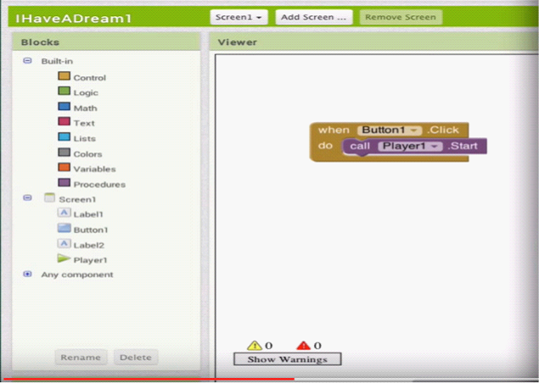

The above screenshot displays a very simple example. It consists of 5 elements: When, click, do, call, start. With ’When’ we create a watch on the button 1 element. In this case we have to read the program like this: „when some event takes place at button 1” – in our case ’click’, and then let’s add the ’do’ command. Namely, if ’click’ event happens, then let the program do something. Here the program makes an inner ’Call’ event. Namely, calls and ’Star’ the (Player 1) player.

Source

EURES
[1] http://nfsz.munka.hu/
[1] https://ec.europa.eu/eures/public/hu/eures-serviceshttps://ec.europa.eu/eures/public/hu/eures-services
https://ec.europa.eu/eures/public/hu/eures-services
Yourock
[1] http://www.szeretlekmagyarorszag.hu/igy-mentsd-el-az-iwiw-es-adataid/
[1] http://yourock.jobs/hu
[1] http://yourock.jobs/hu/node/181http://yourock.jobs/hu/node/181
http://yourock.jobs/hu/node/181
Using pictures in social media
[1] http://www.origo.hu/techbazis/20160302-a-facebookra-toltott-gyerekfotokbol-per-is-lehet.htmlhttp://www.origo.hu/techbazis/20160302-a-facebookra-toltott-gyerekfotokbol-per-is-lehet.html
http://www.origo.hu/techbazis/20160302-a-facebookra-toltott-gyerekfotokbol-per-is-lehet.html
Telephon selection for work
[1] http://www.kantarworldpanel.com/global/smartphone-os-market-share/
[1] http://pcforum.hu/hirek/16769/lenyomta-az-android-az-iphone-t-az-alkalmazasok-szamaban-is

Big job search text
http://www.technokrata.hu/www/2016/06/12/a-google-dontheti-el-az-amerikai-elnokvalasztast/
http://www.fsz.bme.hu/www/other_h.html
https://niif.hu/hu/tortenethttps://niif.hu/hu/tortenet
http://www.netkutatasok.hu/2015/02/kutatopont-az-okostelefonok-aranya-39.htmlhttp://www.netkutatasok.hu/2015/02/kutatopont-az-okostelefonok-aranya-39.html
http://index.hu/kultur/2012/03/03/milliomossa_nem_tesz_a_youtube.hu/
http://index.hu/tech/2016/06/13/a_microsoft_megveszi_a_linkedint/http://index.hu/tech/2016/06/13/a_microsoft_megveszi_a_linkedint/
http://www.urbanlegends.hu/2016/05/politikai-cenzurat-folytat-a-facebook/
[1] http://www.cvonline.hu/blog/page/2http://www.cvonline.hu/blog/page/2
[1] http://www.cvonline.hu/blog/wp-content/uploads/2013/11/kreativ-oneltrajz-mintak-6.jpghttp://www.cvonline.hu/blog/wp-content/uploads/2013/11/kreativ-oneltrajz-mintak-6.jpg
[1] https://www.androidpit.com/search?st=job&t=ahttps://www.androidpit.com/search?st=job&t=a
[1] https://play.google.com/store/search?q=%C3%A1ll%C3%A1skeres%C5%91&c=appshttps://play.google.com/store/search?q=%C3%A1ll%C3%A1skeres%C5%91&c=apps
https://play.google.com/store/search?q=%C3%A1ll%C3%A1skeres%C5%91&c=apps
Anti-theft devices
https://www.cerberusapp.com/https://www.cerberusapp.com/
http://hvg.hu/tudomany/20100302_lapophttp://hvg.hu/tudomany/20100302_lapop
https://support.norton.com/sp/en/en/home/current/solutions/v78442010_EndUserProfile_hu_huhttps://support.norton.com/sp/en/en/home/current/solutions/v78442010_EndUserProfile_hu_hu
https://mobilesecurity.norton.com/?lc=enhttps://mobilesecurity.norton.com/?lc=en
http://preyproject.com/http://preyproject.com/
https://support.microsoft.com/en-us/help/11579/microsoft-account-find-lost-phone-devicehttps://support.microsoft.com/en-us/help/11579/microsoft-account-find-lost-phone-device
http://mspoweruser.com/find-my-phone-updated-with-new-windows-10-look/http://mspoweruser.com/find-my-phone-updated-with-new-windows-10-look/
http://mspoweruser.com/find-my-phone-updated-with-new-windows-10-look/
Backup preparation on telephon
http://www.telefonguru.hu/wikipage/Hogyan_keszithetek_biztonsagi_mentest_a_telefon_adatairolhttp://www.telefonguru.hu/wikipage/Hogyan_keszithetek_biztonsagi_mentest_a_telefon_adatairol
http://www.telefonguru.hu/wikipage/Hogyan_keszithetek_biztonsagi_mentest_a_telefon_adatairol
Backup program
http://pcworld.hu/tippek/5-szoftver-az-androidos-mentesekhez-162516.htmlhttp://pcworld.hu/tippek/5-szoftver-az-androidos-mentesekhez-162516.html
http://napidroid.hu/biztonsagi-mentes-root-nelkul-van-megoldas/http://napidroid.hu/biztonsagi-mentes-root-nelkul-van-megoldas/
http://iphonekozosseg.hu/2014/09/16/erkezik-az-ios-8-igy-csinalj-elotte-biztonsagi-mentest/http://iphonekozosseg.hu/2014/09/16/erkezik-az-ios-8-igy-csinalj-elotte-biztonsagi-mentest/
http://iphonekozosseg.hu/2014/09/16/erkezik-az-ios-8-igy-csinalj-elotte-biztonsagi-mentest/
Task killer
http://appdroid.blog.hu/2010/12/20/tippek_trukkok_tevhitek_a_taskkillerhttp://appdroid.blog.hu/2010/12/20/tippek_trukkok_tevhitek_a_taskkiller
http://appdroid.blog.hu/2010/12/20/tippek_trukkok_tevhitek_a_taskkiller
Google play, Windows store, App Store
http://ajaybansalqa.blogspot.hu/2015/08/play-store-vs-app-store-vs-windows-store.htmlhttp://ajaybansalqa.blogspot.hu/2015/08/play-store-vs-app-store-vs-windows-store.html
http://ajaybansalqa.blogspot.hu/2015/08/play-store-vs-app-store-vs-windows-store.html
Skype, Fring, WhatsApp
http://www.technet.hu/telefon/20120425/igy_keruld_ki_a_telefonadot__ingyenes_okostelefonos_programok/http://www.technet.hu/telefon/20120425/igy_keruld_ki_a_telefonadot__ingyenes_okostelefonos_programok/
http://www.fring.com/http://www.fring.com/
https://www.whatsapp.com/?l=huhttps://www.whatsapp.com/?l=hu
https://www.whatsapp.com/?l=hu
Messenger picture
http://www.cnbc.com/2014/08/11/justified-or-not-outrage-over-facebook-messenger.htmlhttp://www.cnbc.com/2014/08/11/justified-or-not-outrage-over-facebook-messenger.html
http://www.cnbc.com/2014/08/11/justified-or-not-outrage-over-facebook-messenger.html
Twitter photo
https://www.themexpert.com/blog/best-twitter-extension-for-joomlahttps://www.themexpert.com/blog/best-twitter-extension-for-joomla
https://www.themexpert.com/blog/best-twitter-extension-for-joomla
Hangouts
http://phandroid.com/2015/06/29/hangouts-40-ios-update/http://phandroid.com/2015/06/29/hangouts-40-ios-update/
http://phandroid.com/2015/06/29/hangouts-40-ios-update/
Using Google search, statistics
http://www.statista.com/statistics/216573/worldwide-market-share-of-search-engines/http://www.statista.com/statistics/216573/worldwide-market-share-of-search-engines/
Google search tips
http://thepitch.hu/google-trukkok-19-hasznos-keresesi-tipp/http://thepitch.hu/google-trukkok-19-hasznos-keresesi-tipp/
http://thepitch.hu/google-trukkok-19-hasznos-keresesi-tipp/
Boomerang mail photo
https://play.google.com/store/apps/details?id=com.baydin.boomeranghttps://play.google.com/store/apps/details?id=com.baydin.boomerang
https://play.google.com/store/apps/details?id=com.baydin.boomerang
Mailing alternatives
http://lifehacker.com/5812657/the-best-email-client-for-androidhttp://lifehacker.com/5812657/the-best-email-client-for-android
https://play.google.com/store/apps/details?id=com.boxer.emailhttps://play.google.com/store/apps/details?id=com.boxer.email
http://venturebeat.com/2015/10/28/microsoft-revamps-outlook-for-android-and-ios-will-integrate-sunrise-features-and-kill-the-calendar-app/http://venturebeat.com/2015/10/28/microsoft-revamps-outlook-for-android-and-ios-will-integrate-sunrise-features-and-kill-the-calendar-app/
http://venturebeat.com/2015/10/28/microsoft-revamps-outlook-for-android-and-ios-will-integrate-sunrise-features-and-kill-the-calendar-app/
Gmail settings
http://www.hwsw.hu/hirek/53778/google-gmail-android-egyseges-threaded-drive.html

QR kód
https://hu.wikipedia.org/wiki/QR-k%C3%B3dhttps://hu.wikipedia.org/wiki/QR-k%C3%B3d
Handoff
http://appleblog.blog.hu/2014/12/23/gk_megfejti_a_handoff_vajon_mihttp://appleblog.blog.hu/2014/12/23/gk_megfejti_a_handoff_vajon_mi
http://appleblog.blog.hu/2014/12/23/gk_megfejti_a_handoff_vajon_mi
Office package, iWork, Office, Google
http://www.imore.com/iwork-vs-microsoft-office-vs-google-docs

Spotify
https://www.spotify.com/hu/https://www.spotify.com/hu/
Voice recording
https://mobilarena.hu/teszt/ios_7_rendszerbemutato/szamologep_iranytu_hangrogzito_reszvenyek_szamolog.htmlhttps://mobilarena.hu/teszt/ios_7_rendszerbemutato/szamologep_iranytu_hangrogzito_reszvenyek_szamolog.html
http://en.ntrack.com/ios-multitrack-studio.phphttp://en.ntrack.com/ios-multitrack-studio.php
http://www.apowersoft.hu/android-hangrogzito.html#1http://www.apowersoft.hu/android-hangrogzito.html - 1
http://www.apowersoft.hu/android-hangrogzito.html - 1
Gallery apps
https://play.google.com/store/apps/details?id=com.alensw.PicFolder&hl=huhttps://play.google.com/store/apps/details?id=com.alensw.PicFolder&hl=hu
https://itunes.apple.com/us/app/mypics-powerful-photo-viewer/id504793067?mt=8https://itunes.apple.com/us/app/mypics-powerful-photo-viewer/id504793067?mt=8
https://play.google.com/store/apps/details?id=com.fstop.photo&hl=huhttps://play.google.com/store/apps/details?id=com.fstop.photo&hl=hu
https://play.google.com/store/apps/details?id=com.fstop.photo&hl=hu
https://play.google.com/store/apps/details?id=com.fstop.photo&hl=hu
Video apps
http://szifon.com/2013/07/19/visszatert-a-vlc-lejatszo-ipad-re-es-iphone-ra-ingyenesen/http://szifon.com/2013/07/19/visszatert-a-vlc-lejatszo-ipad-re-es-iphone-ra-ingyenesen/
https://play.google.com/store/apps/details?id=org.videolan.vlc.betav7neon&hl=huhttps://play.google.com/store/apps/details?id=org.videolan.vlc.betav7neon&hl=hu
http://szifon.com/2013/05/06/infuse-a-legszebb-videolejatszo-iphone-ra/http://szifon.com/2013/05/06/infuse-a-legszebb-videolejatszo-iphone-ra/
https://itunes.apple.com/us/app/infuse-4-elegant-video-player/id577130046?mt=8https://itunes.apple.com/us/app/infuse-4-elegant-video-player/id577130046?mt=8
http://pcworld.hu/zteblog/milyen-videolejatszot-hasznaljunk-androidon-157516.htmlhttp://pcworld.hu/zteblog/milyen-videolejatszot-hasznaljunk-androidon-157516.html
https://play.google.com/store/apps/details?id=com.mxtech.videoplayer.ad&hl=huhttps://play.google.com/store/apps/details?id=com.mxtech.videoplayer.ad&hl=hu
https://play.google.com/store/apps/details?id=com.mxtech.videoplayer.ad&hl=hu
E-book reader
http://droidpulse.tumblr.com/post/3959139914/ebook-olvas%C3%B3k-androidrahttp://droidpulse.tumblr.com/post/3959139914/ebook-olvas%C3%B3k-androidra
http://www.tomsguide.com/us/pictures-story/583-best-ereader-apps.htmlhttp://www.tomsguide.com/us/pictures-story/583-best-ereader-apps.html
http://www.cultofmac.com/269542/winner-best-ebook-reading-app/http://www.cultofmac.com/269542/winner-best-ebook-reading-app/
http://www.androidcentral.com/best-e-book-readers-androidhttp://www.androidcentral.com/best-e-book-readers-android
RSS
https://hu.wikipedia.org/wiki/RSShttps://hu.wikipedia.org/wiki/RSS
Newsreader applications
http://www.cultofmac.com/412465/best-news-and-rss-apps-for-iphone-and-ipad/http://www.cultofmac.com/412465/best-news-and-rss-apps-for-iphone-and-ipad/
http://www.androidcentral.com/best-news-apps#slide2http://www.androidcentral.com/best-news-apps - slide2
https://play.google.com/store/apps/details?id=com.google.android.apps.genie.geniewidgethttps://play.google.com/store/apps/details?id=com.google.android.apps.genie.geniewidget
https://play.google.com/store/apps/details?id=com.devhd.feedlyhttps://play.google.com/store/apps/details?id=com.devhd.feedly
http://www.androidauthority.com/best-rss-reader-apps-for-android-2-174770/http://www.androidauthority.com/best-rss-reader-apps-for-android-2-174770/
https://play.google.com/store/apps/details?id=com.ideashower.readitlater.prohttps://play.google.com/store/apps/details?id=com.ideashower.readitlater.pro
https://play.google.com/store/apps/details?id=com.ideashower.readitlater.pro
Map and navigation
http://imagazin.hu/hazai-palyan-haromszoros-az-apple-maps-folenye/http://imagazin.hu/hazai-palyan-haromszoros-az-apple-maps-folenye/
http://www.hwsw.hu/hirek/55916/google-maps-terkep-szerkesztes-hozzaadas-javitas-okostelefon-android-iphone.htmlhttp://www.hwsw.hu/hirek/55916/google-maps-terkep-szerkesztes-hozzaadas-javitas-okostelefon-android-iphone.html
http://www.howtogeek.com/229945/the-new-apple-maps-vs.-google-maps-which-is-right-for-you/http://www.howtogeek.com/229945/the-new-apple-maps-vs.-google-maps-which-is-right-for-you/
http://www.hwsw.hu/hirek/50803/google-maps-waze-navigacio-terkep-gps.htmlhttp://www.hwsw.hu/hirek/50803/google-maps-waze-navigacio-terkep-gps.html
https://play.google.com/store/apps/details?id=com.waze&hl=huhttps://play.google.com/store/apps/details?id=com.waze&hl=hu
http://www.hwsw.hu/hirek/46243/navngo-igo-primo-iphone-gps-navigacio.htmlhttp://www.hwsw.hu/hirek/46243/navngo-igo-primo-iphone-gps-navigacio.html
http://www.greenbot.com/article/2951099/web-applications/google-maps-new-your-timeline-feature-helps-you-track-your-travel-history.htmlhttp://www.greenbot.com/article/2951099/web-applications/google-maps-new-your-timeline-feature-helps-you-track-your-travel-history.html
https://maps.googleblog.com/2015/07/your-timeline-revisiting-world-that.html

