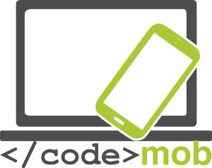

E-Facilitators Mobile
Effective use of mobile devices

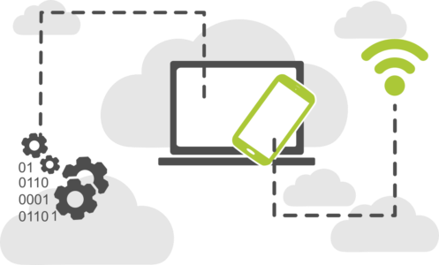

CodeMob: E-Facilitators Mobile. Effective use of mobile devices.
October 2017. http://codemob.eu/. Authors:

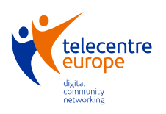

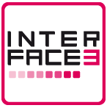

This publication has been co-funded by the European Commission’s Ersamus+ Programme.
The European Commission support for the production of this publication does not constitute an endorsement of the contents which reflects the views only of the authors, and the Commission cannot be held responsible for any use which may be made of the information contained therein.
Index

A. Contextualisation and introduction 5

Introduction to the course 11

B. Methodologies 12
1. Gamification 12
2. Problem based learning - PBL 14
3. Flipped Classroom 17
4. Project Based Learning (PBL) 20

C. Working on competences 24
Introduction 24

1. Information and data literacy: 28
Description of the competence area: 28
Valuable competences in this area: 28
Indicators 28
Methodological suggestions 28
Processes to follow 29
Possible activities 29

2. Communication: 31
Description of the competence area: 31
Valuable competences in this area: 31
Indicators 31
Methodological suggestions 32
Possible activities 33

3. Content-creation: 35
Description of the competence area: 35
Valuable competences in this area: 35
Indicators 35
Methodological suggestions 36
Possible activities 36

4. Safety: 38
Description of the competence area: 38
Valuable competences in this area: 38
Methodological suggestions 38
Possible activities 39

5. Problem - solving: 41
Valuable competences in this area: 41
Methodological suggestions 41
Possible activities 42

A. Contextualisation and introduction
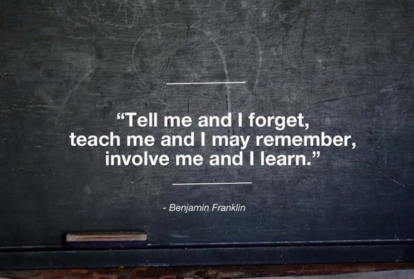

Technologies have changed, and our way of seeing the world and interacting with it has changed too. The presence of new mobile devices has changed the way we interact among ourselves, but also the way we work, study, get informed, etc.

Some of the main contributions of these technologies to the educative and professional worlds are:
- Mobility.
- An immediate access to information.
- Possibility of interacting and communicating in real time through technologies.
- The chance of teleworking, studying and, in general, accessing the productivity resources related to technologies at any time.
- The birth of a wide range of applications that allow us to access, in a very simple and practical way, the new services of the information society.
- The fast evolution of digital products and services, very innovative and more advanced every day, closely related to new services for the citizens, firms and educative centres.

Personalising the learning process
We are experiencing a new educational revolution that shakes the areas of teaching and learning with the need (and also the opportunity) to personalise learning to allow participants (who are more proactive than ever) to:

- express their own singularity
- generate new contents
- interrelate in a different and more immediate way
- find individual answers to their particular needs
- learn autonomously
- personalise their learning pace.

Social constructivism
Nowadays, we are experiencing a revolution in the theories regarding how people learn. This teaching proposal builds on a social constructivist approach of learning:

- It is based on the participants knowledge and their relation with their reality and their own educational environment.
- The students construct their own knowledge relating it to their prior experiences and education and this learning process is linked to the context where it is developed.
- Through these interrelations and new experiences, the students acquire new and specific understanding, and use their knowledge and experience in a flexible way.
- We delve into the situated learning, the cognitive flexibility, the immediate application.
- Learning by doing: the students learn better than developing tasks.
- Learning is an accumulative process and the result is a personal interpretation of the world.

As we will notice in this course, mobile technologies help us to tackle different knowledge and competence areas in an even more effective way:

- Communication
- Citizenship
- Creativity
- Culture
- Work and job opportunities
- Studies and studying opportunities
- Finance management
- Health and personal habits
- Management and planning
- Productivity

With a mobile device we can certainly work and perform a lot of tasks quite similarly as we do with a personal computer, and, within certain areas, they provide more agility and application sense to the process of acquiring or improving competences

Specific characteristics of the mobile learning:

- Learning could follow several methods:
  - formal (structured, scheduled and subject to certain objectives and to an academic plan),
  - non-formal (in non-formal educational institutions)
  - informal, that is, without a preset guideline (for example, spontaneously reading the newspaper, the blog of an specialist in a particular subject, RSS feeds, etc.
  - With smartphones, you can even create 360º spontaneous experiences (for example, opening a social network and finding content useful to learn something; or watching a YouTube video that addresses to other videos with educational content...) in different contexts (for example, on the bus or while waiting in the supermarket line).
Therefore, we can say that mobile devices boost micro-learning (through small units) and also invisible learning, since it takes place without express conscience and joins the person prior structures (that is, the individual automatically integrates the new knowledge to the previously acquired knowledge and experience).
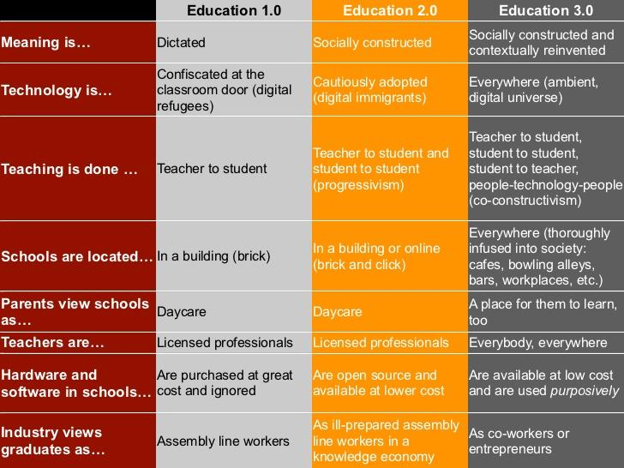
Image: Cristobal Cobo (source www.aprendizajeinvisible.com/en/)

- Learning is liquid and flexible. The 24/7 availability of the mobile devices connected to the Internet allows a continuous learning. In a world in a quick and constant mutation, where the ways and the opportunities to work steadily evolve, it makes no sense to restrict learning opportunities to a certain space and time, or even to preset and fixed contents or immovable goals. Participants have boundless opportunities to acquire new knowledge, abilities, skills and attitudes. From a liquid-learning perspective, the process adapts to the possibilities (pace, capacity, prior experience) of each person and also to the opportunities in life.
- A Personal Learning Environment is promoted, that is, a learning system based on three elements:
  - Tools: Use of different tools and applications helping us to be productive, manage, etc.
  - Resources and information sources.
Accessing to a huge amount of information from a mobile device is easy. Obviously, the difficult part is selecting the sources, but the PLN (see below) will help us to do this selection. Dictionaries, encyclopaedias, web pages of different firms, governments, universities, educational institutions, media, etc.
We must also emphasise the existence of a wide range of resources for self-learning or autonomous-learning. Virtual campus with open resources, MOOCs (Massive Online Open Course), open repositories (like the Spanish YouTube channel dedicated to education <https://www.youtube.com/educacion>)… A whole world accessible from our mobile device with which we can interact.
In general, we can say that, thanks to mobile technologies, we can enjoy a kind of learning that is disseminated, unstacked and globalized (distributed in space and time in a chaotic way, since it can happen at any time, anywhere and in any way).

  - Personal Learning Network: a group of people with whom we can interact in a direct way (chatting with them through social networks, for example) or in an indirect way through objects (for example, through a blog, a YouTube channel, etc.).
The construction of a PLE is personal and individual, and it takes time. Thanks to new technologies, it is achieved in a more continuous and progressive way. The student does no longer depend on the presence of a teacher, since the PLE acts as a continuous reference system.

- Lifelong Learning: just like technologies ―in a constant process of evolution and change―, chances to learn using mobility never end. Mobile devices facilitate a lifelong learning.
- The “Edupunk” concept is growing stronger, relating the teaching-learning world with a DIY (Do It Yourself) approach.

Mobile technologies modify teaching and training processes.
- Roles of the main agents involved change: students and teachers can change their classical roles due to the huge amount of online content. “Learners” generate content and become information sources for others who, why not, can also be their trainers or teachers.
- As we have noted before, the concepts of space and time lose their meaning.
- New learning is added thanks to the existence of new ways of communicating. Multimedia, virtual or simulated reality, 3D video or image production, etc. become more relevant and present, stimulating different channels (auditory, visual, sensorial…) in different ways.
- There is a new map of relevant competences in the professional world (related to social skills, soft skills –ability to communicate, manage the time correctly, be creative, be innovative…) and they are easier to train and develop thanks to mobile technologies, just like the job reality in firms.
- Relationships between people belonging to the same educative community are different and, beyond this point, new agents are added to this community (even people who are geographically far away). The network of contacts is widened and, therefore, so is the radius of influence and interrelation. Mobile technology makes easier the learning among equals (peer to peer).
- Synchrony stops being necessary for learning. Communication and interaction between people who teach and people who learn (we have already mentioned that roles can be inverted quite often) can happen in a non-synchronic way retaining a high importance.
- The key is not what is learnt, but how it is learnt, the way it is done.
- The evaluation of learning done with and thanks to mobile devices is difficult and it has to be done from competences, that is, from knowledge, skills, abilities, attitudes, etc. It is undoubtedly challenging.

Introduction to the course
CODEMOB e-Facilitators: “Mobile, effective use of mobile devices”

Our aim in this course is to approach the world of mobile learning (originated thanks to the use of smart mobile devices) through the exploration of certain open and collaborative methodologies on one side and the analysis and implementation of the Common Framework for Digital Competence, also known as DigComp, on the other, in order to improve the digital competence of the citizens.

In this document, we will explore the following methodologies that we will present in a concise format to facilitate its use:

- Gamification (incorporation of game elements to teaching-learning processes)
- Problem Based Learning
- Flipped Classroom
- Project Based Learning, very similar to the Problem Based Learning, but with a different starting point.

And the following competence areas of the DigComp that we will break down in an appropriate way:

1. Information and data literacy
2. Communication and collaboration
3. Digital content creation
4. Safety
5. Problem solving

The training action, addressed to e-facilitators and digital teachers will have a very practical approach (the methodologies applied are the same that the ones explained). Along this action, students will become protagonists (at the centre of the formative space), creators of educative material and designers of teaching-learning dynamics. From this moment, thank you all for your future contributions to this experience.

B. Methodologies

1. Gamification

Within the scope of formation and learning, gamification involves the application of game mechanisms (traditional or not) to the process of formation/learning in order to promote motivation, effort and engagement towards the process.

This is about something else than using games to learn (which can also be done).

Playing has always been present in human nature and, since a tender age, it is our companion. Broadly, we can say that "playing" is a pleasure, a satisfactory activity linked to the completion of an effort, to the achievement of a goal. The application of gamification to learning comes from this idea. The aim is to influence the students, so as to generate the acquisition of certain skills that, otherwise, would be more complicated to achieve, especially all those related to the habits and customs, but also to attitudes and the need to cover certain objectives.

Through the game, we can:

- Transform people’s habits, customs and attitudes regarding their learning processes: encourage initiative and autonomy, empowerment, decisions taking, risk taking, effort, determination… In brief, their activity related to the life-long learning process.

- Promote the acceptation of chance, the resilience through difficult situations, the resistance to frustration, the assessment of error as a means of learning, etc.

- Boost experimentation, exploration of the environment and the repetition of certain behaviors or activities.

- Assess and self-assess the result of the effort.
According to the authors of Gamificación.com the application of gamification strategies benefits certain sectors. Some examples can be:

- In art, it can help to attract and involve the audience.
- In trade, gamification promotes loyalty among customers and social purchase. Consumers can also easily take part of promotions through QR codes, SMS and the obtainment of rewards.
- In education, the typical persistence, initiative and attention to details found in players stimulate the act of learning.
- In business, gamification increases loyalty and motivation among workers, partners and clients.
- In the environmental arena, or in fields such as health and sport, competition and recognition of success can promote the creation of healthy and sustainable life-habits.

In general terms, we can say that the power of the game, or the introduction of some of its elements, can be used to promote very positive social and cultural changes, reinforcing the desired habits and attitudes. This is a key issue in the field of education and life-long learning. However, the resulting process should not be neither too difficult nor the opposite, since it wouldn't be a real challenge: the wish plus the effort should grant a satisfactory result.

In order to "gamify" a learning process, we can add certain elements as an "added layer" on a default teaching sequence, or create a completely new sequence. The key issue is to make the learning process more interesting, attractive and also dynamic.

We can keep in mind certain elements that are crucial to the game process:

- Dynamics of the game: elements promoting a certain behaviour during the learning activity, responding to human needs linked to the timeless and universal wishes of social recognition, reward, expression, altruism, etc.

- Elements of the mechanics: tools, techniques and programs that contribute to the achievement of goals in a clear and accurate way, and strengthen motivation.

Game dynamics:

- Competition: comparing to other individuals, within a peer group or even in a hierarchical structure. Using rankings, listing grids, a top-ten or any other mechanism to help to show the result of the competition can provide motivation to participate.
- Reward: based on the chance of taking a -personal or group- profit in exchange for performing a certain action. The reward has to be "desired" by the participants and, therefore, significant.
- Status: focused on the achievement of a certain position, prestige or standing within a certain group of people. The public domain of the achieved status is essential.
- Achievement: to attain a certain challenge, get over a certain difficulty or a set of milestones or "missions". Goals must be well defined all the game long and their achievement should be celebrated or publicly expressed.
- Expression and self-expression: creation and display of the own identity as an expression of self-individuality, distinguishing personality, autonomy and originality compared to other individuals belonging to a particular group. It is the expression of the being (either in the real world or in a fantasy world).
Game mechanics:
These are instruments that help us to boost the game dynamics to create the feeling of playing.

- Levels: the introduction of a system of levels or stages, challenges to be achieved before we can consider previous stages well resolved. These are quantitative elements, but they result in the achievement of a specific status (better than the previous one).
- Points: quantitative recognition of the actions performed in a proper way. Points are collected and the sum can lead the "player" or student to achieve the different levels.
- Rankings: they help us to show the position of a player (student) or a group of players (team) compared to the others. They promote the game dynamic of competition.
- Awards, medals or badges: the tangible or digital credential for the achieved goals. Their main characteristic is their public nature.
- Goods or virtual items: they help us to represent the achieved success or status. Also gifts that can be interesting to the participant eyes.
- Challenges: competitions with participants, opponents or the game system itself.
- Missions or milestones: challenges, situations prompting to action, that the participants must accomplish. They should be attractive by nature and/or in relation to the other participants.

2. Problem based learning - PBL

Learning based on problem solving is a methodological strategy that allows the teacher and the student to settle a milestone in the learning process, where the student is the principal actor.

It is aimed to the acquisition of competences, which can be divided in the development of:

- Knowledge: within the competences context, we define knowledge as for the mastery of a subject related to the --habit or long-term-- memory, so that the knowledge is ready to be used in a particular context to face a given situation.
- Abilities and skills: a person can be born with an ability or a natural predisposition (for example, dancing) that eases the performance of a particular set of actions; however, this ability can be developed and improved, or not. We speak of skills when, thanks to a certain training or practice during a relatively long period and in different contexts, we develop and optimize our natural abilities.
- Attitudes: Although there are many definitions of attitudes, here we will consider them as the manifestations of the --innate or learned-- behaviours of the individuals given certain situations, objects, ideas, persons, etc. They are emotional and mental responses to life circumstances.

During problem based learning dynamics, the teacher lays out a question or a problem and the students have to give an answer or find the way to solve it through a process implying:

- the analysis of the problem
- the search for the necessary information to be able to comprehend the problem and gather the resources needed
- the understanding of the information
- the integration of this information to the own experience and the previous knowledge, and
- the application of a certain amount of knowledge and wisdom to solve the problem.

The problem should be significant and relevant to the student (as a personal matter or regarding the interests of a social group to which the student belongs).

On their way to the resolution, the students will identify, independently but with the help of the teacher, what they need to learn to be successful in the learning process.

In order to find the answer or solution, they will follow a circuit already predetermined.

- Presentation of the problem to be solved. It should be defined with a possible solution and fragmented in different parts.
- Analysis of the previous knowledge (of the group or the individual) that will help to solve the problem (what the student knows).
- Identification of the knowledge and the resources needed to develop a solution (what is unknown, which are the questions or mysteries to be solved).
- List of actions or activities that should be accomplished to find a solution.
  - What should be done? (In relation to the problem statement)
  - Why should that be done?
  - Where should that be done? What is it necessary to do it?
- Preparation of the work plan: planning the sequence of actions to be done. How to do it? Distribution of tasks among the participants.
- Definition of the action plan: searching for the necessary information, carrying out actions, communication of the partial results and also half-way questions among students and also to the teachers.
- Elaboration of the answer and argumentation about the method used to find it. At this point, students, after the previous work phase, must exert themselves to communicate not only the obtained result but also the process followed to reach it.

Through this process, students:
- Learn to make decisions, individually or negotiating (with the group)
- Interact with peers and also with teachers
- Use the information of their close context
- Search for the information they need
- Produce and share ideas
- Discuss other possible solutions and also the mechanisms to find them.

Nature of the problems to be dealt with:
- They must be in accordance with the abilities of the students
- They must be significant to the students
- They can come from real or simulated (but potentially real) situations.
- The problem must be posed on a possible or real scenario.

Ways to pose the problem to the students:
- After reading a text
- After watching a short video or multimedia presentation
- Reading a newspaper article.

Ways to present the solution to the teachers:
- With an oral presentation
- With a dossier or document, which may include infographics, mental or conceptual maps, etc.
- Through the elaboration of a digital product, such as a digital presentation, a video, a podcast, etc.

3. Flipped Classroom

The flipped classroom model, with mobile technology, consists of shifting the session the other way around, so that we use the available digital resources and tools to provide the students with an advance of the necessary contents --on a given subject--, which they will review by their own before attending the class.

Once they are in the classroom, they can make the most of the teacher presence, and also of the other classmates, by presenting their doubts and they will better invest the time working with the questions that they were not able to solve on their own before.

In brief, "The Flipped Classroom (FC) is a pedagogical model that moves the work of certain learning processes outside of the classroom and invests the class session time, along with the teacher experience, to promote and boost other processes of acquisition and knowledge practice inside the classroom."

Flip teaching (or flipped classroom) is a form of teaching-learning system in which students learn new content online by watching video lectures, usually at home, and what used to be homework (assigned problems) is now done in class with teacher offering more personalized guidance and interaction with students, instead of lecturing. This is also known as backwards classroom, reverse instruction, flipping the classroom and reverse teaching.

Salman Khan TED 2011 ''Reinventar la educación'' https://www.youtube.com/watch?v=gM95HHI4gLk

Referring to Bloom's taxonomy, previously presented, we can make a comparison between the tasks performed by the students at home --according to the traditional learning model-- and the activities that they can develop in the flipped classroom model:

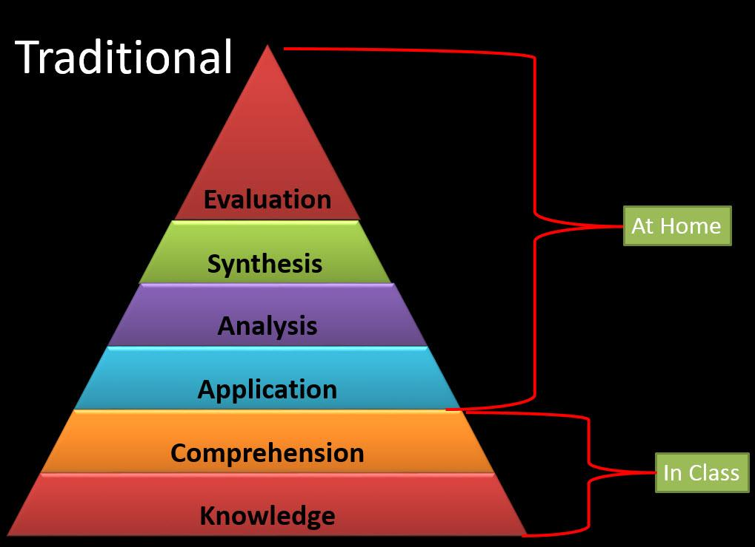
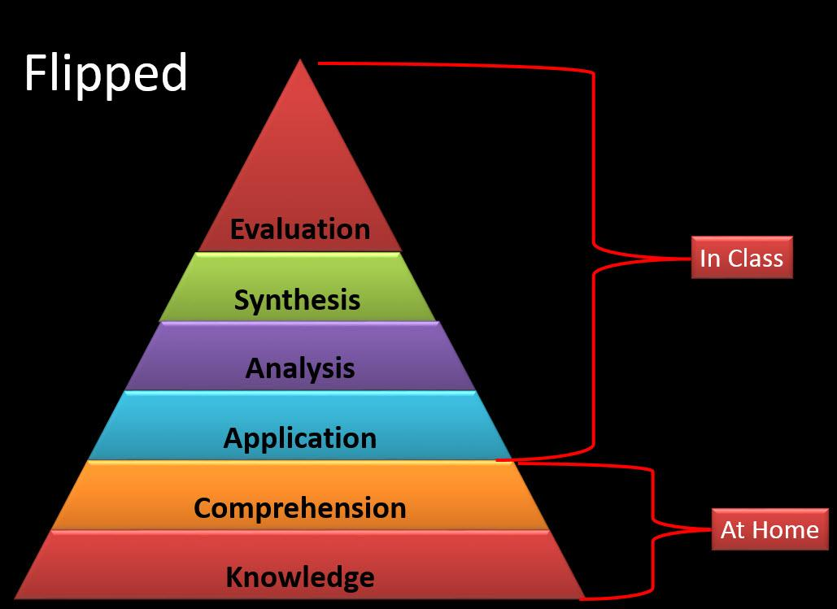
Source for the images: http://uaflipped.com/blooms-taxonomy/

As can be noted, the flipped classroom model draws the development of the mental activities in the lower levels to the individual out-of-the-classroom space and the higher forms of thinking to the classroom space.

Notably, this model embraces the whole sequence described in the Bloom's taxonomy, and thus we can find all kinds of activities:

At home:
- Knowledge-related: such as comprehensive reading, filling-in questionnaires, searching words in a glossary or creating it, etc.
- Understanding-related: creating a infographic summing up the acquired contents, publishing a summary of the content in a blog or summarizing the content in a digital presentation.
In the classroom:
- Application-related: outlining an interview to an expert, creating a possible virtual scenario or creating a timeline with the sequence of an action or a project.
- Analysis-related: drawing a conceptual map, creating a comparative chart.
- Assessment-related: discussing in an organized way through a chat tool or a debate online tool, implementing real or simulated tests or experiments, etc.
- Creation-related: writing the script for a video or a podcast or an e-book.

This model:

- promotes the dedication of the teacher's attention to the students' difficulties, including attention to diversity.
- provides an opportunity to share information and knowledge within the whole educational ecosystem, since students have the chance to interact with their environment in all the stages of the process (which is a constructivist approach: family, teachers, other students) to ask questions and solve problems.
- encourages the autonomy of the students when it comes to consulting educational contents and repeating the consultation as often as necessary (for example, reviewing videos or rereading documents…), and even check other sources found by themselves.
- creates a collaborative learning environment in the classroom (peers support is essential to the success of the proposal).

Flipped Classroom Tools and Resources: https://edshelf.com/shelf/jakeduncan-tools-to-flip-your-classroom/

ANDROID APPS TO SUPPORT BLOOM'S REVISED TAXONOMY assembled by Kathy Schrock: http://www.schrockguide.net/bloomin-apps.html

Other resources applied to education: http://www.android4schools.com/archives/

4. Project Based Learning (PBL)

It is a methodology that places the student at the center of the learning process, as a starring person capable of generating solutions in response to the different opportunities and challenges posed by the society.

It is certainly a methodology closely related to the working environment, and also the entrepreneurship. It specially stands out for urging students to put into practice a wide range of knowledge, abilities, skills and attitudes. That is, an important set of competences, digital ones among them.

We can find different approaches to the Project Based Learning methodology and some of them make it close to the Problem Based Learning. However, in this context, our approach won't be specially focused on problems but on opportunities. When it comes to project based learning, we need to get a (material or intellectual) product. Therefore, cooperation and collaboration among students to achieve this goal are a must.

Observe the following chart comparing both methodologies:

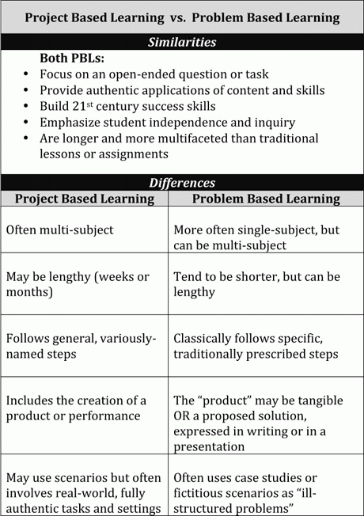
Image Credit: John Larmer

From this point of view, project based learning promotes initiative, proactivity, independence and innovation in different areas: professional, social and personal.

The challenge (that is, the project to be fulfilled) acts like a motor to the motivation and determination to achieve the goal. Moreover, this kind of methodology promotes the group development of assignments.

Within the framework of the present proposal, related to the use of mobile technologies, we have the opportunity to link the Project Based Learning methodology to an entrepreneurship approach, not only from the economic (business) point of view but also from a social perspective.

Therefore, we can make working proposals to the students and, working on them, they may acquire and improve the key competences defined by the teaching team with a real impact on their social context. This can be defined not only through the detection of problems but through the detection of opportunities.

Here we present a set of stages to be accomplished. Though the sequential order might be modified, this is our recommendation:

- Detection of the opportunity to work on. The starting point can be the real social context of the student or the groups of students. We must keep in mind that we want them to work a set of key competences. Considering both factors, we can select a working area where the students themselves choose an opportunity in order to develop an effective solution to a real need. Therefore, the students can find the starting point by themselves.

- Organization of the work teams, including different profiles that may also be complementary.

- Final definition of the challenge, the solution to be achieved. This is certainly the most difficult step. It can be drawn from a brainstorm, where the students propose solutions that might be feasible with the team effort. It is important to remark that a certain amount of realism is needed: the resources and the knowledge to be acquired must be achievable by a group with teachers support.

- Preparation of the plan. The work plan, as well as in the Problem Based Learning methodology, is essential, since it contains the details about the planned tasks, who should develop them and the scheduled calendar. Consider also the necessary competences to perform the task.

- Training and information research. It is essential to acquire certain knowledge, master the tools, develop certain skills, get information, etc. Through this stage, the teacher must work as a guide and companion, ensuring that the group of students considers all the needs and steps to be followed.

- Analysis and synthesis. The students share their work by exchanging ideas, discussing solutions, doing suggestions, etc. During this process, they work together to build a solution in response to the identified opportunity in the given context. They also check that they correctly identified all the stages to be followed and that they are implementing the work plan.

- Elaboration of the product by applying everything they have learnt.

- Presentation of the product or project. At this stage, the group of students verifies the solution provided. They can even carry out opinion polls, market surveys, etc. This stage can bring out new necessary actions in order to improve the product.

- Implementation of improvements, if necessary.

- Assessment and self-assessment. It is important to check the final result through an objective assessment embracing not only the achieved milestone, but also the process followed. Self-assessment is an option, though we have also the opportunity to carry out a co-assessment among peers.
Thanks to this process:

- The students generate a product, an idea, a solution, with a value beyond the classroom environment, something that can have a positive impact in their close reality.

- Motivation increases as they feel the positive effect on their social context. Also their engagement to the task execution. Eventually, their self-esteem is also improved.

- They work on real situation that are, o can also be, part of the professional context.

C. Working on competences

Introduction
The European Commission (EC) aims at identifying the set of key competences for personal development, social inclusion, active citizenship and citizens' employability. One of this key competences is the digital competence, on which we are focusing.

The EC, through the Joing Research Centre (JRC), has been working to outline the digital competence framework, identifying 5 areas of competence development and 21 digital competences:
The aim is for everyone to have the key set of competences needed for personal development, social inclusion, active citizenship and employment.

The JRC is presently working to break down this competences in 8 levels of learning outcomes and examples of knowledge, skills and attitudes related to each competence.

This digital competence framework (also known as DigComp), was first published in 2013. As a result, we have a tool that we can use to improve the citizens' digital competence.

At the same time, DigComp should help policy-makers to create policies directed to improve competence acquisition, educational plans and teaching-learning initiatives of the different specific key groups.

According to the Joing Research Centre:

“The European Digital Competence Framework for Citizens, also known as DigComp, offers a tool to improve citizens’ digital competence. DigComp has become a reference for many digital competence initiatives at both European and Member State levels”

Eventually, the JRC's work serves as a reference shared with the rest of Europe, since it provides a common language that we can use to identify and describe the key areas of the digital competence.

Regarding the development of the curriculum for teachers and e-facilitators, we take “DigComp 2.0: The Digital Competence Framework for Citizens” as a framework, always having in mind the presently published document and that:

It constitutes phase 1 of the update of the framework which focuses on the conceptual reference model, new vocabulary and streamlined descriptors. (...) Also gives examples of how DigComp is used at the European, national and regional levels.”

The DigComp Conceptual reference model
Competence areas  Dimension 1 | Competences  Dimension 2
1. Information and data literacy | 1.1 Browsing, searching and filtering data, information and digital content  1.2 Evaluating data, information and digital content  1.3 Managing data, information and digital content
2. Communication and collaboration | 2.1 Interacting through digital technologies  2.2 Sharing through digital technologies  2.3 Engaging in citizenship through digital technologies  2.4 Collaborating through digital technologies  2.5 Netiquette  2.6 Managing digital identity
3. Digital content creation | 3.1 Developing digital content  3.2 Integrating and re-elaborating digital content  3.3 Copyright and licences  3. 4 Programming
4. Safety | 4.1 Protecting devices  4.2 Protecting personal data and privacy  4.3 Protecting health and well-being  4.4 Protecting the environment
5. Problem solving | 5.1 Solving technical problems  5.2 Identifying needs and technological responses  5.3 Creatively using digital technologies  5.4 Identifying digital competence gaps

The acquisition of the digital competence through mobile devices

This train-the-trainer course is aimed to the students' (end users) acquisition and training of the digital competences defined in the DigComp, but from a mobile device approach, so that they can take advantage of this kind of technology to learn in the most effective way.

Both the 5 competence areas and the 21 digital competences will be considered in relation to the goals to be achieved in our curriculum in order to promote their progressive development.

Digital competence and employability

While we are focusing our efforts on the digital competence, we have in mind an orientation to the people employability promotion that urges us to stress two particular aspects:

- Competences related to problem resolution, and within this area, competence indicators related to job search and job application.
- All the competences related to the ability of learning to learn, which we will be working in a transversal way in this curriculum.

Our work will be therefore focused on practices or simulations within the frame of a professional-oriented social context in the interest of the employability of the young end user.

New technologies, new methodologies

The arrival of new technological resources, of new applications and programs, opens a whole new range of opportunities for learning. The mobile world opens the door to a whole universe of possibilities that we are going to explore together. However, we cannot omit the need, and also the opportunity, to include a new educational model drawn on the application of new open and collaborative technologies, reflection of the changes that also are taking place in the job market.

We started this document presenting some of these open and collaborative methodologies that can be even easier to implement thanks to the mobile devices. These methodologies should help us to achieve the objectives of apprehending competences while learning about the context, the content and the use of the mobile and its applications.

In the following pages of this document, we will focus on the presentation of each competence area, the competences included and the set of associated indicators, according to the DigComp study.

Next, we will identify possible processes and methodologies to be followed (methodological suggestions) in order to delve into the acquisition or the improvement of the competences. We will propose some of the activities that we can create to encourage learning and, to illustrate this, we will suggest some resources and mobile applications suitable for different occasions.

This work is not attempting to be exhaustive, but a way of stimulating the creativity of the trainer in charge of future training actions.

1. Information and data literacy:

Description of the competence area:
Identify, locate, retrieve, store, organise and analyse digital information, judging its relevance and purpose.

Valuable competences in this area:

1.1 Browsing, searching and filtering data, information and digital content

To articulate information needs, to search for data, information and content in digital environments, to access them and to navigate between them. To create and update personal search strategies.

1.2 Evaluating data, information and digital content

To analyse, compare and critically evaluate the credibility and reliability of sources of data, information and digital content. To analyse, interpret and critically evaluate the data, information and digital content.

1.3 Managing data, information and digital content

To organise, store and retrieve data, information and content in digital environments. To organise and process them in a structured environment.

Indicators
% individuals who have used the internet in the last three months for:
- finding information about goods and services (1.1),
- reading or downloading online news/newspapers/news magazines (1.1),
- obtaining information from websites of public authorities and public services (1.1),
- Seeking health information (1.1),
% individuals who have:
- copied or moved a file or folder (1.3),

Methodological suggestions
We can find a wide range of strategies in this competence area, all of them related to the search, management and evaluation of digital information.

Some suggestions for working with the students:
- work with subjects that the student can find interesting and motivating both as an individual and as a member of a social group. We must keep in mind the sociocultural perspective of the students and aim for what can be relevant in their ecosystem.
- relate practical exercises to relevant subjects in the frame of their learning process: searching, managing and evaluating the quality of information related or connected to their school curriculum or their professional development can be very interesting.
- the existence of a vast amount of information sources on the Internet does not guarantee that the students know how to work with them and how to evaluate their quality. Guidance and help from the teacher will be essential to achieve good results.

Processes to follow
There are many activities that can be developed to strengthen these competencies and it is probably impossible to work on each of them separately. This is a scenario that we will find very often when developing competencies of any kind.

- Web navigation (Mobile browsers offer a typical web navigation).
- Practicing the usage of the browsers’ bookmarks.
- Using syndication tools to save relevant sites.
- Selecting and compiling information and references, as well as multimedia materials from the web in order to generate and elaborate new contents from these materials. Content curation.
- File system to store information. Mobile phones offer different operative systems to store and manage their file system in a specific way.
- There are several alternatives to the file system offered by the operative systems: the cloud systems. Several applications on the cloud allow us to store and manage our documents and files (Drive, Dropbox, iCloud…).
- Knowledge and advanced use of search engines and metasearch engines (Google).
- We can browse through information that has been filtered and segmented previously by navigation tools (applications such as Scoopit that find filtered information).

Possible activities
Clue games, proposing games and dynamics that can only be solved by searching information with the help of clues or facilitations given by the facilitator or the teacher. The QR code system can be used in this activity to reveal the successive clues as participants get to certain points.

Online contests (A quiz on twitter) demand research but also communication, data and license protection, netiquette, adaptation to the medium and other skills. For this reason, it can be applied to this specific area and to other areas in this curriculum. The idea is to ask questions (with a specific hashtag that all participants have to follow) urging the students to do online research, elaborate an answer, link the found result, mention the source, etc… always answering the question. The fastest student gets the highest score if the answer is right. Students get penalty points in case of inappropriate behaviours in the medium or bad netiquette. If students work in pairs, an extra work of consensus and agreement will be added to the game dynamics.

Webquest, “is a didactic proposal of guided search that uses mainly Internet resources. It takes into account the development of basic skills, contemplates cooperative work and individual responsibility, prioritizes the building of knowledge through the transformation of information in the creation of a product, and it also contains a straight evaluation of the process and the results.” Definition agreed on the Segones Jornades de Webquest (2006).

Resources and mobile apps
Operative systems for each device: iOS, Android, Windows.
Browsers: Chrome, Safari, Firefox.
Search engines: Google.
Storage systems on the cloud: Drive, Dropbox, iCloud.
Content syndicators: Feedly.
Content curation: Scoopit, Storify.
QR code reader
Social networks as a source of information: Twitter, Facebook

2. Communication:

Description of the competence area:

Communicate in digital environments, share resources through online tools, link with others and collaborate through digital tools, interact with and participate in communities and networks, cross-cultural awareness.

Valuable competences in this area:

2.1 Interacting through digital technologies
To interact through a variety of digital technologies and to understand appropriate digital communication means for a given context.

2.2 Sharing through digital technologies
To share data, information and digital content with others through appropriate digital technologies. To act as an intermediary, to know about referencing and attribution practices.

2.3 Engaging in citizenship through digital technologies
To participate in society through the use of public and private digital services. To seek opportunities for self-empowerment and for participatory citizenship through appropriate digital technologies.

2.4 Collaborating through digital technologies
To use digital tools and technologies for collaborative processes, and for co-construction and co-creation of resources and knowledge.

2.5 Netiquette
To be aware of behavioural norms and know-how while using digital technologies and interacting in digital environments. To adapt communication strategies to the specific audience and to be aware of cultural and generational diversity in digital environments.

2.6 Managing digital identity
To create and manage one or multiple digital identities, to be able to protect one's own reputation, to deal with the data that one produces through several digital tools, environments and services.

Indicators
% individuals who have used the internet in the last three months for:
- sending/receiving emails (2.1),
- telephoning over the internet/video calls (via webcam) over the internet (2.1),
- participating in social networks (2.1, 2.3),
- posting messages to chat sites (2.1, 2.3),
- uploading self-created content to any website to be shared (2.2),

Methodological suggestions
- Working with a centre of interest important to the participants can be a good strategy: video games, fashion tendencies, sports or the daily live in the telecentre can be good examples.
- Communicating about a certain subject of public interest “opening the classroom walls” and aim at interacting with the exterior will promote the continuity of the work and will make it more interesting.
- Promoting work with a positive impact on the territory or a social area close to the participants will pique their interest: fighting for the rights of a specific collective, communicating in a positive way about subjects or social vindications of the young ones, make the young people become the centre of the communication…
- Making the work into a challenge, setting objectives and working to achieve them will grant a real and palpable benefit in tasks with this competence.

Processes to follow
Communication is a very rich and interesting area when it comes to the digital context. It also a great promoter for the rest of the areas, because communication is the tool we use to develop relationships between individuals, and it allows us to both create and co-create content. Once more, we face a great number of possible processes that will help us to develop the competences of this area. The most notable ones are:

- Communicating through the digital media (instant messaging systems like Whatsapp or telegram)
- Appropriate adaptation to the context and the medium where communication takes place. (Competence it contributes to: 2.1) Note that it can take place in public spaces (social networks, for example) and in private spaces (chats or Whatsapp).
- Active use of the different possible ways of communication and interrelation by adding references to others to our own discourse: Sharing, referencing, attributing (2.2):
  - file sending
  - sharing 2.0 – social networks, blogs...
  - mentioning sources or authors of publications (RT)
- Participating in digital networks and services that allow the community to participate, participative tools offered by state organisms. Governments and/or political parties are increasingly offering the population tools and devices aimed at democratizing decisions and promoting individual participation in politics and decisions. (2.3)
- Direct interaction with organisms and managers through networks and established mechanisms. (2.3).
- Attracting attention, feeling capable of expressing oneself on the Internet. The best method to reinforce this skill is practicing in the medium until a feeling of comfort and knowledge develops.
- Co-creation and co-construction, collaborative creation of information and contents. Use of collaborative and remote work: Priatepad, drive, shared conceptual maps, collaborative blogs that allow a shared creation (2.4).
- Contributing to content creation through the use of hashtags to gather information on a common subject or concept. These hashtags will also help us to generate shared, thematic and assembled opinion (2.4).
- Adaptation to the communication medium. Being polite to facilitate communication among the different participants. To be successful in this point, we must know the proper manners on the context where we are expressing ourselves. It is necessary to check the use conditions and the netiquette, but we must also observe the proper use of the site where we are going to publish our impressions (2.5).
- Participating regularly to promote the good use habit (2.5).
- Reputation, conservation of the individual identity or the corporative identity. Keeping and promoting the good practices that improve the image we offer online of ourselves and of the organizations or corporations we belong to and their favourable environments (2.6).

Possible activities
As we have mentioned previously in the section devoted to processes, communication is constant in the digital medium. Therefore, any activity done online allows us to develop this competence in a certain way. Below, we offer some possible activities as an inspiration for teachers that could help them to explicitly work with it.

Creating user accounts on different social networks and sharing information in an adequate way.

I analyze and I learn (team work): Each group chooses a network and describes the characteristics that define communication in that space. How to develop them in the best way through the mobile phone.

Creating a Whatsapp group for communication among students in order to work on the adequacy of the tool while using it.

Creation of a log book (or project). Generation of a space that allow us to communicate in different formats the daily advance of a project or a workshop. This can be done through a cooperative blog where a different author writes every post. This posts can contain text, photos or videos, and they must help to explain the work in progress.

Generation Youtuber. Creation of a YouTube channel to share videos recorded by small groups. Authors of content and music must be referenced. Spread the videos or the channel around the Internet to get more views.

Speak to your government. Several governments, like the European, try to bring the citizens closer to their representatives by offering inquiry forms or open communication channels. We can also communicate with them through their twitter public profiles (for example). Promoting an activity of participation with questions to one of these authorities will allow us to show the participants this closeness.

Create your communication plan. If we have an advanced group, we can ask them to conceive a communication strategy: analysis, objectives, definition and characteristics of the target audience, strategy, actions, evaluation, consideration and adaptation for a new period.

Quizzes and adequacy of the answers and their references (see possible activities of area 1).

Resources and mobile apps
Communication between individuals or groups: Whatsapp, telegram, imessage, messenger (facebook)
Public or open communication: Social networks, Twitter, Facebook, Instagram, blogs (wordpress).
Generation of communicative multimedia contents: youtube, periscope, snapchat…
Shared content editors: piratepad, drive, mindmaps…
Video editors: youtube, magisto, ...
Photo editors: canva, snapseed, camera+
Photo sharing: google fotos, flikr, Instagram.
Video sharing: youtube, vine, periscope (streaming), Facebook Streaming.

3. Content-creation:

Description of the competence area:

Create and edit new content (from word processing to images and video); integrate and re-elaborate previous knowledge and content; produce creative expressions, media outputs and programming; deal with and apply intellectual property rights and licences.

Valuable competences in this area:

3.1 Developing digital content

To create and edit digital content in different formats, to express oneself through digital means.

3.2 Integrating and re-elaborating digital content

To modify, refine, improve and integrate information and content into an existing body of knowledge to create new, original and relevant content and knowledge.

3.3 Copyright and licences

To understand how copyright and licences apply to data, information and digital content.

3. 4 Programming

To plan and develop a sequence of understandable instructions for a computing system to solve a given problem or perform a specific task.

Indicators
% individuals who have used the internet in the last three months for:
- creating websites or blogs (3.1).
% individuals who have:
- created electronic presentations with presentation software (e.g. slides), including e.g. images, sound, video or charts (3.1).
- used basic arithmetic formulae to add, subtract, multiply or divide figures in a spreadsheet (3.1).
- used copy and paste tools to duplicate or move information within a document (3.2);
- written a computer programme using a specialised programming language (3.4);

Methodological suggestions
- Proposing challenges to achieve can be a good “motor” for the acquisition of this competence.
- In this area of knowledge, exploring the creative skills of participants will make some of them to get especially involved, because they will discover their personal qualities.
- Consciously connecting the work and the tasks at hand with objectives related to the employment and learning world will stimulate the right visualization of personal objectives and, at the same time, it will offer the e-facilitator or digital teacher arguments to develop professional and orientation tasks.

Processes to follow
As we have noted in the previous competence, the two of them are closely linked, since the content we can create through communication is the same we can obtain through content creation. However, we can generate content independently of how we communicate it. Some processes we suggest for content creation are:

- Promoting the ability to create content in different formats (Multimedia). Text, photo, video, infographics…
- Creating an individual or a collective blog with a multi-user function.
- Integration and reworking. Modifying, adding and redoing to improve the existing content. Editing the initial material or creating derivative works. Creation of memes or gifs.
- Using applications for graphic material edition (photo, video, audio).
- Creating multimedia lists and creating a new user experience through the selection: playlists (youtube, spotify).
- Recognition of licenses, correct mention when using materials by other authors, sharing with a respect for the author.
- In the area of programming, being capable of giving specific and sequenced instruction to do things or solving problems through technological devices (this content is a part of the course that complements the present one, so it will be excluded from this curriculum).

Possible activities
Reporters: creation of a blog including graphic materials, video, summaries of what has been done during the formative meeting.
You are the DJ today. Creation of a collaborative playlist by the participants.
The exhibition. Creation of a thematic exhibition about the close environment. It would be interesting to make an exhibition showing reality as it is but also with modifications, editions and filters. For example: How I would like my environment to be.

Photo and video workshop in the street. The mobile phone gives us the advantage of being able to go outside to create new materials. This way, we can work on an open context while promoting content creation.

A short film. Create a short film using audiovisual narrative techniques. To do so, every participant of each group should get a specific professional role: director, actors, cameramen, scriptwriters, light and sound technicians, continuity, props… From this point on, every participant will take part in the film, first planning, writing and deciding how it will be and finally recording, editing, uploading it to the Internet and sharing it. The activity will be more interesting if the the mobile device is used through the whole process.

Resources and mobile apps
Built-in cameras and text editors of the mobile device. Most of them also include edition tools.
Other applications for content edition and creation:
- Text: drive, notes, evernote, piratepad, blogs
- Photo: (All the image editing tools allow us to create them from the same app) Instagram, snapseed, camera+, photosynth, snapchat, (even facebook and twitter)
- Video: Youtube, magisto, instagram (facebook and twitter) periscope, vine, hiperlapse.
- Infographs: canva, phonto, Notegraphy
- Audio and podcast creation.
Blogs creation: Wordpress, blogger.
Creation of layers of augmented reality: Layar

4. Safety:

Description of the competence area:

Personal protection, data protection, digital identity protection, security measures, safe and sustainable use.

Valuable competences in this area:

4.1 Protecting devices
To protect devices and digital content, and to understand risks and threats in digital environments. To know about safety and security measures and to have due regard to reliability and privacy.

4.2 Protecting personal data and privacy
To protect personal data and privacy in digital environments. To understand how to use and share personally identifiable information while being able to protect oneself and others from damages. To understand that digital services use a “Privacy policy” to inform how personal data is used.

4.3 Protecting health and well-being
To be able to avoid health-risks and threats to physical and psychological well-being while using digital technologies. To be able to protect oneself and others from possible dangers in digital environments (e.g. cyber bullying). To be aware of digital technologies for social well-being and social inclusion.

4.4 Protecting the environment
To be aware of the environmental impact of digital technologies and their use.

Indicators
- use any kind of IT security software or tool (anti-virus, anti-spam, firewall etc.) in order to protect private computer and data (4.1, 4.2);
- update one or more security products at least occasionally (4.1, 4.2).

Methodological suggestions
- Developing this competence allows us to think about our personal behaviours or those of our closest friends and reaching conclusions that will help us change our attitude towards our personal protection and our safety habits.
- Reflecting on the uses of technology from a transversal perspective and elaborating lists of pros and cons related to these uses can help to build conscience about the environmental situation.

Processes to follow
Protection and safety are a constant must in every process and we have to stay vigilant at all times. Therefore, in this area, we will try to promote healthy and good habits for a safe use of the tools and devices, as well as a respect for the others and our own privacy.

- Protecting the devices and adopting measures to keep them protected. Mobile safety. Installing an antivirus program on the mobile phone.
- Protecting personal data and privacy, with regard to the digital spaces where we use and share the data, as well as for the content we are sharing, and the places where we are using them. Teaching conscience on how to manage it. Example: when we introduce personal data or we access to bank accounts from our mobile phones, do we do it from protected places and networks? Through public WiFi connections? In public spaces like the underground where someone can see us introducing our passwords?
- On the health perspective, we must educate about the risks that a constant use of mobile devices can pose to our vision and our body posture, and also the risks involved in walking on the street while we are distracted reading or playing a game.
- We must educate participants about the effects on the environment of certain components of the mobile devices and the environmental effects of certain technologies such as the wireless network.

Possible activities
Debate: How the mobile phone affects me and my environment? Proposing a debate among students to make them conscious about the subject and let them absorb the possible consequences of using a mobile phone. Assuming contrary positions after a certain time should be encouraged.

Instal party. Installation of an antivirus program on the mobile phone.

Draw your personal data map. Do you know where did you submit your data? Which are the networks where you opened an account and your information is available? Do a research online and draw a map with your digital footprint.

Mobile industry and environmental awareness. History of the mobile phone, research about its components (coltan and others) and social campaigns related to it. Research about alternative technologies, recycling of devices, etc.

Resources and mobile apps
Antivirus: Avast
Privacy sections of all social networks.
Safety sections of mobile operative systems

5. Problem - solving:
Identify digital needs and resources, make informed decisions as to which are the most appropriate digital tools according to the purpose or need, solve conceptual problems through digital means, creatively use technologies, solve technical problems, update one's own and others' competences.

Our assignment takes into account all competencies complementing this one, but it is specifically set in this area.

Valuable competences in this area:

5.1 Solving technical problems
To identify technical problems when operating devices and using digital environments, and to solve them (from trouble-shooting to solving more complex problems).

5.2 Identifying needs and technological responses
To assess needs and to identify, evaluate, select and use digital tools and possible technological responses to solve them. To adjust and customise digital environments to personal needs (e.g. accessibility).

5.3 Creatively using digital technologies
To use digital tools and technologies to create knowledge and to innovate processes and products. To engage individually and collectively in cognitive processing to understand and resolve conceptual problems and problem situations in digital environments.

5.4 Identifying digital competence gaps
To understand where one’s own digital competence needs to be improved or updated. To be able to support others with their digital competence development. To seek opportunities for self-development and to keep up-to-date with the digital evolution.

Indicators
- connected and installed new devices (5.1),
- installed a new or replaced an old operating system (5.1),
- modified or verified the configuration parameters of software applications (5.1),
- buying or ordering goods or services for private use (last 12 months) over the internet (5.2),
- selling online (5.2)
- job search or sending an application (5.2).
- doing an online course (5.2),
- Internet banking (5.2)
- Making an appointment with a practitioner via a website (5.2)

Methodological suggestions
- A very interesting approach to work with this competence is to set individual or group challenges aimed at solving real problems from the students’ environment.
- Participants can be encouraged to propose challenges that they have detected in their territory or personal environment.
- It is important to choose wisely the dimension of the challenge or the problem to be solved. It must not be impossible, but participants should also be granted enough freedom to define challenges that can be significant to them.

Processes to follow
We must keep our minds open and receptive in this area, but also a resolute attitude. The better we know the digital media, the greater our creativity and resolution skills will be, because we will have more resources and we will recognize them. For this reason, processes in this area depend on recognizing what we know and improving the weak points we detect.
- Getting to identify problems and being able to solve them in a digital context.
- Being able to think on digital or technological solutions when facing new needs.
- Including technology in creative processes and in generating new knowledge or new products. Thinking in digital tools to facilitate a creative teamwork for creation.
- Participating individually or in groups to conceptualize solutions in digital environments.
- Identifying the individual skills that we must improve in ourselves.
- Being constantly updated on digital novelties.
- Growing individually in the digital area by promoting our individual strong points and learning about those areas.
- Recognizing our own weak points.

Possible activities
Simulations: Proposing situations to solve through simulated realities like, for example, looking for a job through the mobile phone.

Comparing prices online. Analyzing different products in different web spaces. We will try to develop our critical sense comparing different applications but also the price of the products. At the same time, we will work on safety when buying online.

Procedures via Internet. Training session on online banking, making medical appointments, making appointments to request documents, etc. Knowing the different services we can use through online platforms to speed up our daily lives.

Creating an app to solve a need. Designing an application to face a detected need with the necessary programming systems. Analyzing the problem, searching a possible solution with a mobile app (digital solution), making the project, designing it, testing it, corrections, detection of imperfections and new needs.

Resources and mobile apps

In this case, we could use all the resources and knowledge learnt during our training sessions as well as other knowledge and digital experiences that helped us to solve a specific case or situation in the past. The only limits are our creativity and our imagination.

Members of the Consortium:

Foundation for Community Network | Interface3 | Teb Association | Technical University of Dortmund | Telecentar

Coordinated by:

Telecentre Europe
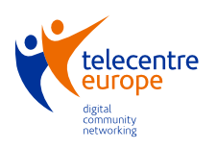

https://ec.europa.eu/jrc/en/publication/eur-scientific-and-technical-research-reports/digcomp-20-digital-competence-framework-citizens-update-phase-1-conceptual-reference-model
Adaptation from www.marinva.es
http://www.gamificacion.com/referencias
Adaptation from source: http://www.gamificacion.com/
Adaptation from source: http://www.gamificacion.com/
Adaptation from source: http://www.gamificacion.com/
Adaptation of definitions by R.Jeffress and Kimball Young
http://www.theflippedclassroom.es/what-is-innovacion-educativa/
http://www.theflippedclassroom.es/what-is-innovacion-educativa/
http://www.theflippedclassroom.es
Source: http://www.edutopia.org/blog/pbl-vs-pbl-vs-xbl-john-larmer
https://ec.europa.eu/jrc/
https://ec.europa.eu/jrc/en/publication/eur-scientific-and-technical-research-reports/digcomp-20-digital-competence-framework-citizens-update-phase-1-conceptual-reference-model
https://ec.europa.eu/jrc/en/digcomp/digital-competence-framework
VUORIKARI Riina, PUNIE Yves, CARRETERO GOMEZ Stephanie, VAN DEN BRANDE Godelieve: DigComp 2.0: The Digital Competence Framework for Citizens. European Comission (2016). ISBN 978-92-79-58876-1. ISSN 1831-9424. Avalaible at https://ec.europa.eu/jrc/en/publication/eur-scientific-and-technical-research-reports/digcomp-20-digital-competence-framework-citizens-update-phase-1-conceptual-reference-model (consulted August 2016)

